Friday 10th September 2021

To Principals, Sports Coordinators and Parents,

In addition to the recent correspondence sent on Wednesday 1st September 2021, we would like to inform you of the most recent sporting cancellations from Catholic Schools NSW Sport and NSWPSSA and School Sport Unit.

**TERM 4 SPORT CANCELLATIONS -**

Due to the impact of COVID-19 across New South Wales, the School Sport Unit and CSNSW Sport has regrettably made the decision to cancel **all** NSWCCC, MacKillop, Polding, NSWPSSA, and NSW All Schools events on the revised term four calendar:

**CANCELLED**

* NSW All Schools Secondary Triathlon on Monday 25 October at Penrith
* NSWPSSA Primary Boys Cricket Championship on Tuesday 26 October to Friday 29 October at Dubbo
* NSWPSSA Primary Girls Cricket Championship on Tuesday 02 November to Friday 05 November at Barooga
* NSWPSSA Primary Girls Touch Football Championship on Tuesday 09 November to Thursday 11 November at Tuggerah
* NSWPSSA Primary Boys Touch Football Championship on Tuesday 09 November to Thursday 11 November at Tuggerah
* NSWPSSA Primary Golf Championship on Monday 15 November to Wednesday 17 November at Moorebank
* NSWPSSA Primary Girls Softball Championship on Tuesday 23 November to Friday 26 November at Camden
* NSWPSSA Primary Boys Softball Championship on Tuesday 23 November to Friday 26 November at Camden.
* MacKillop Girls & Boys Cricket Selections on Thursday 7 October – Friday 8 October at Wagga Wagga
* Polding Girls & Boys Cricket Selections on Friday 15 October at Lismore
* MacKillop Girls & Boys Softball on Thursday 28 October at Warwick Farm
* Polding Girls & Boys Softball at Wahroonga
* NSWCPS Golf 18 Hole & 9 Hole Tournaments @ Blackheath

**POSTPONED**

* NSWCCC Girls Cricket Selections Wednesday 24 November @ Riverwood

In addition to the NSWCCC, MacKillop & Polding events cancelled last week

**CANCELLED NSWCPS & NSWCCC in Term 4**

* NSWCPS Girls Rugby 7s – Ryde
* NSWCPS Golf Tournament – 13 September - Blackheath
* NSWCCC Berg Cricket Championships – Term 4 2021 & Term 1 2022
* NSWCCC Downie Cricket Championships - Term 4 2021 & Term 1 2022
* NSWCCC Junior Basketball Championships – Mon 25 October & Tuesday 26 October – Penrith
* NSWCCC Open Water Polo Championships – Wednesday, 27 October – SOPAC
* NSWCCC Junior Water Polo Championships – Friday, 29 October – SOPAC
* MacKillop Athletics Championships – Friday, 29 October – SOPA
* Polding Athletics Championships – Monday, 8 November - Hunter

Any sporting events that are not listed above are still pending postponement or cancellation announcements. Further information about these events will be provided as soon as it is made available.

We understand the disappointment that may follow this announcement, however, as always, the health, safety and wellbeing of all members of the school community were at the heart of this decision. We thank you for your patience and understanding as we continue to navigate this challenging time. Refunds will be provided to all those students who have paid for their selected sport that has been cancelled.

Please feel free to use this letter in your School newsletter or School Facebook page to update staff, parents and students. If you have any further questions or concerns please do not hesitate to contact us.

Yours in Sport,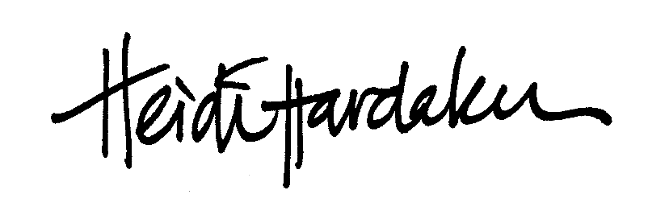

***Tim Kennedy***

Heidi Hardaker Tim Kennedy