
LEVEL NEWSLETTER
2026  Term One  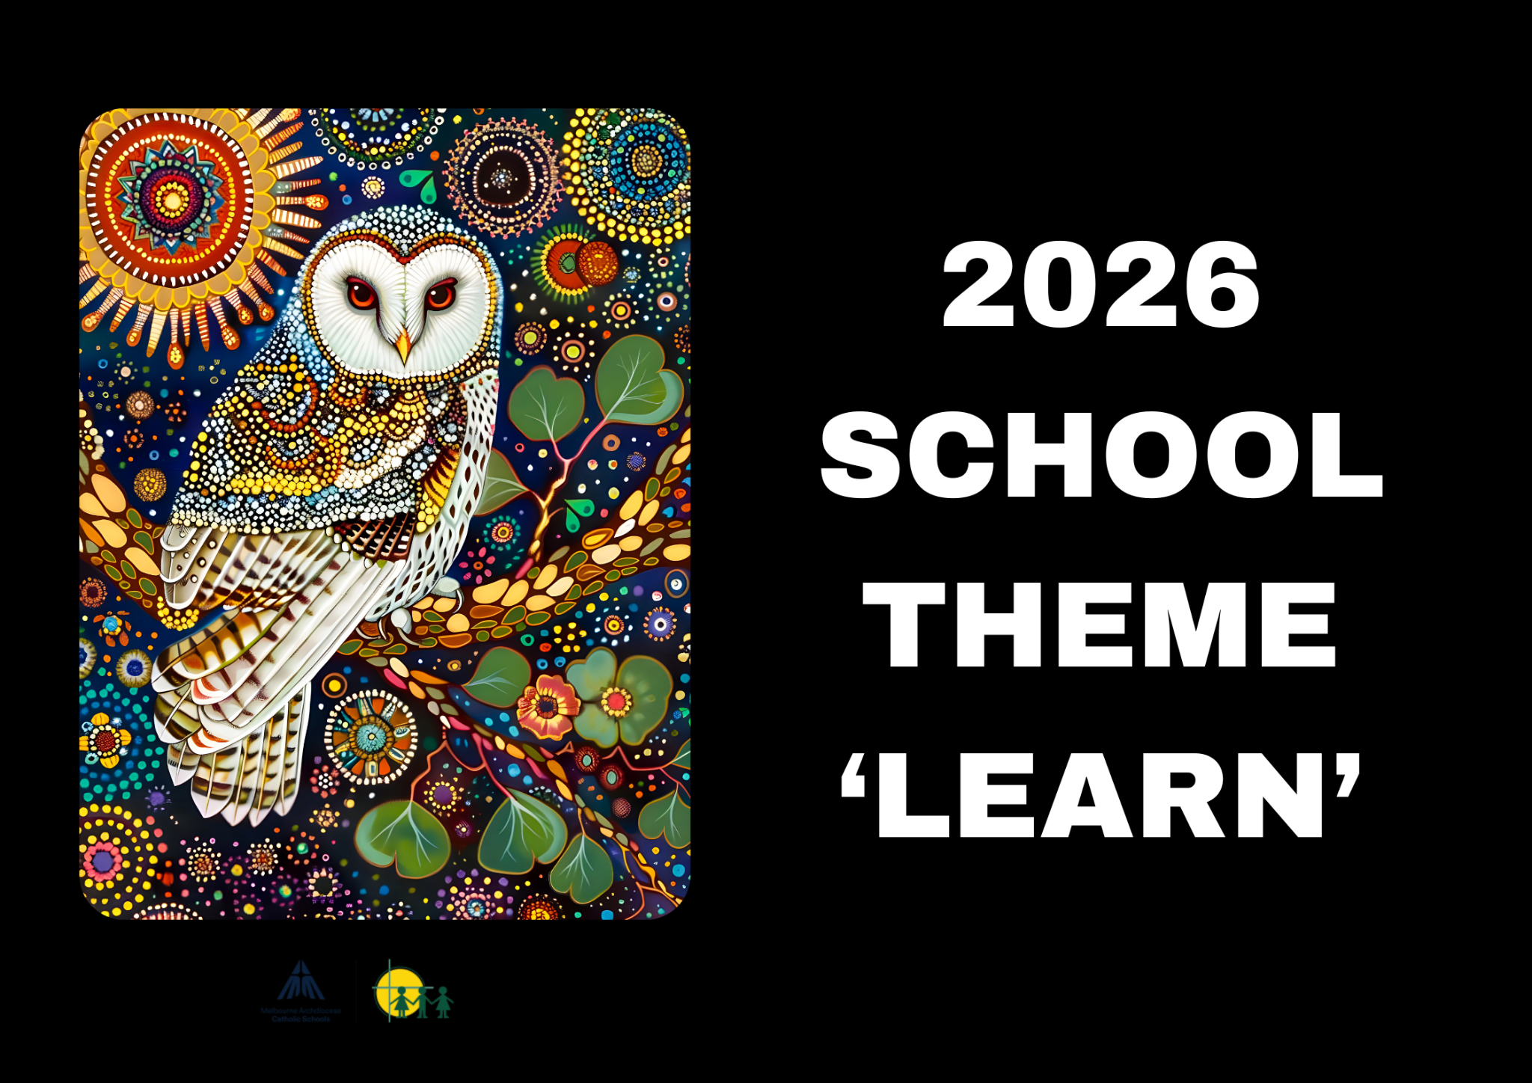 |  |   BIRTHDAYS  January: Sam Ghazale 4/1, Amelia Scamell 5/1, Madelyn Tran 29/1  February: James Papalia 5/2, Laura Samyue 8/2  Maya Seshadri 10/2  March: Hazel Lewis 3/3, Aariana Singh 5/3, Chiara Santolin 19/3, Keira Wardley 24/3, Lauren Williamson 31/3  April: Jackie Chua 9/4, Audrey Niu 30/4
Staff Contact |  | Please remember to only email staff between the hours of 8am & 4pm (Mon-Fri)  vpejic@hfmw.catholic.edu.au  asmith@hfmw.catholic.edu.au  bgrabau@hfmw.catholic.edu.au  kburman@hfmw.catholic.edu.au
Specialist Classes | MONDAY
Specialist Classes | TUESDAY | 5PG Stem, 5SG Stem
Specialist Classes | WEDNESDAY | PG - Performing Arts, Physical Education, Auslan, Art  5SG - Physical Education, Auslan, Art, Performing Arts
Specialist Classes | THURSDAY
Specialist Classes | FRIDAY | Level Sport
RELIGION   | TOPIC:  We are commencing the term developing our routines of prayer. We think about types of prayer and the purpose of prayers. We move into the Lenten season as we prepare for Easter. Students will explore ways in which Lent offers opportunities for growth and transformation. They will continue their journey in prayer, reflecting on how they live and act.
SPELLING  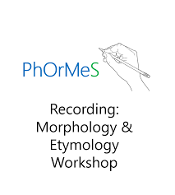 | We are continuing using the PhOrMeS spelling program which aims to give students knowledge about word meanings which can then be used to understand spoken and written language to a high level and help our students use mature vocabulary within their writing.  A key component will involve studying Morphology which looks at the forms of words or words’ morphemes (their smallest units of meaning). We will be teaching students the underlying patterns of meaning in English (prefixes, base words, root words and suffixes) to boost their ability to accurately predict meanings of words they have never been taught! Morphology reveals the beauty of our English language and benefits word reading, learning and spelling.  Weeks 2-4 - Spec/Spic/Spect -See/Observe  Weeks 5-8 - Homophones  Weeks 9-10 — Dic/Dict -Say/Tell/Proclaim
LITERACY  (Reading/Writing)   | We are beginning Term 1 with a novel study, “War Horse” by Michael Morpurgo. Through studying this historical narrative, students will focus on the craft of narrative writing and will be introduced to persuasive writing in preparation for Naplan which takes part in Week 7.  Reading and writing are intrinsically linked in literacy. A knowledge of vocabulary is important to develop an understanding of topics and genre and is a strong focus, particularly in the study of historical narratives.
MATHEMATICS  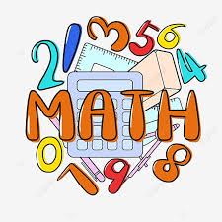 | We begin the year by learning about Data Representation and different types of graphs such as Dot Plots, Line Graph and Spreadsheets. We will be identifying variable types and calculating the mode of a data set  Weeks 1-3, Data Representation  Weeks 4 - 5, Factors and Multiples  Weeks 6 - 8, Multiplication and Division  Weeks 9-10, Perimeter and Area
KNOWLEDGE BASED/  INQUIRY   | In the first half of the term students are developing their understanding that there are several dimensions that impact on our health and wellbeing. They will consider what it means to be physically, socially and emotionally healthy. They will explore their own and others’ views about health and suggest what it might mean for certain groups of people; for example, the elderly, people with a disability or those from another culture. Students will consider factors that affect their own and others’ ability to access and effectively use health information, products and services. They will discuss and develop strategies for improving their personal health.  In the second half of the term, as part of our Civics and Citizenship curriculum students identify the importance of values and processes to Australia’s democracy and describe the roles of different people in Australia’s legal system. They identify various ways people can participate effectively in groups to achieve shared goals and describe different views on how to respond to a current issue or challenge.
BEHAVIOUR CURRICULUM   | Routines  We will spend time establishing routines in our classroom, such as lining up, entering and exiting the classroom and moving around the school. Having routines promotes a feeling of safety in students, as routines provide consistency, predictability and structure (AERO, 2021). Well-established routines enable students to independently follow them, reduce interruptions and increase teaching time (Archer & Hughes, 2011). Routines help to free up students’ working memory to focus on learning, as once routines become automatic, students won’t have to think about these things while focused on learning (Chaffee et al., 2017, Simonsen et al, 2008).  This term our focus is:  Lining up and sitting down after break times  Calm entrance/exit routine

 | Term One Important Dates (refer to our Google Calendar as well)  FEBRUARY  Wed 4 Prep Rest Day  Fri 6 Parent Welcome Event  Sun 8 Prep/New Family Welcome Mass (10am)  Mon 9 Children’s Mental Health Week (Wear an outfit that makes you feel confident and comfortable)  Tues 10 Safer Internet Day  P&F Meeting (6:30pm)  Meet the Teacher (Prep-Year 6)  Wed 11 Prep Rest Day  Meet the Teacher (Prep-Year 6)  Thur 12 District Swimming  Fri 13 Whole School Mass (9:15am)  FIRE Carrier Induction (10am)  Tues 17 Shrove Tuesday  Wed 18 Ash Wednesday (12pm Mass)  Prep Rest Day  Fri 20 Interschool Sport (1)  Mini Vinnies Soccer Event  Play Group commences (9:30am)  World Day of Social Justice  Wed 25 SAC Meeting (5:30pm)  Wed 25 Prep Rest Day  Fri 27 Interschool Sport (2)  MARCH  Wed 4 Prep Rest Day  Division Swimming  P&F Meeting (6:30pm)  Thur 5 Twilight Sports Day  Fri 6 School Closure Day (Vision for Engagement)  Sun 8 International Women’s Day (Give To Gain)  Mon 9 Labour Day Public Holiday (School Closed)  Wed 11 NAPLAN commences  Year 4 Reconciliation/Eucharist Info Night  Fri 13 Year 3-6 Athletic Trials  Sun 15 Catholic Education Week (Christ Beside Me-Walking in the Footsteps of St Patrick)  Tues 17 St Patrick’s Day  Wed 18 Open Day (all day) Everyone Welcome  Fri 20 Community Colour Run (Major Fundraiser)  Mass of St Patrick (St Patrick’s Cathedral)  Sat 21 Harmony Day  World Down Syndrome Day  Tues 24 Sacrament of Reconciliation (5pm)  Fri 27 Halogen Young Leaders Day  Summer Sport Gala Day (TBC)  Tues 31 EMR Swimming  APRIL  Thur 2 End of Term 1 (1pm finish)  Holy Thursday  Fri 3 Good Friday  Sun 5 Easter Sunday

