Course Confirmation for 2020

All parent payments for 2020 will be made via Compass Course Confirmation. The link can be found in your “My News” section on the opening page or via the “Organisation” menu.

STEP 1: You will be prompted to answer a few questions regarding the acceptance of College School Policies:

Please note you cannot continue unless you answer all questions.

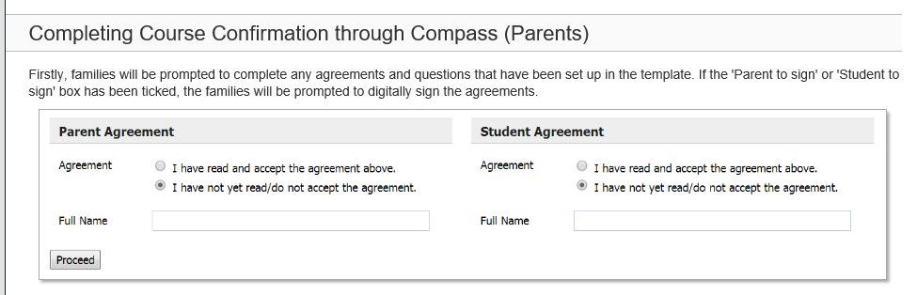

STEP 2: Once all agreements and questions have been completed, you will be asked to pay for any subject charges, essential, optional, or voluntary items. Eg:

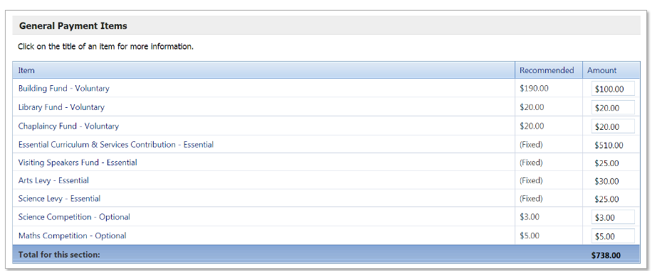

Voluntary and Optional Payments

There are 3 options available for payment against the voluntary and optional payments:
- Accept the default amount;
- Enter alternative amount; or
- Enter a “0” for no payment to be made

To pay, you have a choice to pay in full, by instalments, or pay at the school. Please note that the payment plan on Compass will not be scheduled until you press the Pay and Finalise button.

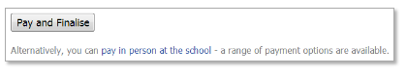

If you wish to pay via an individual payment plan, eg Centrelink, or organise another payment option, please complete all steps within Compass Course Confirmation, print out invoice and phone or drop into General Office for further assistance.

Thank you

