STUDENT ABSENCES

If your child is absent from school for any reason, it is important that you notify the school, along with the reason for the absence. Please check your XUNO dashboard to ensure all unexplained / unapproved absences have been addressed.

How to provide an explanation for unexplained absences
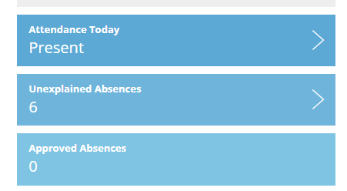
- Click on the unexplained absences icon

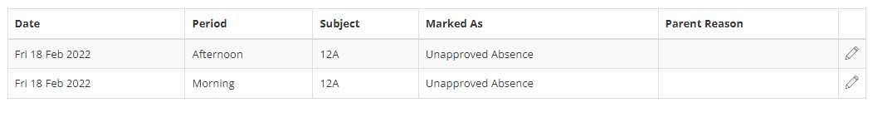
- Then click on the pencil on the right-hand side to enter a reason. If you have more than one child, you will need to select them individually.

How to send an absence note
On the occasion your child is unwell, attending a medical appointment or has one booked for a future date. these can all be lodged via XUNO, saving you a phone call to the school.
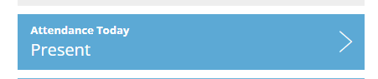
To lodge:
- Click on the Attendance Today

- Click on “Send an Absent Note
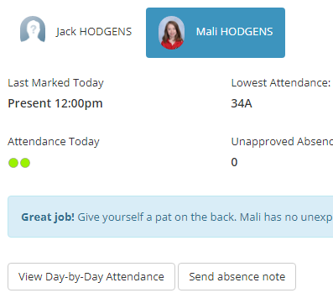

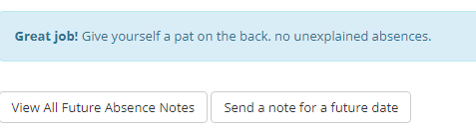
- Then click on “Send a note for a future absence” and enter all details as required and press SAVE.

Family Holidays
If you are going on a family holiday in school time, we ask that you put this in writing as early as possible as approval from the principal is required and teachers need time to create individual learning plans for your child to complete whilst on holidays. It is important that all students attend school every day unless they have a valid reason.
