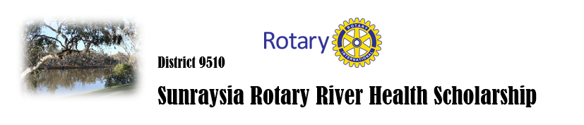2026
This scholarship aims to encourage motivated students from the Sunraysia area to pursue further studies that will address issues in the Murray-Darling Basin. A wide range of challenges face this crucial part of our nation. Climate change, water policy, urban and industry needs, recreation and environmental considerations all place demands on the basin.
The question of what is an appropriate field of study is an open one. Gone are the days when Biologists Chemists and Engineers were seen as the natural leaders to address water and drainage basin issues. Ethicists, philosophers and historians will have as much to contribute in the future. Perhaps the scholarship applicants themselves will be the ones suggesting how their fields of interest are relevant.
The scholarship will be awarded to one worthy applicant annually to follow a tertiary study at an institution of their choice. Scholarship applicants will be evaluated on a range of criteria including scholastic performance, communication skills, community involvement, and personal skills and character.
Scholarship holders will be encouraged to speak to Rotary clubs and other community groups when the opportunities occur, as such presentations by young leaders are important in meeting the Basin’s challenges.
The scholarship of $5000 will be for a student who will take up a tertiary study in 2027 or are current first year tertiary students
Application forms and information about the selection process are available from the
Rotary Club of Red Cliffs. email: rotaryredcliffs@outlook.co.au
For further information please phone 0428 165 355

