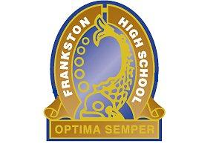
FRANKSTON HIGH SCHOOL
2015 CHAPLAINCY FUNDRAISING DINNER
RAFFLE PRIZES
‘Please support the business who supported our school’

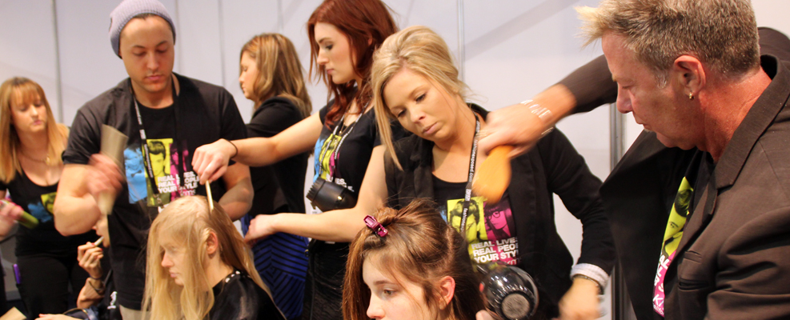 |   Cut and Blow Dry Voucher  (Donated by Wayne and Beckie White)  9783 4195
Fox clothing & accessories  (Donated by Anne and Craig Thomson)  AVAILABLE AT MOST SURF SHOPS  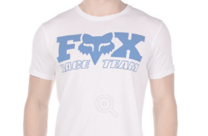   | 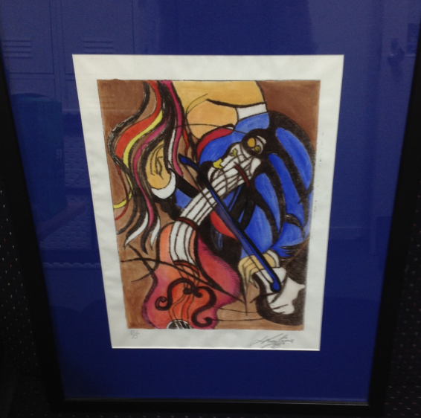  Painting  (Donated by Lynn Keating)
Pro Street Scooter  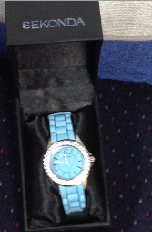  Ladies Watch | Gravity Zone Family Voucher  Seaford  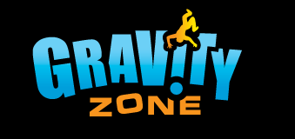  1300 479 663    Plant  (Donated by Debbie Albiston)
Voucher from   | Techni Ice  14 Tooyal St Frankston  9783 1922
La Porchetta Dinner Voucher  Frankston 9770 0885   |   