Level 5 Homework Matrix
Homework tasks should ideally be completed with adult supervision. The Homework Matrix for each level will be available in the Connect newsletter once a fortnight. Tasks will be completed in student homework books and handed in to the teacher, to be signed, two weeks later on a Friday morning (even weeks). Teachers will sign homework books.

L5/6 – Reading + 8 tasks/fortnight

Reading (compulsory)  Read for: minutes every day.  Record the title of your book and the pages read in your diary. Ask an adult to sign your diary.  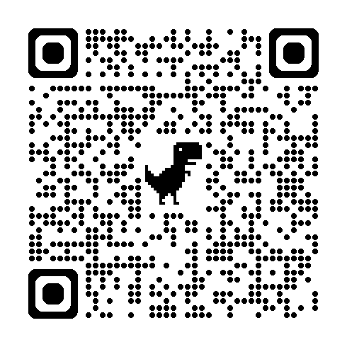 | Writing (grammar)  Write one descriptive paragraph about a real or imagined event.  Remember to include words that help your reader identify:  Who is involved?  What is happening?  Where is it taking place?  Try to use descriptive adjectives and precise verbs to paint a picture for your reader.  Challenge: Include at least one complex sentence to make your writing more interesting. | Physical Education Challenge  Athletics Practice  Go for a run at home with a parent or guardian. Alternate between jogging and sprinting. Remember to learn forward, use your pumping arms and drive your knees when you sprint. | Gratitude  Pick 3 people you are grateful for  this month. Make sure you explain  why you picked each person.
Spelling:  Look up the definition of at least 3 of the following words and write it out:  objected, ascertained, mournfully, unaccountably, symbolism, exasperated | Inquiry:  Tell someone in your family about Fast Fashion and discuss the impact on the environment and what we can do to balance it out. | Art Challenge  Observe and draw a leaf carefully. Focus on detail, texture, shading and accurate proportions. | Mindfulness  Lay in a quiet room of the house or  somewhere comfortable outside  e.g. on the grass for a few minutes.  Take a moment to just stop and  listen to all the sounds around you.
Handwriting  Write a sentence with each of your spelling words that demonstrates your understanding of its meaning. | Maths Skills/Fluency  Create a 4, 5 or 6-digit number.  How many different ways can you rename your number?  Example: 4,325  = 4 thousands + 3 hundreds + 2 tens + 5 ones  = 43 hundreds + 2 tens + 5 ones  Challenge: Add 1 thousand and 2 hundreds to your number. | Science Challenge  Can you learn the first 20 elements on the periodic table? | Emotional Literacy  Create a feelings collage using  magazines, coloured paper or art  supplies. Find pictures  representing different emotions to  create a collage that visually  portrays your feelings.
Maths  Fraction Number Line Challenge 📏  - Draw a number line from 0 to 1 and choose 2 fractions to place on it.  - Find 3 fractions that belong between your two fractions.  - Prove that your fractions belong there. You could use a model, equivalent fractions or explain your thinking in words.  Example:  I placed 2/12 between 1/16 and 2/4 because twelfths are larger parts than sixteenths, and 2/12 is still less than 2/4. | Online Platforms  - Complete tasks on Mathletics  - Play a game on Maths frame  - Listen to a story on Storybox | Mandarin Challenge  ✏️ Translate these words.  米饭 mǐ fàn → ______  面条 miàn tiáo → ______  饺子 jiǎo zi → ______  鸡肉 jī ròu → ______  蔬菜 shū cài → ______  奶茶 nǎi chá → ______  好吃 hǎo chī → ______  不好吃 bù hǎo chī → ______ | Empathy  Think about 3 ways in which you  can brighten someone’s day this  week or ways in which you can  cheer someone up if you notice  they’re sad.

