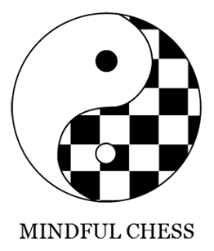
South Melbourne Primary

Chess Club Enrolment Form

Term 4, 2023

Chess has been played for thousands of years across diverse regions and cultures. Chess club provides kids the opportunity to master this timeless art while socialising, having fun and sharpening their minds.
Through this interpersonal challenge it has been shown that kids develop analytical capabilities, foresight, planning, decision making skills, discipline and much more. These skills are helpful in both academic and personal life. While chess inherently involves competition, our club maintains an emphasis on emotional awareness and sportsmanship.
Throughout the term classes will involve learning strategy and tactics, exercises, games and a term-long tournament.
CLASS DETAILS:
CLASS TIMES: 3:30-4.20pm (sharp!) every Wednesday
*Please tick and let me know if your child attends OSH on Wednesdays. If so, you must give OSH permission for them to come to chess
DATES: 11th Oct – 13th Dec
PICKUP LOCATION: Gym foyer (please request gym door code for access)
MEMBERSHIP FEE: $118 per term (*pro rata if joining late)
ENQUIRIES
Contact Felix Chandler: felixchandler@mindfulchess.com.au
   
SMP – Member details and payment * if your child has already enrolled in the past simply send an email confirming payment
To join please return the following details. Payment can be made in cash to the chess teacher or pay via bank transfer and send a scanned email to felixchandler@mindfulchess.com.au
Child Name:___________________________Age:______________Phone: ___________________________
Parent Name:________________________Email:________________________________________________
Please select payment method: Cash Direct Debit * include child’s name as reference
Bank Transfer payment details:
ACC. Name: Mindful Chess
BSB: 063238
Account No: 11195581
*Please complete payment before returning enrolment form and include your child’s name in the reference

