

**26/07/2024**

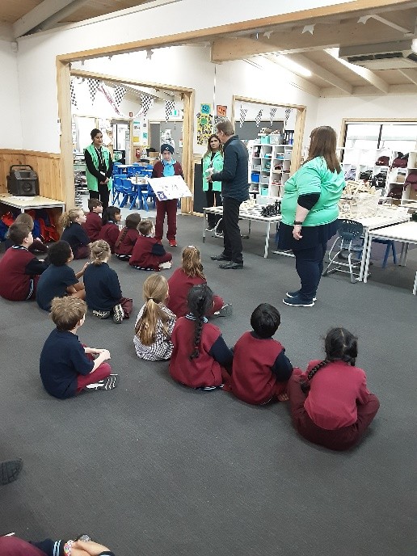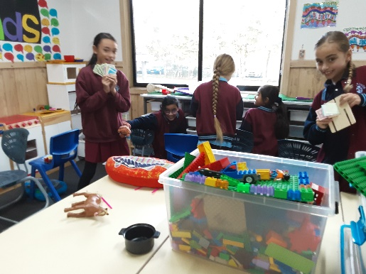[](https://pp.campaustralia.com.au/)

Join in the fun of Outside School Hours Care activities and experiences with Your OSHC and Rocketeers.

**Make a booking**

Book now

Join us for a month-long celebration of everyone's favourite athletics competition! Dive into a world of active play, group games, art experiments, cultural journeys and more. There's something for everyone as we explore the excitement and spirit of the Olympics through fun and engaging activities! Every location’s game will be different, so chat to your Coordinator to find out more.

* Principal Afternoon Tea
* Big Art Day Friday
* Battin Relay
* Program highlight

**Activities coming up**

**Oatlands Primary School OSHC**