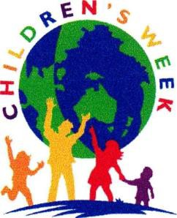

CHILDREN'S WEEK 2023
Friday 20 October - Sunday 29 October
Minister for Education Award
Nomination Form

Details of Nominee:
Category (please tick)
O Primary School O Secondary School Student up to 18years

Name
Address | Post Code
Date of Birth | Telephone:

Parent/Child’s caregiver Email

School Attending

Synopsis of contribution of the nominee. Please attach supporting documentation not exceeding one page or 500 words with photographs if available, which demonstrates the achievements of the nominated student or students. For more information see Guidelines or the website. No organisation can have more than one nominee in each category. No Parent can nominate their child. No adult can nominate themselves or any family member.

Details of Nominating Party
Name | Position
School/Organisation
Address | Post Code
Telephone: Best number
Email:
Student Media Consent Yes/No

Principal / Line Manager endorsement: Yes/No

Signed; Date:
Nominations due by FRIDAY 22nd SEPTEMBER 2023
Email: mberlemon@hotmail.com
Or Post to: Children's Week Association of SA
PO Box 2103 Magill North 5072
https://sachildrensweek.org.au

