
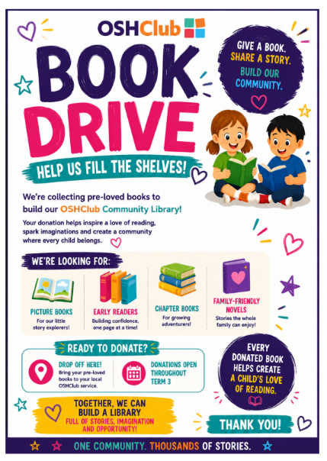
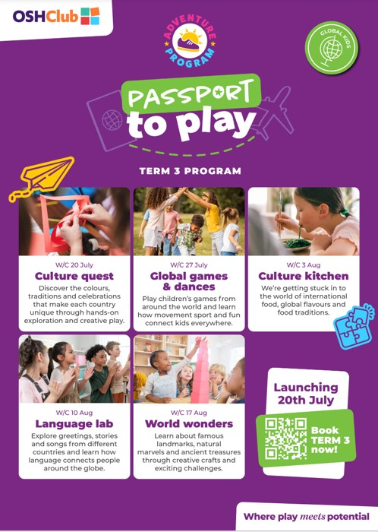
STARTS THIS WEEK!
Bunyip OSHClub – AUGUST 2026
THIS FORTNIGHT AT OSHC
THIS TERM AT OSHC

bunyip@oshclub.com.au
0458 013 302
This term we are really settling into Oshc, the children are embracing our new clubs, and we have put a heavy focus on child led activities on the planner. We are currently organising to work with Beyond Blue to help raise awareness and money for Men’s mental health and have enjoyed experiences special days in oshc such as world friendship day.
We have seen an influx of bookings lately and are so excited to see our little Bunyip Oshc growing, we have welcomed back families and welcomes in new families, as our numbers grow our programs will too to reflect the diverse interests and needs of the children present.
This past fortnight we have really been enjoying imagination play, we have set up schools, performances, and sung songs. The children have also enjoyed sitting down and reading to one another. Wet weather does not stop our Bunyip children from having fun and using some amazing imagination skills.
We have also been working a lot on our child safe standards, helping to empower our young minds to be aware of their rights, their voice and their safety, we would love input from families on what you would like to see on our planners.
We are still setting up our community book drive as we are hoping to set up a book library where everyone is welcome to come and grab books, swap books, etc. Any donations are greatly welcome.
Bunyip OSHClub – AUGUST 2026
CHILDRENS CORNER
What has been your favourite thing at OSHClub recently?
“Playing Basketball” - Josh

What is one thing we can improve on or change at OSHClub?
“More sports equipment for older children” - Noah

What’s your favourite thing that has been on the menu?
“Tuna Bake” - Lilly
POLICY CORNER CHILD SAFE STANDARDS
Delivery and Collection of Children  At OSHClub, our number one priority is that we keep your children safe. To do so, we need to make sure that they are being dropped off and collected appropriately.  When dropping off it is important that guardians walk their child to the door. This ensures that they make it here safely and allows us to potentially communicate any vital information.  Collection of children is even more important as we need to ensure that your child is going home with the correct person. If you or a family member has never collected your child before, we will need to see ID and ensure they are authorised to pick up. If you do need someone different to collect your child as a one off, please let us know in writing with their full name.  If you have any further questions regarding this policy - please let us know! |  | Child Safe Standard 8  Here at OSHClub, we follow the Child Safe Standards which is a list of 11 standards that we need to implement to keep children safe. Child Safety Standard 8 is staff and volunteers are equipped with the knowledge, skills, and awareness to keep children and young people safe through ongoing education and training. We embed this standard by ensuring educators are engaging in regular weekly reflections, policy of the week, appropriate and active supervision, conducting practice emergency drills and engaging in appropriate and up to date training. If you have any further suggestions on how we can embed this standard, please let us know!
REMINDERS
If your child has a medical condition, you must supply an action plan, and applicable medication with a pharmacy label.

