

**20/09/2024**

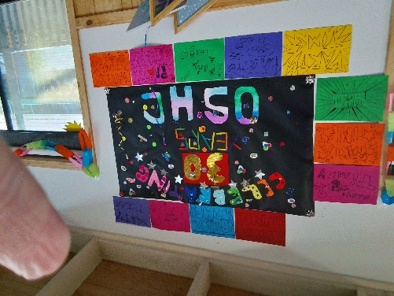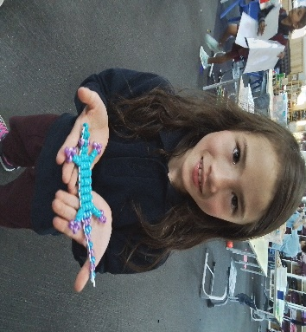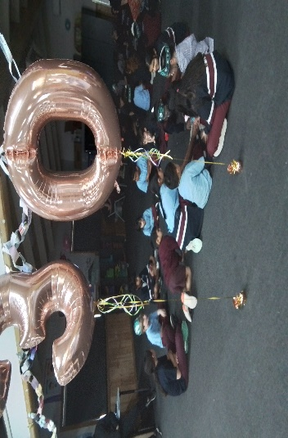](https://pp.campaustralia.com.au/)[](https://apps.apple.com/app/apple-store/id1529575453?pt=120333103&ct=edmbookings&mt=8)[](https://play.google.com/store/apps/details?id=au.com.campaustralia.parent)

**Oatlands Primary School OSHC**

Join in the fun of Outside School Hours Care activities and experiences with Your OSHC and Rocketeers.

**Make a booking**

Book now

* SunSmart Team Poster
* Grow Herbs or flowers
* Remembrance Day

**Activities coming up**

**A message from your Coordinator**

Spring Rocketeers Coming up, come and join in the fun with a visit to Silvers Circus and explore Nature’s Play at the Royal Botanic Gardens. We also have incursions to enjoy and Club Base days at the service, to have fun and be involved. Then term four starts, please provide hats for your children to enjoy outdoor play safely and be SunSmart.