

REMINDERS:

Non notified absences will incur a $20 fee. Please be sure to notify the service via phone or via the parent portal app.
Welcome back for the last term of the year. How fast this year is flying by, we are working on settling back into routines at Oshclub and are so excited for all the fun term 4 has to offer. We are busy building paper Mache planets, working on planting new gardens, changing up our wall displays and cleaning up the oshc room. We are also celebrating nutrition week and World children's day in the upcoming weeks, information can be found in service, class dojo or email. For any questions, please feel free to reach out.
We have lots of left over clothes from holiday program if anyone is missing anything please pop in and have a look in the lost and found.
As we are now in term 4 it is back to No hat no play, please ensure your children's hats are in their school bag ready for lots of outside play.
We look forward to getting to see everyone and hearing about everyone's holiday adventures, and hope everyone enjoyed their holidays as much as we did.

What’s been happening…
BUNYIP
OSHCLUB

Policy Corner

Child Safe Standard
Sun Protection
Child Safe Standard 2
Here at OSHClub, we follow the Child Safe Standards which is a list of 11 standards that we need to implement to keep children safe. Child Safety Standard 2 Is: Child safety and wellbeing Is embedded in organizational leadership, governance and culture. We embed this standard by setting clear OSHClub expectations and rules, conducting practice emergency drill procedures with children, communicating to all staffs/parents about children's medication, and modelling exemplary behavior. If you have any further suggestions on how we can embed this standard, please let us know

As we enjoy the warm weather, it's important to remember the significance of sun protection for our children. With the extreme heat, children are more vulnerable to heat-related issues like dehydration and heat stroke. Our Educators are ensuring that sun safety is integrated into our program planning. A sunscreen station is set up in the service and children are reminded to reapply sunscreen every 2 hours and 20 minutes before outdoor play. Supervision is crucial in ensuring children are protected from the sun. Educators model good sun safety practices, especially during outdoor activities. Educators understand the UV Index is important, and any ratings over level 3 require sun protection measures. Sun safety resources, including posters are available around the service, and they are use as discussion starters in children’s meetings. Let's work together to keep our children safe and healthy under the sun!

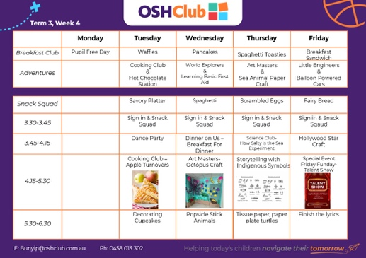
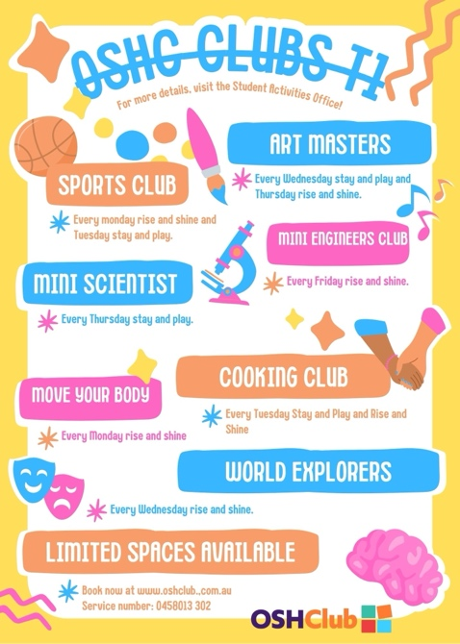
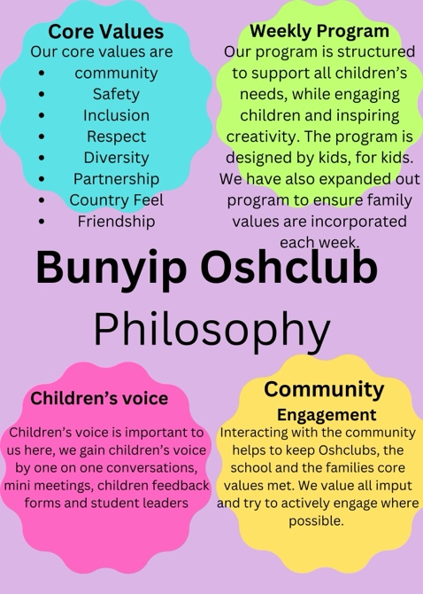

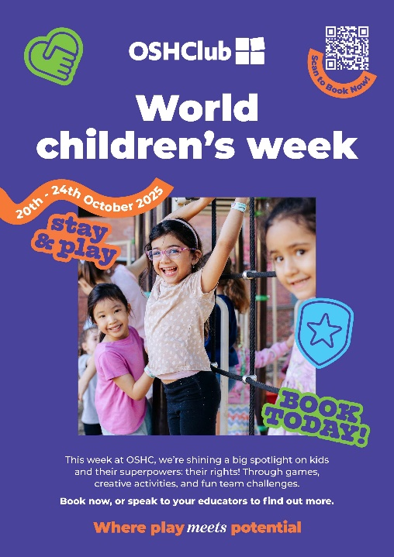
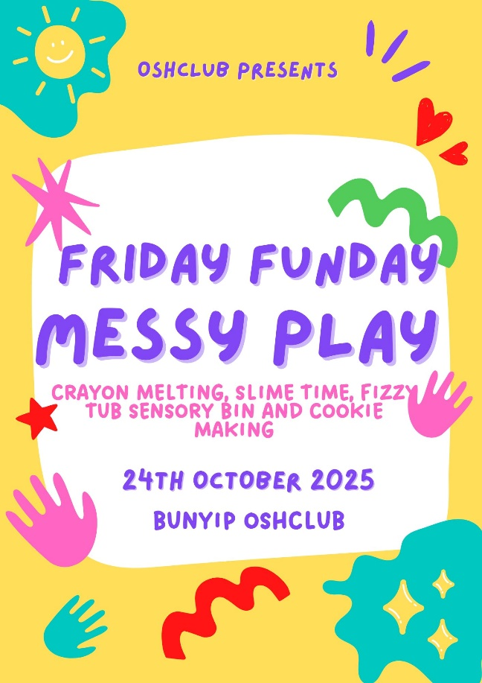
Upcoming Events

PHOTO GALLERY
