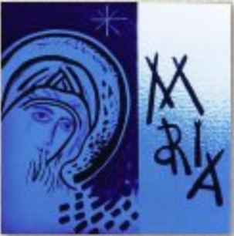

|  |  |
| --- | --- |
| CHILD’S NAME : |  |
| DATE OF BIRTH: |  |
| ADDRESS: | ........................................................................................................................................................ |
| FATHER’S NAME: |  |
| MOTHER’S NAME: |  |
| PARENT’S EMAIL: |  |
| HOME NUMBER: |  |
| MOBILE: |  |
| SCHOOL: |  |
| ACADEMICAL YEAR: |  |

**$40 Contribution to cover the expenses**

**# please bring a photocopy of Baptism certificate of your child. #**

St Mary Star of the Sea Cottesloe/ Corpus Christi Mosman Park

2 McNeil Street Peppermint Grove WA 6011

Ph: 93842421 Fr James / Fr Rodrigo Email:[cottesloe@perthcatholic.org.au](mailto:cottesloe@perthcatholic.org.au)

Enrolment form for Sacraments 2019

**Enrolment Day**: Tuesday 12th March between 2.30pm and 5pm at Cottesloe Parish hall

**Parents please bring this completed form with you.**

**Enrolment Mass**: Sunday 17th March at 10am or 5pm in Cottesloe Church

|  |  |
| --- | --- |
| Reconciliation(yr 3+)15 May |  |
| Eucharist(yr 4+) 30June |  |
| Confirmation(yr 6+) 9 June |  |