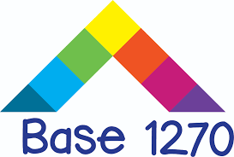
Vacation Care Program

Monday 23rd September – Thursday 26th September 2019

Operational Hours for Base 1270 – 8am to 6pm Monday to Friday

$65 per day or part-day (plus additional costs for some days as noted below). Parents to provide morning tea and lunch for their child unless otherwise stated. Afternoon tea is provided. As well as the planned activities listed each day, children are free to choose from a variety of additional activities at Base 1270 such arts, crafts, sports and cooking.

Mon  23  Sept | Anything with wheels  Today we will be riding around the school on our favourite push power toy. Bring along your rollerblades, bike, scooter, skateboard, or any other wheeled device you may have. Please make sure you bring your helmet. NO HELMET – NO RIDING
Tues  24  Sept | The AMAZING Race  In a small educator-led team, you will put your skills and knowledge to the test in Base 1270’s version of the AMAZING Race. The activities will test your team-building, cooperation and communication skills. Who will be the first team to the pit stop and be declared the Base 1270 AMAZING race champions?
Wed  25  Sept | Olympic and Commonwealth Games  Test your skills and knowledge in a number of Olympic and Commonwealth Games activities. There will be a number of activities from the opening and closing ceremonies, to trivia, races and more.
Thurs  26  Sept | Inflatable World  Please note that an additional cost of $10 applies for this day.  Come and join in the fun at the biggest indoor inflatable playground in Australia. We will be departing Base 1270 at 9.30am and spending 2 hours on the inflatable playground. We will be returning to Base 1270 at 12.30pm. After expending all of our energy, we will be having a Base 1270 cinema experience.
Fri 27  Sept | Base 1270 will be closed today due to the AFL Grand Final Public Holiday

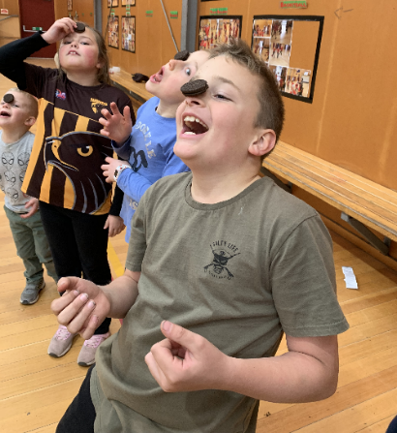
For bookings for the Vacation Care Program, please visit and book through
‘My Family Lounge’ http://buninyongps.vic.edu.au/after-school-care/

Should you have any questions or difficulty with the booking process, please contact Mel:

- Phone: 5341 3560
- Email: oshc@buninyongps.vic.edu.au

