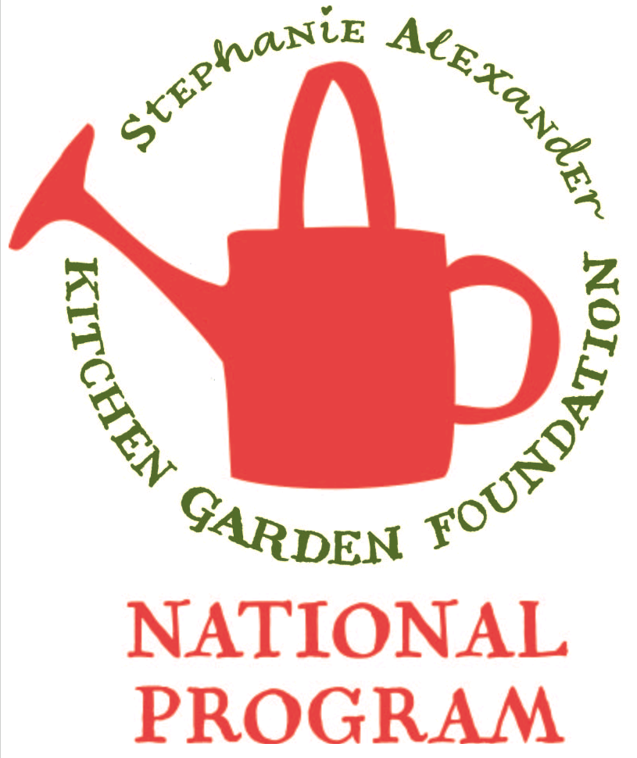
Ratatouille

Season: Summer / Autumn

Type: Vegetable Dish

Difficulty: Easy

Serves: 24 tastes in the classroom or 4 at home

Fresh from the garden: Tomatoes, Eggplant, Capsicums- red and yellow, Thyme, Basil, Zucchini

Recipe source: Taste.com.au

Equipment:  * knives  * kettle  * bowl  * slotted spoon  * frying pan  * wooden spoon  * measuring spoons  * chopping boards  * serving dishes | Ingredients:  - 4 tomatoes  - 3 tablespoons olive oil  - 1 large onion, chopped  - 1 red capsicum, diced  - 1 yellow capsicum, diced  - 1 eggplant, diced  - 1 zucchini, diced  - 1 tablespoon of tomato puree  - ½ tablespoon chopped fresh thyme  - 2 tablespoons torn fresh basil  - 1 garlic clove, crushed

What to do:
- Boil kettle of water and pour into a bowl.
- Score a cross with a knife in the base of each tomato and plunge into the bowl of boiling water for 20 seconds.
- .Remove with a slotted spoon and peel skins of tomatoes and discard.
- Chop the tomato flesh into medium sized pieces.
- Chop the onion into small pieces.
- Dice the capsicums, eggplant, zucchini.
- Heat the olive oil in large frying pan (or electric frying pan) over medium heat and add the onion.
- Cook for 2-3 mins then add capsicum and cook for a further 5 mins.
- Transfer onion and capsicum to a plate and set aside.
- Add the eggplant and zucchini and cook for 5-6 mins.
- Return the onion and capsicum to the pan and stir in tomato paste.
- Add thyme and tomatoes.
- Reduce heat to low and cook for 15 mins stirring occasionally.
- Stir in the basil and garlic.
- Serve warm on its own or with meat or fish.

