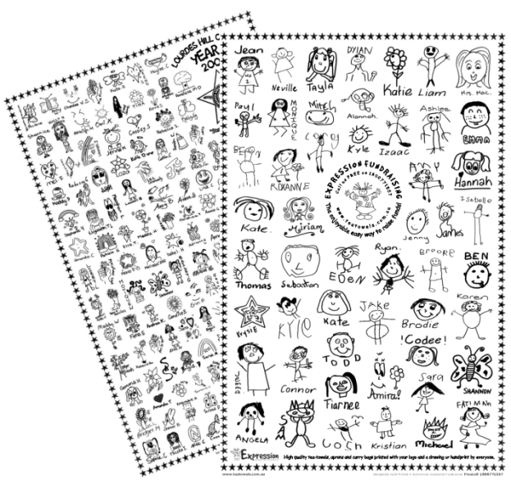
CUMBERLAND TEA TOWEL & APRON FUNDRAISER 2023

Dear Parents

This year the Parents & Friends Association is running the popular group tea towel and apron project.

The unique souvenir tea towels and aprons contain drawings done by all the students and staff at our school. The pictures will be arranged into one commemorative design and will be screen printed in black onto high quality white tea towels and in white onto black aprons.
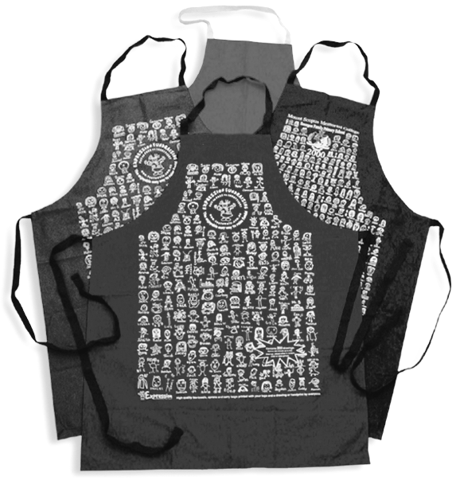
We chose this project because it involves the children, produces a wonderful memento and meaningful gift for parents, relatives and special friends. The tea towels and aprons look amazing, are so easy to post and make a fabulous reminder of your child’s early years. There is an example of a tea towel and an apron at the Primary Admin office in the Cumberland building.

They are a great idea for Christmas presents. Just imagine a loved one wearing an apron or using a tea towel displaying your child’s fabulous artwork.

The cost is $15 for one limited edition souvenir tea towel and $20 for one apron. They can be ordered by sending the order form below with payment to Aitken College Parents and Friends Association (P&F) in an envelope clearly marked “TEA TOWELS & APRONS with your child’s name and class”. The items purchased will be delivered to your child via the homeroom teacher.

Support Aitken College and place your orders now. Each child from Cumberland has their picture and name included, so make sure you do not miss out on this unique one-off opportunity to preserve your child’s artwork and remember friends and teachers forever!

Orders CANNOT be taken after the due date. To avoid disappointment, place your order now.

Final orders are due before Friday 20 October 2023

If you have any queries, please contact Parents & Friends Association via email pandf@aitkencollege.edu.au

--------------------------------------------------------------------------------------------------------------------------------------------------------------------------------
CUMBERLAND TEA TOWEL & APRON ORDER FORM 2023

Child’s Name: _______________________________________________ Class: _____________

Number of Tea Towels Ordered @$15ea: 1 2 3 or more → ______ Total $________
Number of Aprons Ordered @$20ea: 1 2 3 or more → ______ Total $________
Please enclose payment with your order.
Cash or cheques made payable to: Aitken College Parents and Friends Association

Payment method: Cash Cheque (Payable to Aitken College Parents & Friends Association)
Visa MasterCard Amex

Credit Card Number: Expiry Date:

Name on Card:

Signature: Date:

TOTAL Enclosed: $ _________

