**St. John’s School, Euroa  
SCHOOL IMPROVEMENT PLAN**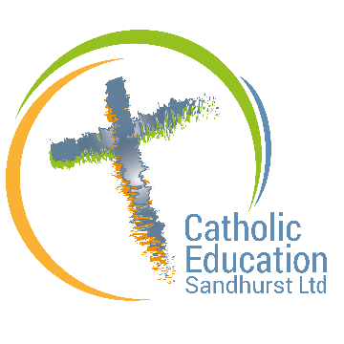

**2024 -2028**

**School Identity Statement:**

St John's Catholic school is a community, inspired by truth, love and service, that challenges and supports each person to be the best they can be.

**School Vision Statement:**

St John's School strives to be a community where...

* Students build a relationship with God and Jesus' teachings are modeled and lived.
* The total development of each person is nurtured: Cultivating mind, spirit, body, character and imagination.
* Home, school and parish work in partnership to create a vibrant learning community.
* Difference is valued, risk taking is encouraged and achievements are celebrated within a safe and supportive environment.
* Our environment is child safe and all children are respected and are protected from harm.

|  |  |  |  |
| --- | --- | --- | --- |
| **SCHOOL IMPROVEMENT PRIORITIES** | **LINKS TO CES Ltd STRATEGIC DIRECTIONS** | **CES Ltd STRATEGIC**  **ENABLERS** | **SCHOOL IMPROVEMENT GOALS** |
| Integrate the values and principles of the Catholic Faith through a culture of continuous learning. | **Catholic Community:**  Catholic school identity is preserved and enhanced by explicitly putting forward the Catholic faith as the host tradition in dialogue with the school's plural context1, out of the conviction that faith and culture enrich each other.  **Learning Community:**  Through high-impact pedagogical strategies, students' learning is relevant, contemporary and differentiated to their needs. | * Culture of dialogue * Student empowerment in voice, agency and leadership. * Partnerships | 1. To renew our Catholic Identity to align with our school Charism and Mission of the Catholic Church through a redefined vision and mission. 2. To maintain the ongoing commitment to our faith community and development. 3. To foster stimulating, enriching, and empowering learning environments for all students. This will be achieved by developing a comprehensive School Improvement Plan, grounded in a clear and explicit improvement agenda, and driven by the active involvement of the entire school community. |
| To achieve outstanding learner growth for every student and every teacher every day. | **Learning Community:**  Through high-impact pedagogical strategies, students' learning is relevant, contemporary and differentiated to their needs.  **Well Community**  Dynamic healthy communities that build trusting and respectful relationships to enhance student learning, wellbeing and safety. | * Partnership Innovation & Collaboration | 1. To implement a coherent sequenced plan for curriculum delivery. **(Embedding Low Variance, Knowledge-rich Curriculum / Leading Improved Literacy Outcomes)** 2. To monitor alignment between the written and taught curriculum. **(Instructional Coaching / Assuring Positive Learning Environments)** 3. To enact a professional learning plan and provide coaching on approaches to maximize student learning **(Instructional Coaching)**   **Key Initiatives**   * Catholic Formation & Mission * The Neuroscience of Learning * Leading Improved Literacy Outcomes * Embedding Low Variance, Knowledge-rich Curriculum * Assuring Positive Learning Environments (5) * Instructional Coaching |
| Build a culture of continuous improvement between staff students and families. | **People Focused Community**  Fostering collaborative relationships in which members work  interdependently to achieve common goals in a culture of trust,  respect and mutual accountability.  **Stewarding Community**  Nurturing and growing the gifts and talents of its members so that they may be shared for the benefit of  many. | Innovation & Collaboration  Partnerships | 1. Students' diverse needs are collaboratively planned, implemented and embedded across the curriculum. 2. Families are valued as partners in student learning. 3. Strengthen processes and structures for supporting well-being across the school, ensuring a strong sense of belonging and pride. |