Under-12 Country Skills Days Registrations Open!

The Under-12 Country Skills Days are back!
Held on Saturday 16 and Sunday 17 July 2022 at 10 regional centres across Victoria, the 2022 Under-12 Country Skills Days are part of a development program for players of all abilities and standards born in 2011 or 2012 from all associations located in regional Victoria.
Skills Days are for players of all abilities and standards and are open to all athletes at country associations. The coaching programs concentrate on the individual skills relevant for players in the specific age group.
Each Under-12 Skills Day participant will receive:
- Coaching and development
- Official Skills Day T-Shirt
- Official Skills Day Drink Bottle
- Official Skills Day Basketball
- Participation Certificate
Under-12 Skills Days events run from 10am - 4pm each day. We ask that all participants please bring their own lunch.
Participants who are registered before Tuesday 5 July at 9am will receive our Early Registration Rate of $99 (including GST), so make sure you register quickly! Registrations made after that time will be $120 (including GST), with online registrations closing on Tuesday 12 July at 9am.
For further information on Basketball Victoria’s Under-12 Skills Days, please contact Craig Hockley – craig.hockley@basketballvictoria.com.au.

South Central
Bellarine, Camperdown, Cobden, Colac, Corio Bay, Geelong, Lorne, Mortlake, Lara, Surfcoast
Location: Bluewater Leisure Centre, 118 - 134 Hearn Rd, Colac
Boys: Saturday 16 July
Girls: Sunday 17 July

Link to register: U12 Skills Day
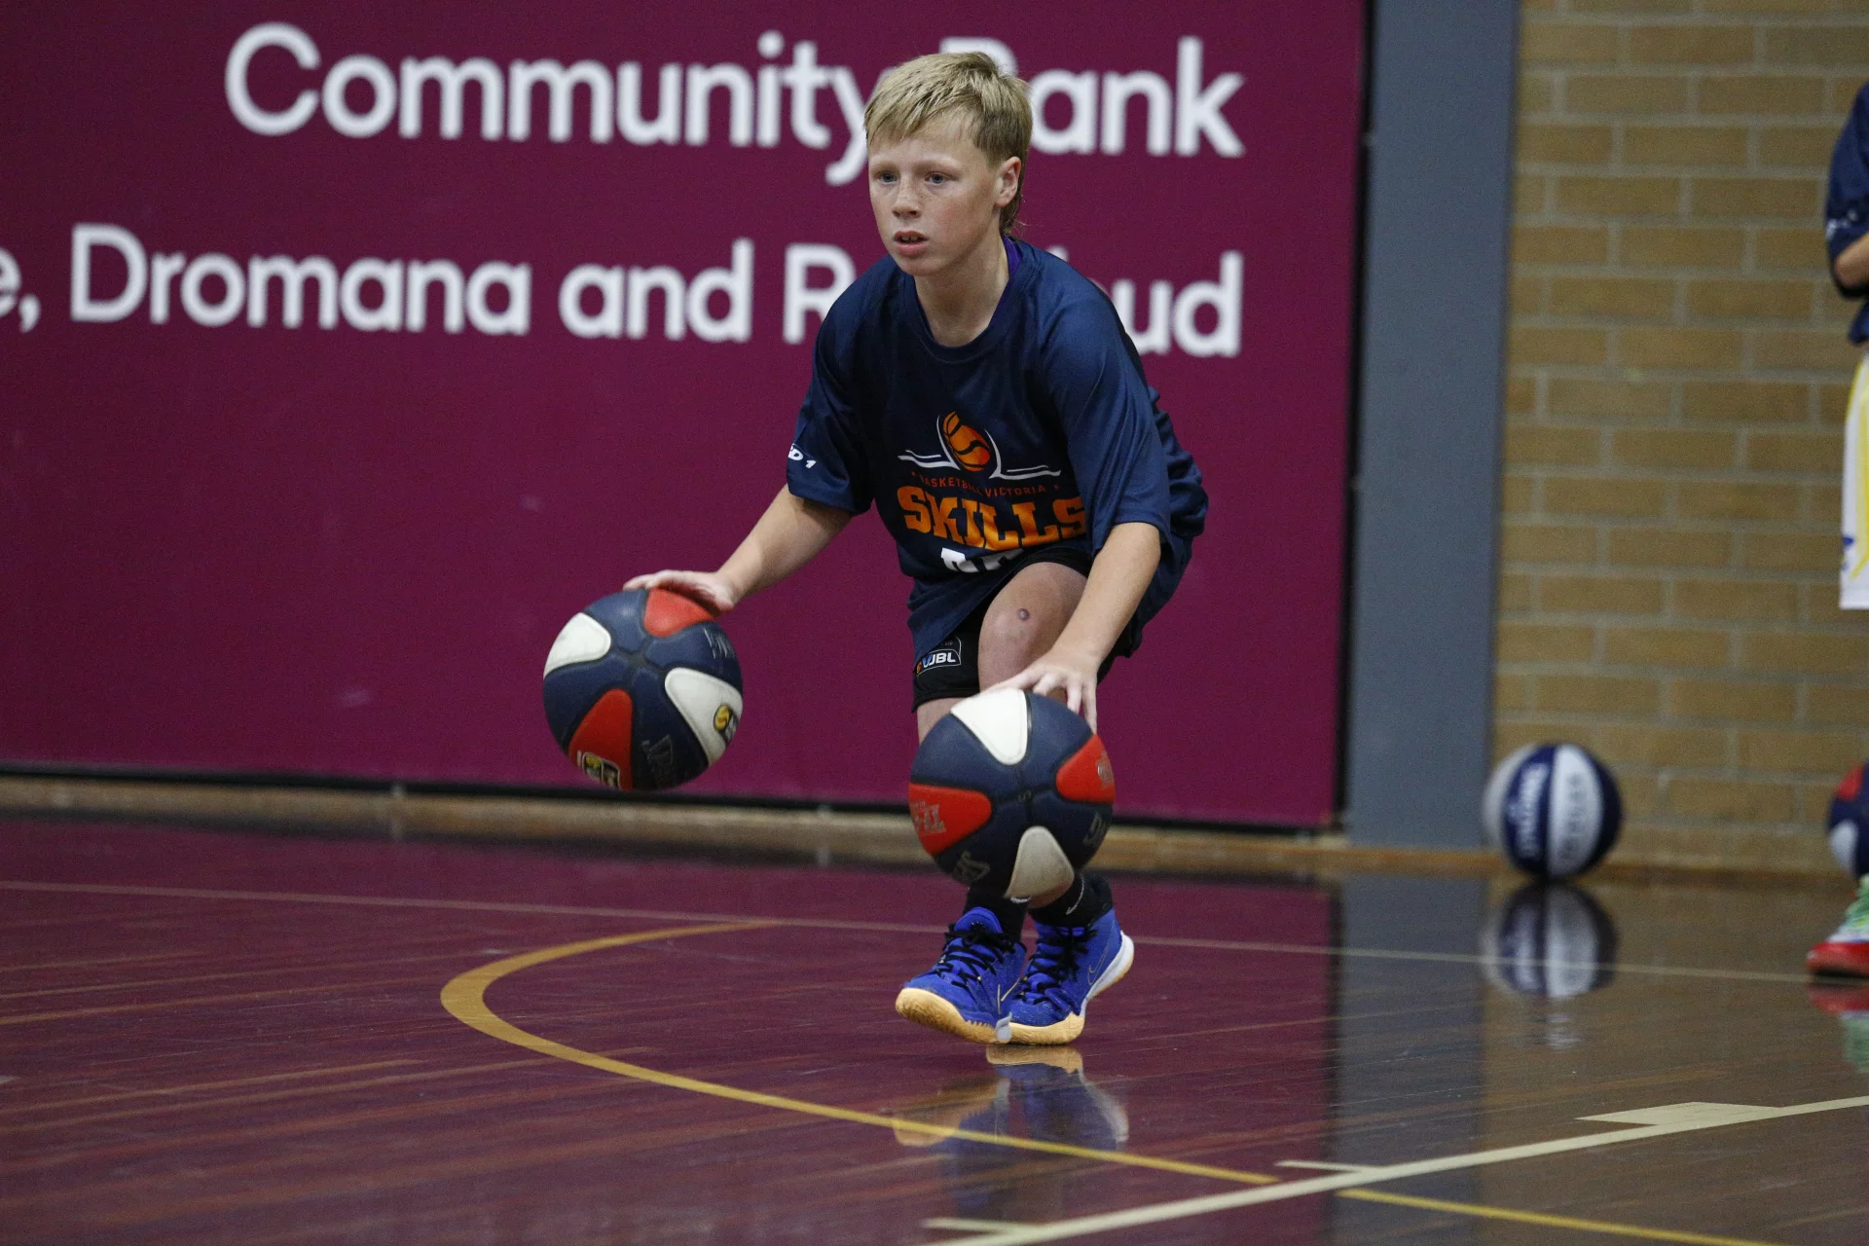
Administrator: Cate Johnson: cate.johnson@education.vic.gov.au

