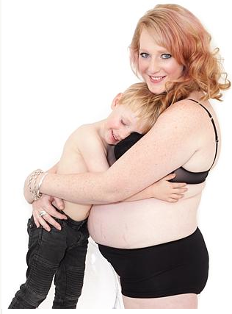
~Maddie Gore~
An Inspiration to women everywhere

Maddie Gore stands today as a very confident, headstrong single mother of two beautiful boys, Toby Lee 5 years old and Jaxx who is nine months old. She is an inspiration to women everywhere who encounter her life story.

Matthew Flinders was a great starting place for Maddie. She said “I feel that during my time there I began to develop a set of values that I still carry with me today.” Her life has not been without struggles, At the age of 13, she struggled with her mental health. She says, “When you experience first hand every situation that has a stigma attached, it teaches empathy and understanding. ‬‬I know I look at people and can see them as who they are, without judgment or criticism no matter what circumstance they may be in, I wouldn’t be able to do that if my life had been an easy one.”

The 365 Day Project is a project that Maddie created. It is an initiative to empower women to love themselves. It is about accepting yourself and learning to love who you are, it’s about making it okay to not be okay and creating a healthier community; not in your body but your mind. ‬Maddie’s goal was to find 365 brave women that would strip down into their underwear and be photographed with every lump and bump on show. She created a flipbook, calendar with 365 photos of local women in their underwear, celebrating their bodies post baby. For every calendar that is sold the proceeds are donated to peri-natal health. “This project is completely, totally putting it out there to break the stigmas in Geelong, and hopefully further than Geelong. We are learning to love ourselves instead of hating these beautiful bodies we have.”

Although Maddie has had many struggles throughout her life it hasn’t stopped her from becoming the person she is today. As a result of these struggles, Maddie believes that she can improve peoples’ lives; she wants to empower people to think differently about themselves and to love who they are.

By Rachael Lawn

