**INCLUSION AND DIVERSITY POLICY** 

**(includes Equal Opportunity and Sexual Harassment)**

**Help for non-English speakers**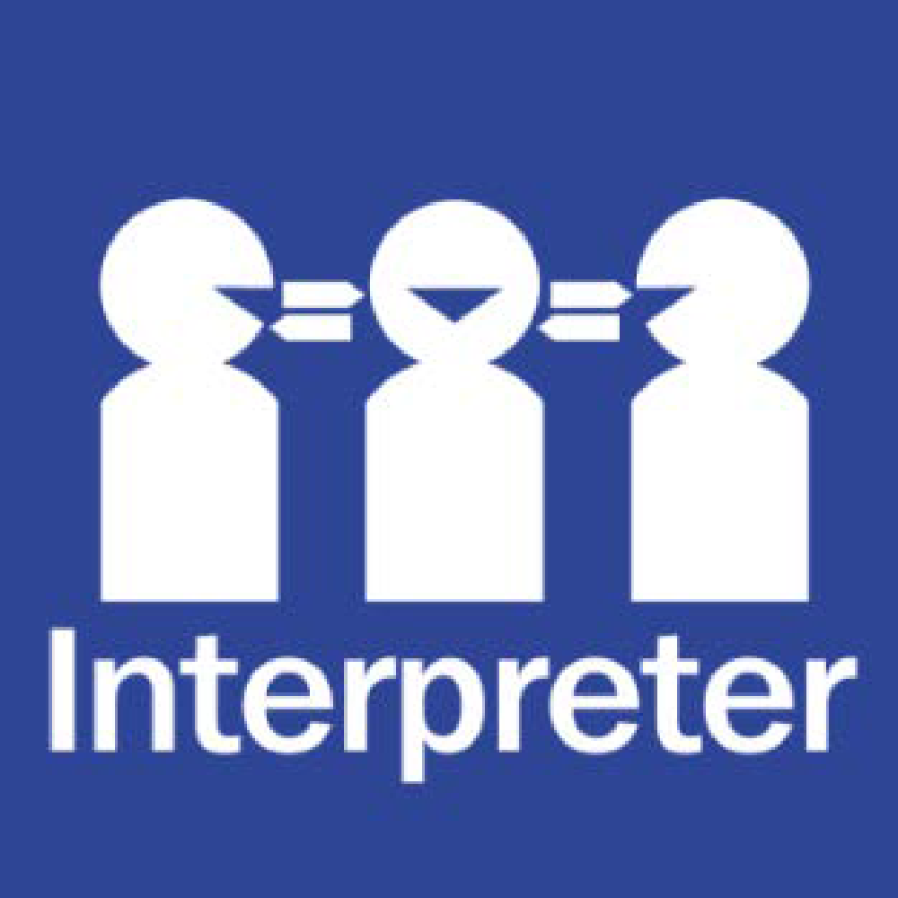

If you need help to understand the information in this policy please contact Deborah Crane)

**PURPOSE**

The purpose of this policy is to explain Pascoe Vale North’s commitment to making sure every member of our school community, regardless of their background or personal attributes, is treated with respect and dignity. This policy should be read alongside the following Department of Education and Training policies:

* Equal Opportunity and Human Rights
* For staff, the [Respectful Workplaces](https://www2.education.vic.gov.au/pal/respectful-workplaces/overview) policies (including [Equal Opportunity and Anti-Discrimination](https://www2.education.vic.gov.au/pal/equal-opportunity/overview), [Sexual Harassment](https://www2.education.vic.gov.au/pal/sexual-harassment/overview) and [Workplace Bullying](https://www2.education.vic.gov.au/pal/workplace-bullying/policy)) as these whole of Department policies apply to all staff at Pascoe Vale North Primary.

**POLICY**

### **Definitions**

*Personal attribute*: a personal characteristic that is protected by State or Commonwealth anti-discrimination legislation. These include: race, disability, sex, sexual orientation, gender identity, religious belief or activity, political belief or activity, age, intersex status, physical features, pregnancy, carer and parental status, breastfeeding, marital or relationship status, lawful sexual activity, employment activity, industrial activity, expunged homosexual conviction or personal association with anyone who is identified with reference to any protected attribute.

*Direct discrimination:* unfavourable treatment because of a person’s protected attribute.

*Indirect discrimination*: imposing an unreasonable requirement, condition or practice that disadvantages a person or group of people with a protected attribute.

*Sexual harassment:* unwelcome conduct of a sexual nature towards another person which could reasonably be expected to make that other person feel offended, humiliated or intimidated. It may be physical, verbal, visual or written.

*Disability harassment*: an action taken in relation to the person’s disability that is reasonably likely, in all the circumstances, to humiliate, offend, intimidate or distress the person.

*Vilification*: conduct that incites hatred towards or revulsion or severe ridicule of a person or group of people on the basis of their race or religion.

*Victimisation*: subjecting a person or threatening to subject them to detrimental treatment because they (or their associate) has made an allegation of discrimination or harassment on the basis of a protected attribute (or asserted their rights under relevant policies or law).

### **Inclusion and diversity**

Pascoe Vale North Primary strives to provide a safe, inclusive and supportive school environment which values the human rights of all students, families, staff and community partners.

Pascoe Vale North Primary is committed to creating a school community where all members are welcomed, accepted and treated equitably. Our school community will respect all individuals, regardless of their backgrounds or personal attributes so that they can participate, achieve and thrive.

Pascoe Vale North Primary acknowledges and celebrates the diversity of backgrounds and experiences in our school community. We will not tolerate behaviours, attitudes or actions of any kind that serve to unfairly label, stereotype,demean or discriminate others. At Pascoe Vale North Primary, we value the human rights of every student and we take our obligations under anti-discrimination laws and the Charter of Human Rights and Responsibilities seriously.

***Pascoe Vale North Primary will:***

* actively nurture and promote a culture where everyone is treated with respect and dignity
* ensure that students are not discriminated against (directly or indirectly) and where necessary, are reasonably accommodated to participate in their education and school activities (eg schools sports, concerts, information sessions ) on the same basis as their peers
* acknowledge and respond to the diverse needs, identities and strengths of all students
* encourage empathy and fairness towards others
* educate students in the development of respectful relationship practises
* challenge stereotypes that promote prejudicial and biased behaviours and practices
* contribute to positive learning, engagement and wellbeing outcomes for students
* respond to complaints and allegations appropriately and ensure that students are not victimised

Pascoe Vale North Primary School implements the ‘Respectful Relationships’ program’ across the school for all students. We embed mindfulness education into our everyday teaching, in conjunction with the ‘Smiling Minds’ program. Our approach to managing and supporting positive behaviours within our school community has a strong emphasis on developing and maintaining positive relationships between all students and staff.

Bullying, unlawful discrimination, harassment, vilification and other forms of inappropriate behaviour targeting individuals or groups because of their personal attributes will not be tolerated at Pascoe Vale North Primary. We will take appropriate measures, consistent with our **Student Wellbeing and Engagement and Bullying** policies to respond to students who demonstrate these behaviours at our school.

Students who may have experienced or witnessed this type of behaviour are encouraged to speak up and to let their teachers, parents or carers know about those behaviours to ensure that inappropriate behaviour can be addressed.

At Pascoe Vale North Primary, we ensure that the students who have been subjected to discrimination, villification, harassment or victimisation are given the appropriate care and support needed to help maintain or restore their wellbeing and rights.

At Pascoe Vale North Primary, students who have made mistakes or errors in judgement with their behaviours towards others are coached with a restorative practice focus. We endeavour to maintain our positive relationship with these students whilst coaching them to address the needs and rights of the students who have been affected by their actions. We aim to educate students about emotional regulation, positive communication and other practices that will help to ensure positive relationships are maintained with others in the future. . Families are notified if a student is the perpetrator or victim of consistent negative behaviours or if a particular action is significant in its negative impact of the parties involved. At Pascoe Vale North Primary School, we endevour to involve our families and work alongside them in supporting their child’s developement of positive behaviours and relationships. Behaviour Support Plans may be implemented to help monitor and support students in the development of their positive behaviour towards all members of our school community.

**Reasonable adjustments for students with disabilities**

Pascoe Vale North Primary also understands that it has a legal obligation to make reasonable adjustments to accommodate students with disabilities. A reasonable adjustment is a measure or action taken to assist students with disabilities to participate in their education on the same basis as their peers. Reasonable adjustments will be made for students with disabilities in consultation with the student, their parents or carers, their teachers and if appropriate, their treating practitioners. Our school may consult through Student Support Group processes and in other less formal ways. For more information about support available for students with disabilities, and communicating with us in relation to a student’s disability, please refer to our school’s **Student Engagement and Wellbeing Leader** for further information.

**COMMUNICATION**

This policy will be communicated to our school community in the following ways:

* Available publicly on our school’s website
* Included in staff induction processes and staff training
* Discussed at annual staff briefings/meetings
* Attached to school COMPASS portal in the documentation section

**RELATED POLICIES AND RESOURCES**

Please refer to all other policies on the school website or in the COMPASS portal or contact the school for further information.

For staff, please see the Department’s [Equal Opportunity and Anti-Discrimination Policy](https://www2.education.vic.gov.au/pal/equal-opportunity/policy-and-guidelines), [Sexual Harassment Policy](https://www2.education.vic.gov.au/pal/sexual-harassment/policy-and-guidelines) and [Workplace Bullying Policy](https://www2.education.vic.gov.au/pal/workplace-bullying/policy) which apply to all staff working at our school.

Other relevant Department policies and resources on the Department’s Policy and Advisory Library are:

* + [Equal Opportunity and Human Rights - Students](https://www2.education.vic.gov.au/pal/equal-opportunity-human-rights-students/policy)
  + [Students with Disability](https://www2.education.vic.gov.au/pal/students-disability/policy)
  + [Koorie Education](https://www2.education.vic.gov.au/pal/koorie-education/policy)
  + [Teaching Aboriginal and Torres Strait Islander Culture](http://www.education.vic.gov.au/school/teachers/teachingresources/multicultural/Pages/koorieculture.aspx)
  + [Safe Schools](http://www.education.vic.gov.au/about/programs/health/Pages/safe-schools-coalition.aspx?Redirect=1#link8)
  + [Supports and Services](http://www.education.vic.gov.au/school/parents/needs/Pages/supportservices.aspx)
  + [Program for Students with Disabilities](http://www.education.vic.gov.au/school/teachers/learningneeds/Pages/psdhandbook.aspx)

**POLICY REVIEW AND APPROVAL**

|  |  |
| --- | --- |
| Policy last reviewed | August 2022 |
| Consultation | School Leadership Team - July  School Council - July |
| Approved by | Principal : Deborah Crane |
| Next scheduled review date | August 2026 |