

Parent/Carer Newsletter
4

Child Safe Standard 4
Working together for Child Safety

‘’Families and communities are informed and involved in promoting child safety and wellbeing.’’

As Catholic educators, we have a moral, mission-driven and legal responsibility to uphold and actively promote the wellbeing and safety of every student entrusted in our care. Our commitment to the protection of students ensures they have agency and voice about all matters that impact their safety. Our Catholic communities ensure systems, processes, policies and cultures encourage and respect the voices of children and young people.
This newsletter series provides an overview of what the Child Safe Standards are, how they are designed to help keep children and young people safe and what schools governed by Melbourne Archdiocese Catholic Schools (MACS) are doing to prioritise and achieve this.

Overview of Child Safe Standard 4:

The Child Safe Standards
The Child Safe Standards are a set of guidelines that help organisations create safe environments for children and young people.

They make sure that children are protected from harm, listened to, and respected. These standards require organisations to have strong leadership, clear policies, and a culture that puts children first.

As a parent or carer, you can expect organisations to involve families, empower children, train staff properly, and respond to concerns quickly and respectfully.
To be aligned, schools must support the following:
- Families participate in decisions affecting their child
- The organisation engages and openly communicates with families and the community about its child safe approach and relevant information is accessible.
- Families and communities have a say in the development and review of the organisation’s policies
- Families, carers and the community are informed about the organistion’s operations and governance.

“The role of the family in building a culture of life is decisive and irreplaceable” This quote comes in the greater context of Pope John Paul’s message about the family being at the heart of the “civilization of love”.

Working together for Child Safety

Parent/Carer Newsetter 4 2 of 2

What does this look like in a school environment?

- Keeping families informed: We provide parents, carers and the community with regular updates about child safety and wellbeing so everyone knows what is being done to keep children safe and so parents and carers can continue the conversation at home.
- Inviting parent, carer and community involvement: We create varied opportunities for families, carers and community members to participate in surveys, forums or school events that focus on child safety and wellbeing, and seek their feedback
- Working together: We build trust and open communication with families, carers and the wider community. We ensure families, carers and members of the community have access to a variety communication channels.
- Welcoming different perspectives: We are always open and welcoming of ideas that help keep children safe. We create varied ways for people to provide us with their feedback and share their ideas. We also actively seek to go beyond the school gate to meet families and the wider community at different places of learning, so we are all walking together.

How Parents, Carers and Guardians can get involved!
Want to know more?
If you have any questions or would like to learn more about how we’re supporting child safety, please get in touch.

More information on the Child Safe Standards can be found via the Commission for Children and Young People (CCYP) website.

Check out these additional resources from below to learn more:

The Australian Institute of Family Studies (AFIS): Parents' Involvement in their Children's Education Community Engagement

The Australian Institute for Teaching and School Leadership (AITSL):
Strengthening Parent Engagement to Improve Student Outcomes

Child Safe Standard 4 is about making sure schools, families, carers and the wider community work together to keep children safe. Here are some simple ways families can help:

- Stay informed: Read school updates about safety and wellbeing
- Keep talking: Have regular, open conversations with your child about what safety feels like for them and how they feel when they are at school or other places away from home. Ensure they know they have trusted adults they can speak to if they are concerned. Make sure they know who these adults are.
- Get involved: Attend school events, take part in surveys or forums that seek your feedback. Let your children see that you prioritise this connection with the school.
- Share your perspective: Contact the school with any ideas or thoughts you have that will help everyone to keep children safe. You may be able to offer a unique perspective or idea that the school has not considered.
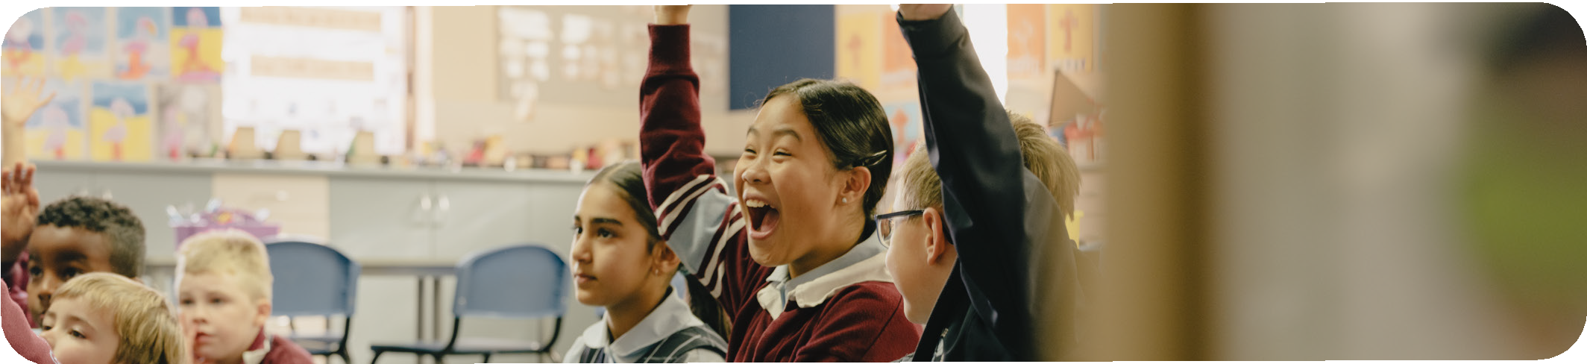

Working together for Child Safety

