
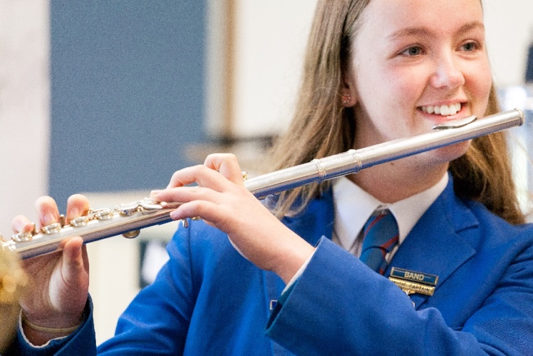

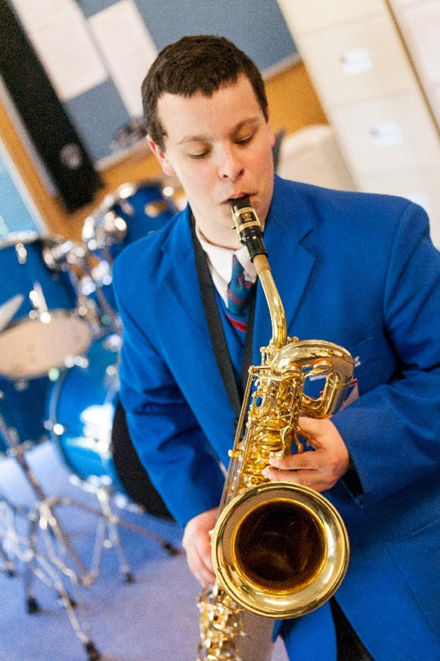
9 Facts on the benefits of students learning music:

- Music education uniquely contributes to the emotional, physical, social and cognitive growth of all students.
- Musical training can enhance brain function.
- Music improves literacy and numeracy skills.
- Playing music improves concentration, memory, listening skills and ability to express feelings.
- Music develops better self-esteem.
- Music relieves stress and anxiety.
- Music nurtures a student’s creative side.
- Music helps students with special needs open up and communicate.
- Music gives a sense of belonging and a safe place at school.
Please complete an application form and return it to the office!
Are you interested in learning an
instrument?
- Trumpet
- Trombone
- Saxophone
- Clarinet
- Flute
- Voice (limited spaces)
- Guitar (limited spaces)
- Bass Guitar
- Piano
- Drums & Percussion
- Audio Mixing

Mary MacKillop
Catholic Regional College
Music Program


Mary MacKillop

Catholic Regional College
Instrumental Music Application Form
Student name: ______________________________________________
Homeroom: __________
Instrument Selection: (circle choice)
Trumpet Trombone Saxophone
Clarinet Flute Guitar
Drums/Percussion Bass Guitar Piano
Voice Audio Mixing
Lesson Scheme Years 7 to 12: (circle choice)
30 Minute Individual Lesson @ $30+/lesson

30 Minute Group Instrumental Lesson @ $18/lesson
(certain instruments only)

Student Agreement:
I, ______________________________________________, hereby agree to:
- Punctually attend my weekly scheduled lesson time with my, instrument, books & equipment
- Practice regularly, at least 20 minutes per day, over 5 days per week
- Attend all weekly ensemble rehearsals, either during school time, or after school, as required.
Student signature: __________________________________ Date: _____________

Parent/Guardian Agreement
I/We have read, understood and accept the terms & conditions as outlined in the Mary MacKillop College Music Tuition Guide. I/We acknowledge that additional Instrumental Tuition fees will be billed on top of Mary MacKillop College Fees and are to be paid promptly, or lessons will cease.

Parent/Guardian Signature: ___________________________ Date: _____________
PLEASE HAND THIS COMPLETED FORM TO STUDENT RECEPTION

