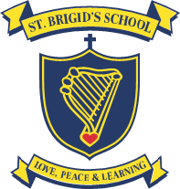


Vinnies School Uniform Price List –St Brigid’s School Kilburn

2021

Description | Retail Price (inc GST)
Daywear - Summer
Valetta dress with dark navy corded piping with school emblem | $73.50 & $78.00*
Sportswear - Summer
Sports short sleeve polo with school emblem | $52.50
Sports long sleeve polo with school emblem | $52.50
Sports shorts with school name | $38.00
Sportswear - Winter
Navy Zip Track Jacket with school emblem | $63.00 & $68.00*
Nylon cotton fleece straight leg track pants with school name | $44.00
Other
Navy microfiber bucket hat with school emblem | $15.00

* Where two prices are listed for an item, the lower price applies to smaller sizes and the higher price applies to larger sizes (eg. Larger sizes = Dress sizes 10 - 16, Track top –12A)

Ordering Process:
- Visit our web page: www.vinnies.org.au/StBrigids
- Place your contact details and order on the web form and press submit.
- A representative from Vinnies will contact you between 12 - 3pm Monday – Friday to confirm order and receive payment.
- Orders will be delivered to St Brigid’s School every Monday’s.

