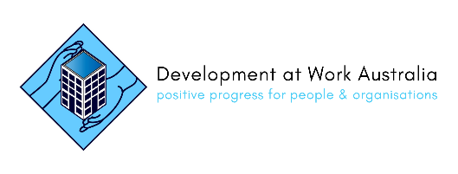

**Book your FREE help now – we’ve started! Book is using the QR Code below or**

**this Humanitix link:** [https://events.humanitix.com/free-support](https://events.humanitix.com/free-support?_ga=2.237271936.1034926292.1683351425-692596579.1675383437)

**Bridget will contact you and organise a time for your FREE sessions in May or June.**

**Or email:** [**support@developmentatwork.com**](mailto:support@developmentatwork.com) **Or text: 0403 941222**



**Supported by a grant from the Wyatt Foundation**

Lets try everything!



**Starts May 2023**

**Friendly personal help via**

**Small group coaching (2-3 people)**

**Workshops (10 - 15 people)**

**at neighbourhood centres/libraries near you**

**& 3 zoom workshops**

**Tell us what you need help with, including:**

* **Using a PC, notepad or smartphone**
* **Being safe online**
* **Email, LinkedIn or Facebook**
* **Finding information / free help online**
* **Writing a resume / applying for jobs**
* **Online research / online shopping**

**Or just join in and learn something new!**

**Ever thought**

**“Someone should make this easier”**

**Want FREE help to do things online?**

**FREE digital literacy coaching, for those on no or low income, to help you do what you need to online, with way less stress.**



**Please invite your friends & neighbours on a low income too across Adelaide and Mount Barker**