WEST BEACH PRIMARY OSHC VACATION CARE

Monday 28th September | Tuesday 29th September | Wednesday 30th September | Thursday 1st October | Friday 2nd October
INCURSION –  Today Old MacDonald’s travelling Farm will be visiting us.  We have baby animals such as guinea pigs, chickens, ducks, goats, lambs and a piglet. You can cuddle, feed and brush the animals and our farmer can answer any of your questions.  Please bring recess, lunch and a water bottle | INCURSION –  Come learn and develop your soccer skills with an experienced soccer coach.  &  Our netball clinic will cover all aspects of the game, including attacking, defending, shooting and match practice. Learn and develop new skills in a fun and inclusive environment.  Please bring recess, lunch and a water bottle | Cultural Day  You are invited to be part of a cultural experience where you will learn and explore different cultures from around the world.  Cooking: As a group, we will cook vegetarian fried rice together and enjoy for our lunch.  Please bring recess and a water bottle | 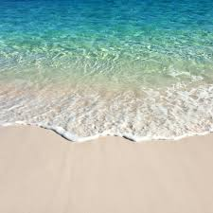  Beach Day  EXCURSION -  Let’s have fun in the sand and the sun! Children will learn the importance of beach safety and spend time playing games on the sand and swimming/splashing in the water.  Will you find X that marks the spot in our treasure hunt?  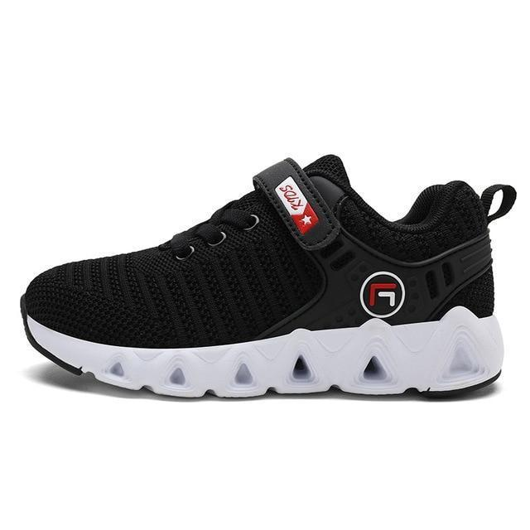  Wear enclosed shoes. Bring bathers/rashie and a towel.  Please bring recess,  lunch and a water bottle | 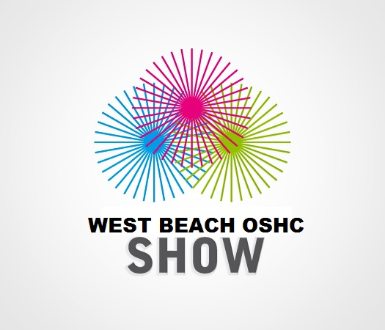As the Royal Adelaide show has been cancelled, we have decided to host our very own WEST BEACH OSHC SHOW.  INCURSION –  Make your own fairy floss, bounce on the jumping castle, get your face painted and play one of our carnival games.  Please bring recess,  lunch and a water bottle
Learning Outcomes – | Learning Outcomes – | Learning Outcomes – | Learning Outcomes – | Learning Outcomes -
Monday 5th October | Tuesday 6th October | Wednesday 7th October | Thursday 8th October | Friday 9th October
PUBLIC HOLIDAY  SERVICE IS CLOSED | CARDBOARD BOX  Today we will have a large number of cardboard boxes at our disposal.  In our main activity, the children will be asked ‘what can you make with a cardboard box?’ In this imaginative play experience, children can use boxes and craft equipment to make houses, spaceships, boats or anything that they imagine.  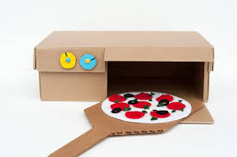  Please bring recess, lunch and a water bottle | Let’s go play under the sea and while we are there we will :  Make Origami boats, get crafty with  Sea shell Art & enjoy some  Water Play  In the arvo we will watch finding Nemo and Dory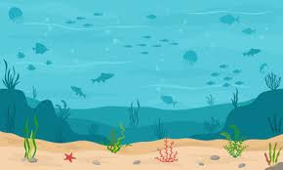  Please bring recess, lunch and a water bottle | Today we will be having lots of fun on Go Karts!!! Take turns as we race around the school yard!  How long will it take you to do a lap of our course……..?  & Craft: Design your own ceramic plate  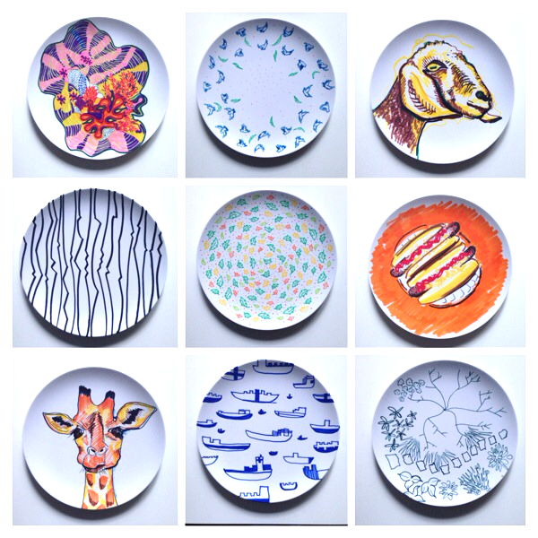  Please bring recess, lunch and a water bottle | MOVIES AT OSHC  MOVIE TBA  Come to the OSHC cinema where we will have a movie played on our school projector. Popcorn and a fruit box will be provided.  You will also be able to learn how to make your own movie on the OSHC IPads.  Please bring recess, lunch and a water bottle
Learning Outcomes – | Learning Outcomes – | Learning Outcomes – | Learning Outcomes – | Learning Outcomes –

