
Fluffy Pancakes

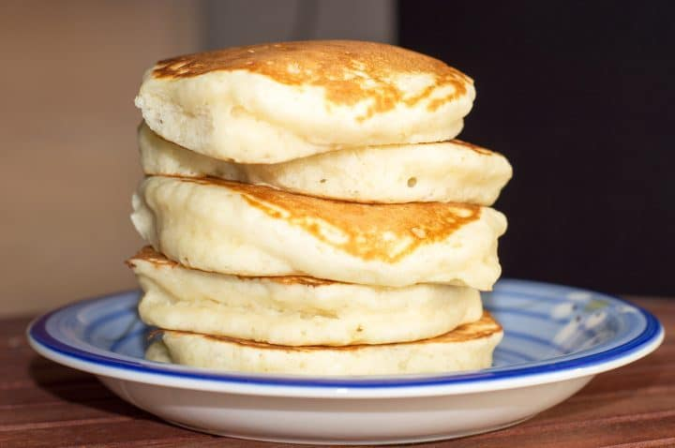

Fresh from the garden: Lemons and eggs (from our chickens)

 | Ingredients:  - 300ml milk  - 2 eggs (beaten)  - 200 grams self-raising flour  - 1 teaspoon baking powder  - 40 grams sugar  - Butter  - Lemons (sliced into wedges)
  Equipment:
  - Measuring jug
  - Measuring spoon
  - Scales
  - Bowls
  - Wooden spoon
  - Spatula
  - Metal spoon
  - Frying pan

What to do:

- Measure out the ingredients and put in a bowl.

- Whisk until the mixture is smooth without and lumps.

- Heat a small spoonful of butter in a pan.

- Spread a small amount of batter into the pan and wait for bubbles to appear on the surface.

- Flip over to the other side.

- The pancakes are ready when both sides are golden brown.

- Serve with lemon wedges.
\

