
Bird Profile No. 2
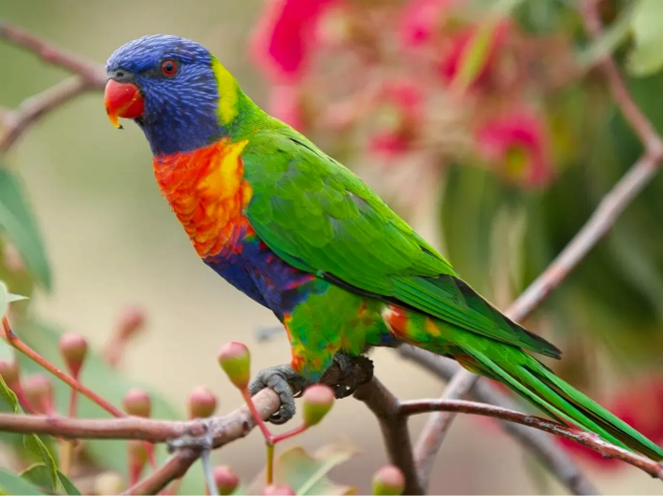
© State of New South Wales (Department of Education), 2023
https://fieldofmar-e.schools.nsw.gov.au/fact-sheets/birds/rainbow-lorikeet-fact-sheet
Common Name | Rainbow Lorikeet
Scientific name | Trichoglossus moluccanus
Description: What I look like. | 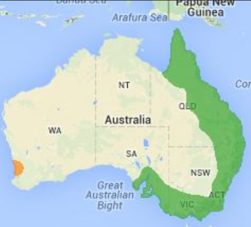
Distribution: Where I occur
Habitat: Where I live. | Forests, woodlands and gardens,
Diet: What I eat. | Nectar, some insects from foliage or caught in mid-air, berries and honeydew
Breeding: | July to December  Nests - small bowl shaped made of twigs and grass, usually 3 to 10 metres above the ground with two to 3 small oval-shaped eggs
Call: What I sound like. | Many different calls including coughs, a harsh ‘yac a yac’ and a loud ‘chok’ https://birdlife.org.au/bird-profiles/red-wattlebird/#

