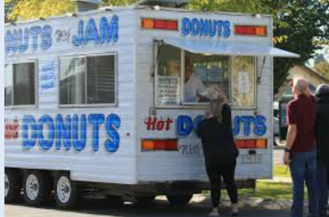**The Market**

As I shuffled through the wave of excited and jostling people, I could smell the lingering aroma of freshly squeezed orange juice fill my nose.

When the wave started to clear the Devil’s Hot Jam Donut Van came into view. My mouth started to water. I instantly dashed over to the van and buy two donuts (because that was the minimum amount you could buy). I bite into the sugar covered donut indulging in the hot jam and the warm dough. After happily devouring the hot jam donut I strode away from the market.

That day was pretty good.

