**What’s happening in Careers?**

Year 10

The Year 10 students have completed their profiling and should continue to explore the different industries that were recommended.

Year 11

The Year 11 group were very fortunate to have a presentation careers in the aviation industry from Steve Ricci, (MOB 2014). Steve is a helicopter pilot who works for United Aero helicopters. They contract to a number of industries, so his work is constantly changing. He has worked mustering, counting animals in Canada, doing seismic work in Alaska and firefighting in Canada. He has a broad view of the aviation industry and all of the opportunities that exist in this space and the boys got a really fantastic perspective of how to enter the industry.

Year 12

The Year 12 group should be continuing to explore courses and opportunities in their field of interest. I hope that many of them made it to the UWA Open Day on March 12 and that I will see them exploring the Curtin campus at their Open Day this Sunday, 26 March.

Careers Department

Students and families in Year 10, 11 and 12 will have access to these online resources which will be used with students in their MyPath sessions. There is a huge wealth of information on this site, where students can explore industries in depth to find out more about the Careers and industries they are interested in. It also has a resume builder, digital portfolio, virtual work experience, scholarship finder, job finder and micro credentialling opportunities. So much to explore!

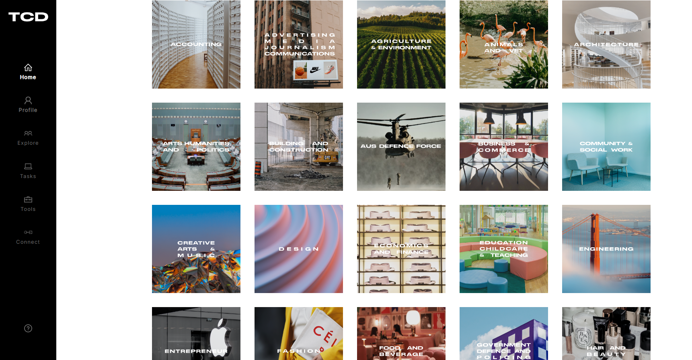

Careers, VET and WPL News Portal

Parents and students can access this portal via SEQTA. It is updated regularly with news and opportunities and is a great resource.

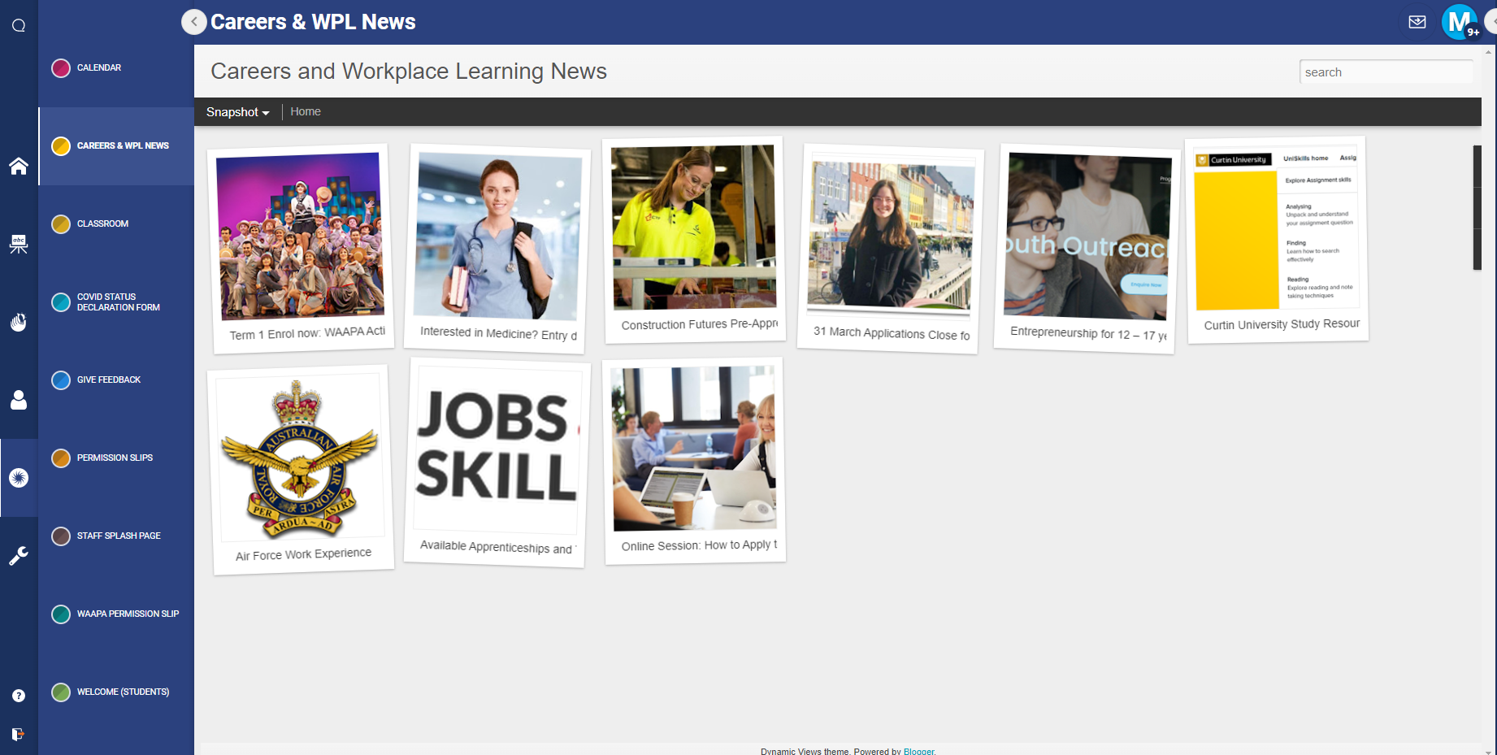

### University Open Days 2023

In 2022 most of the universities had more than one open day. They called them different things, like, the Curtin Undergraduate Expo, but they all delivered opportunities to explore the campus, check out courses, talk to lecturers and meet current students.

|  |  |
| --- | --- |
| **26 March** | [Curtin Open Day](https://www.curtin.edu.au/events/curtin-open-day/) |
| **2 April** | [Notre Dame](https://events.nd.edu.au/openday2023/begin) |
| **29 April** | [Murdoch University](https://www.murdoch.edu.au/events) |
| **2 April**  **Joondalup**  **30 April**  **Mt Lawley** | [ECU Open Day](https://www.ecu.edu.au/open-day/overview) |

**26 March Curtin Open Day**

There is so much on at the Curtin Open Day that their new day planner is practical and helpful.

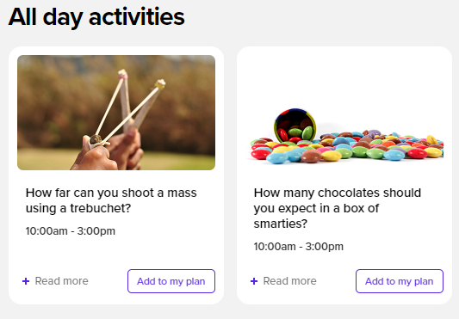**Middle School Highlights**

* Find your perfect job at the career wheel.
* Do the Year 9 and 10 student and parent info session

**Senior School Highlights**

* If you are in Year 12, go to the Financial Planning Booth
* Check your Global study passport competition.
* Book into Year 11 and 12 Student and Parent info sessions.
* Book into presentations and join some of the hands-on activities.

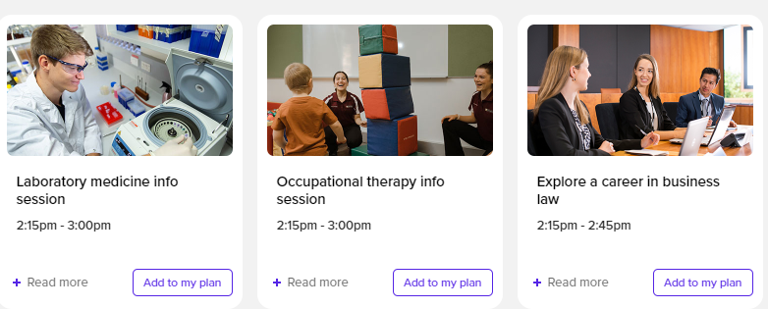

### Text Description automatically generated with low confidence2 April Notre Dame Open Day

Notre Dame does a lot of work up front. They ask you to identify what information you are looking for and I guess they will customise your Open Day experience for you.

You can register [HERE.](https://events.nd.edu.au/openday2023/begin)

### 29 April Murdoch University Open Day

Murdoch has created [a program](https://www.flipsnack.com/murdochwa/open-day-2022-program/full-view.html) that shows the events. Many of the presentations are repeated and you can plan out your day and take it with you to the Open Day. [Text, website
](https://www.flipsnack.com/murdochwa/open-day-2022-program/full-view.html)

**Curtin Focus on Mining Camps**

The Focus on Mining program consists of residential camps that provide an opportunity for students to explore career and study pathways in WA’s resources sector. During the camps, students tour mine sites and meet role models in industry.6

The Focus on Mining Camps are five-day residential camps for high school students to experience what it’s like to study and work in the mining industry in WA. Students will get to tour mine sites, participate in hands-on workshops and meet industry leaders.  The program targets students in Year 11 or 12 who have an interest in science or engineering, and would like an introduction to the mining and resources sector.

Students from throughout WA are welcome to apply and support is available for regional students to take part.

The camp is free with all travel, meals and accommodation provided thanks to the support of Northern Star Resources and the WA School of Mines.

Focus on Mining 2023 is:

Dates: 3 – 7 July  
Time: 5-day residential camp  
Location: Perth – Kalgoorlie – Perth  
Cost: Free

* [Apply here](https://curtin.au1.qualtrics.com/jfe/form/SV_73BI3l1w5cVFCUm)

### 4 May 2023 Notre Dame Doctor of Medicine Online Information Session 5pm

### 

Learn more about pursuing a Doctor of Medicine at the No.1 University in Australia for Overall Employment of Graduates.*

You’ll hear from School of Medicine academics, including National Head of School Professor Gervase Chaney, along with staff from both the Admissions and the Prospective Students Offices.

We’ll provide you with important information around how to apply, course structure and professional experience, and also give you an opportunity to ask questions during the Q&A.

Register [HERE](https://events.nd.edu.au/doctor-of-medicine).

*\*2021 Graduate Outcomes Survey-Longitudinal (medium term outcome)-qilt.edu.au*

### 9 May Curtin Medicine Information Session

Join us online for our Medicine Information Session and see why Curtin’s unique Bachelor of Medicine, Bachelor of Surgery (MBBS) is for you. You’ll hear from Curtin Medical School experts who’ll share their top tips on submitting a competitive application. You’ll also have a chance to ask our panel your questions.

### Notre Dame Assured Pathway to Podiatric Medicine

This undergraduate pathway is for academic high achievers who have not already stared any post school studies.

SHORTER PATHWAY

Assured Pathway students who undertake the Podiatric Health & Medical Sciences will commence the Doctor of Podiatric Medicine in the second year, reducing the overall study period by one year.

Find more information [HERE.](https://www.uwa.edu.au/study/how-to-apply/health-and-medical-sciences-applications/assured-pathway-dpm-domestic)

**Students may also be interested in the** [**Bachelor of Biomedical Science**](https://www.notredame.edu.au/programs/fremantle/school-of-health-sciences/undergraduate/bachelor-of-biomedical-science) **pathway at Curtin.**

|  |
| --- |
|  |
| |  | | --- | | **Curtin Future Students - UBL home game** | |

|  |  |
| --- | --- |
| |  | | --- | | Curtin University Sport and Recreation team along with the Future Students team would like to invite you and your school to attend our University Basketball League, Future Students Game on **Wednesday 5 April 2023**, **10.00am - 2.30pm**.  This event is for year 11 and 12 students and high performing athletes (including those in younger year levels). It will not only provide them with the opportunity to watch the Curtin University Carnaby's basketball team in action, but is also an opportunity to talk with Curtin students and staff about the uni, including how to enrol, what courses are offered, what sports they can play, how they can live on campus, and how they can mix sport with study.  With games starting at 12.00pm and 2.00pm, you can pick a time that suits you.  Tickets will go fast, so to be sure you don't miss out, complete your [expression of interest](https://register.curtin.edu.au/page.redir?target=https%3a%2f%2fcurtinforms.wufoo.com%2fforms%2ffuture-students-ubl-game-eoi%2f&srcid=201433&srctid=1&erid=27196358&trid=20f8539b-40fb-40c5-82ed-1026fd73e4db) now. | |
| |  | | --- | | **Year 12 Application Support Info Evening** | |

|  |  |
| --- | --- |
| |  | | --- | | Applying to uni can be tricky to navigate, so to support your year 12 students and parents when TISC applications open on **Monday 1 May 2023**, we are hosting the [Year 12 Application Support Info Evening](https://register.curtin.edu.au/page.redir?target=https%3a%2f%2fwww.curtin.edu.au%2fevents%2fapplication-support-evening%2f&srcid=201433&srctid=1&erid=27196358&trid=20f8539b-40fb-40c5-82ed-1026fd73e4db) that same night from **5.30pm - 6.30pm**.  Students, parents and educators can join the event online for information covering:   * assistance with how to apply * early offers * pathways   To complement this event, we will provide resources to assist your students through the application process as well.  Please encourage all of your year 12s to register for the event using the link above, and don't hesitate to reach out to the team before then with your questions. | |

|  |  |  |  |  |  |  |
| --- | --- | --- | --- | --- | --- | --- |
| |  |  |  |  |  |  | | --- | --- | --- | --- | --- | --- | | |  |  |  |  |  | | --- | --- | --- | --- | --- | | |  |  | | --- | --- | | |  | | --- | |  | | | |  | | --- | | [UWA Parents Space](https://app.seek.uwa.edu.au/e/er?utm_campaign=Dom%20%7C%202023-02-02%20%7C%20UWA%20Updates%20February%20%7C%20Career%20Advisers%20%7C%20C&utm_medium=email&utm_source=Eloqua&s=1802092&lid=1053&elqTrackId=A79705E08FE47A4883943D47013DDF0D&elq=824726a625e54ba1a2a71cf28ef1ec3c&elqaid=1077&elqat=1) Help your teenager figure out what to study or navigate their transition from secondary school to uni! Find advice, tips and all the info you wish you knew when you were a teenager, shared by other parents and guardians like you. | | | |

|  |  |
| --- | --- |
| |  | | --- | |  |  27 March UWA Postgraduate entry to Medicine Webinar School students can be awarded an [assured pathway into medicine at UWA](https://www.uwa.edu.au/study/how-to-apply/health-and-medical-sciences-applications/assured-pathway-md-and-dmd-domestic). This pathway is for high achieving domestic school leavers who do well in their undergraduate degree.  Students can also apply directly for a place in the program once they have a degree from UWA or another university. This webinar provides information on how to apply for a career in medicine. Register [HERE.](https://www.uwa.edu.au/study/how-to-apply/health-and-medical-sciences-applications/assured-pathway-md-and-dmd-domestic) 28 March UWA Bachelor’s degree in Data and Computer Science Webinar Join us for an upcoming webinar on UWA bachelor's degree in data and computer science where you'll learn about each program's structure, entry requirements, specialisations and potential career paths. This webinar will be presented by academic staff from UWA's School of Physics, Mathematics and Computing, the UWA Future Students team and current student panellists, and includes a Q&A session where you can ask any questions you may have about studying at UWA. Register [HERE](https://www.uwa.edu.au/study/Events/Bachelor-degrees-in-Data-and-Computer-Science-Webinar) 29 March UWA Bachelor’s degrees in Business and Commerce Webinar   Join us for an upcoming webinar on UWA bachelor's degrees in business and commerce where you'll learn about each program's structure, entry requirements, specialisations and potential career paths. This webinar will be presented by academic staff from UWA's Business School, the UWA Future Students team and current student panellists, and includes a Q&A session where you can ask any questions you may have about studying at UWA. Register [HERE.](https://www.uwa.edu.au/study/Events/Bachelor-degrees-in-Business-and-Commerce-Webinar) 30 March UWA Everything you need to know about Psychology Webinar Join us for an upcoming webinar on UWA undergraduate and postgraduate degrees in psychology where you'll learn about each program's structure, entry requirements, specialisations and potential career paths. This webinar will be presented by academic staff from UWA's School of Psychological Science, the UWA Future Students team and current student panellists, and includes a Q&A session where you can ask any questions you may have about studying at UWA.  Register [HERE](https://www.uwa.edu.au/study/Events/Everything-you-need-to-know-about-Psychology-Webinar). 31 March UWA Bachelor’s degree studies in Music, Art and Media Studies Webinar Join us for an upcoming webinar on UWA bachelor's degrees in music, art, and media studies where you'll learn about each program's structure, entry requirements, specialisations and potential career paths. This webinar will be presented by academic staff from UWA's School of Social Sciences, School of Design, Conservatorium of Music, the UWA Future Students team and current student panellists, and includes a Q&A session where you can ask any questions you may have about studying at UWA.  Register [HERE](https://www.uwa.edu.au/study/Events/Bachelor-degree-studies-in-Music-Art-and-Media-Studies). |

|  |  |  |  |
| --- | --- | --- | --- |
| |  |  |  | | --- | --- | --- | | |  |  | | --- | --- | | |  | | --- | |  | | |  Bachelor of Geographical and Spatial Science Challenge yourself with the [Bachelor of Geographical and Spatial Science](https://app.seek.uwa.edu.au/e/er?utm_campaign=Dom%20%7C%202023-03-05%20%7C%20UWA%20Updates%20March%20%7C%20Career%20Advisers%20%7C%20C&utm_medium=email&utm_source=Eloqua&s=1802092&lid=1310&elqTrackId=B31495F76A62438DC525D40A03092550&elq=3e42d10f72b44490931973aef064f4a5&elqaid=1104&elqat=1) where you'll develop fundamental spatial science skills, knowledge and techniques to solve the world's biggest environmental issues.  This course has a strong focus on understanding the environmental processes including climate and hydrology that interact with landscapes, people and drive economies, including broader geography principles, demography and regional development. |

|  |  |  |  |  |
| --- | --- | --- | --- | --- |
| |  |  |  |  | | --- | --- | --- | --- | | |  |  |  | | --- | --- | --- | | |  |  | | --- | --- | | |  | | --- | | [Register now](https://app.seek.uwa.edu.au/e/er?utm_campaign=Dom%20%7C%202023-02-02%20%7C%20UWA%20Updates%20February%20%7C%20Career%20Advisers%20%7C%20C&utm_medium=email&utm_source=Eloqua&s=1802092&lid=1274&elqTrackId=D1FCB77F8E8A34B98C2CF3761B0D76E5&elq=824726a625e54ba1a2a71cf28ef1ec3c&elqaid=1077&elqat=1) | | | | |
| |  |  |  | | --- | --- | --- | | |  |  | | --- | --- | | |  | | --- | | UWA Future Students Athlete Program – On-Campus Tour and Webinar The UWA Future Student Athlete Program is here to support emerging and developmental players in year 10, 11 and 12 who are considering university study. Future student athletes can sign up [online here](https://app.seek.uwa.edu.au/e/er?utm_campaign=Dom%20%7C%202023-03-05%20%7C%20UWA%20Updates%20March%20%7C%20Career%20Advisers%20%7C%20C&utm_medium=email&utm_source=Eloqua&s=1802092&lid=1315&elqTrackId=DE9C48F98EE0CF8CCEB1707F9A3B1C26&elq=3e42d10f72b44490931973aef064f4a5&elqaid=1104&elqat=1). Through signing up members will gain exclusive access to our On-campus Tour and Webinar which will be held in April (parents and students welcome). Providing a unique insight into life as a student athlete and support mechanisms available to assist student athlete’s pursuit of achieving their dual career aspirations.  If you have any further questions regarding this program please contact [performance@sport.uwa.edu.au](mailto:performance@sport.uwa.edu.au) | | | |

### 1 May Early Offers for 2024

Year 12s will be able to apply for a place at a university in WA for 2024 from Monday 1 May. You will NOT have an advantage over other applicants who do not apply early.

|  |  |  |  |
| --- | --- | --- | --- |
| **University Early Offers for 2024 Open 1 May** | | | |
| **University** | **Information** | **Key Contact** |
| **Curtin** | If your final ATAR score is 3 points above your predicted ATAR, you’ll receive a $3000 scholarship.  [Apply through TISC](https://www.tisc.edu.au/static/home.tisc) from 1 May and choose Curtin as your first preference.  [How to Apply to Curtin](https://www.curtin.edu.au/study/undergraduate/early-offers/#:~:text=Early%20offers%20for%202024%20will,from%20Monday%201%20May%202023.&text=Early%20offers%20are%20available%20for,can%20focus%20on%20your%20studies.) | [Book an appointment with a student counsellor](https://future.connect.curtin.edu.au/app/bookings?usa=support) |
| **UWA** | Apply directly to UWA or through TISC  [Ealy Offers Information](https://www.uwa.edu.au/study/how-to-apply/early-offers)  Early offers based on end of Year 11 and mid-Year 12 results or STAT results. | Phone  [131 UWA (131 892)](tel:08131892) 8.30am–5.00pm (AWST), Monday to Friday  Online consultation  [Book a virtual consultation](https://appointments.applications.uwa.edu.au/UWA.OASIS/Home/AppointmentMenu) |
| **Notre Dame** | You can start to fill out your Notre Dame application now by going [HERE.](https://apply.nd.edu.au/psc/CSPRD/OLA/SA/c/ND_OLA.ND_OLA_NUR_REG_FL.GBL?CAMPUS_URL=https://mycampus.nd.edu.au/psp/CSPRD/OLA/SA/s/WEBLIB_SCC_NUR.SCC_SS_GATEKEEPER.FieldFormula.IScript_SCC_GateKeeper?SCC_APPL_CONTXT_ID=SCC_NURCTXT_20200513195142)  [How to apply to Notre Dame](https://www.notredame.edu.au/study/how-to-apply) | Email: [*online.admissions@nd.edu.au*](mailto:online.admissions@nd.edu.au)  Phone 9433 0533  [For a personalised campus tour go here](https://www.notredame.edu.au/community/campus-tours) |
| **ECU** | Year 11 results are used to calculate a predicted ATAR.  If you're studying a Certificate IV or enabling course, or if your predicted ATAR doesn't quite meet the minimum entry requirements for your course, you'll still be eligible for an early offer. This offer will be conditional on you meeting all entry requirements for your course.  [Applications through TISC](https://www.tisc.edu.au/static/home.tisc)  Get current information [HERE](https://www.ecu.edu.au/degrees/undergraduate). | Phone: 6304 0000  Enquire [HERE.](https://www.ecu.edu.au/future-students/course-entry/domestic-student-enquiries) |
| **Murdoch** | [Year 12 Early offer Program for 2024 enrolments](https://www.murdoch.edu.au/study/how-to-apply/year-12-early-offer-program) | Phone: 1300 6873 624  [Ask a question here](https://www.murdoch.edu.au/contact-us/ask-a-question). |

## Free concert tickets

The Conservatorium of Music invites you to our [2023 Concert Series](https://app.seek.uwa.edu.au/e/er?utm_campaign=Dom%20%7C%202023-03-05%20%7C%20UWA%20Updates%20March%20%7C%20Career%20Advisers%20%7C%20C&utm_medium=email&utm_source=Eloqua&s=1802092&lid=1313&elqTrackId=FC5718ACCDC8ABB48053944F1B2B2887&elq=3e42d10f72b44490931973aef064f4a5&elqaid=1104&elqat=1). A packed program of over 200 stimulating performances and events showcasing the immense talent of our emerging artists and their mentors, along with celebrated alumni, and nationally and internationally recognised guest artists. We warmly welcome students to attend any of our in-house concerts for FREE!

To book tickets, just email: [concerts@uwa.edu.au](mailto:concerts@uwa.edu.au) or call 08 6488 7835.

|  |  |  |  |
| --- | --- | --- | --- |
| |  |  |  | | --- | --- | --- | | |  |  | | --- | --- | | |  | | --- | | ATAR Music Bootcamp Wednesday 19 April | 10:00am – 3:00pm   Get ATAR ready with hands-on workshops with some of Australia’s leading musicians.  Grab your instrument (or voice) and learn about: practice strategies, aural and rhythm, music analysis, improvisation, performance etiquette, dealing with performance anxiety, and so much more! Plus get some real-life study and practice tips from a student who aced their WACE music exam! | | | |

|  |  |  |  |  |
| --- | --- | --- | --- | --- |
| |  |  |  |  | | --- | --- | --- | --- | | |  |  |  | | --- | --- | --- | | |  |  | | --- | --- | | |  | | --- | | [Register now](https://app.seek.uwa.edu.au/e/er?utm_campaign=Dom%20%7C%202023-03-05%20%7C%20UWA%20Updates%20March%20%7C%20Career%20Advisers%20%7C%20C&utm_medium=email&utm_source=Eloqua&s=1802092&lid=1308&elqTrackId=B7178328056CE35E4B4A9E4461EBA27E&elq=3e42d10f72b44490931973aef064f4a5&elqaid=1104&elqat=1) | | | | |

### 7 May applications close: Air force Careers Day

This is a day of experiences. Students need to register so that all get a chance to experience the activities.

[An Aerial View: Air Force Careers Day (20 June 2023)](https://defencecareers.nga.net.au/cp/index.cfm?event=jobs.checkJobDetailsNewApplication&returnToEvent=jobs.listJobs&jobid=A01E9373-1A74-5F24-1CC4-D15F45EF4E30&CurATC=defenceworkexp&CurBID=EBDFCAA3%2DB025%2DF7B7%2D3BD4%2D6D3FA42B2291&JobListID=83AA67BB%2D5AB1%2D7A5E%2DA521%2D6D3E05DAE980&jobsListKey=6f366adf%2De349%2D441e%2D8d92%2Dff2a835bfb45&persistVariables=CurATC,CurBID,JobListID,jobsListKey,JobID&lid=89570470186) **Job Ref - WEP/01097/23**

* 20th June 2023
* RAAF Base Pearce Great Northern Highway, Bullsbrook WA 6084
* Air Force

[Information Pack Word Document](https://defencecareers.nga.net.au/publicfiles/defencecareers/jobs/A01E9373-1A74-5F24-1CC4-D15F45EF4E30/WEP0109723-07-Feb-2023.WEP%20-%20Information%20Pack%20-%20Work%20Experience%202020.docx)[Information Pack PDF Document](https://defencecareers.nga.net.au/publicfiles/defencecareers/jobs/A01E9373-1A74-5F24-1CC4-D15F45EF4E30/WEP0109723-07-Feb-2023.WEP%20-%20Information%20Pack%20-%20Work%20Experience%202020.pdf)

* [Start New Application](https://defencecareers.nga.net.au/cp/index.cfm?event=jobs.checkJobDetailsNewApplication&returnToEvent=jobs.listJobs&jobid=A01E9373-1A74-5F24-1CC4-D15F45EF4E30&audienceTypecode=defenceworkexp&CurATC=defenceworkexp&CurBID=EBDFCAA3%2DB025%2DF7B7%2D3BD4%2D6D3FA42B2291&JobListID=83AA67BB%2D5AB1%2D7A5E%2DA521%2D6D3E05DAE980&jobsListKey=6f366adf%2De349%2D441e%2D8d92%2Dff2a835bfb45&persistVariables=CurATC,CurBID,JobListID,jobsListKey,JobID&lid=89570470188)
* [Access Existing Application](https://defencecareers.nga.net.au/cp/index.cfm?event=jobs.existingApplicationAuthenticationSwitch&returnToEvent=jobs.listJobs&jobid=A01E9373-1A74-5F24-1CC4-D15F45EF4E30&applicationid=&AppProcessStepNumber=1&audienceTypecode=defenceworkexp&CurATC=defenceworkexp&CurBID=EBDFCAA3%2DB025%2DF7B7%2D3BD4%2D6D3FA42B2291&JobListID=83AA67BB%2D5AB1%2D7A5E%2DA521%2D6D3E05DAE980&jobsListKey=6f366adf%2De349%2D441e%2D8d92%2Dff2a835bfb45&persistVariables=CurATC,CurBID,JobListID,jobsListKey,JobID&lid=89570470190)
* [Preview Application Form](https://defencecareers.nga.net.au/cp/index.cfm?event=jobs.previewApplication&returnToEvent=jobs.listJobs&jobid=A01E9373-1A74-5F24-1CC4-D15F45EF4E30&audienceTypecode=defenceworkexp&CurATC=defenceworkexp&CurBID=EBDFCAA3%2DB025%2DF7B7%2D3BD4%2D6D3FA42B2291&JobListID=83AA67BB%2D5AB1%2D7A5E%2DA521%2D6D3E05DAE980&jobsListKey=6f366adf%2De349%2D441e%2D8d92%2Dff2a835bfb45&persistVariables=CurATC,CurBID,JobListID,jobsListKey,JobID&lid=89570470192)

### 31 March Applications Close for Rotary Youth Exchange 2024

Successful applicants for the Rotary Youth Exchange program spend 12 months in a foreign country with board and accommodation provided by host families.

Students must be between the ages of 15 and 18 on the 1 January on the year of their exchange.

Young people make lifelong friends, change their world views and have a brilliant time.

Contact [Rotary Youth Exchange](https://youthexchange.asn.au/) Western Australia for details on how to apply.

### What Job Opportunities are available?

You can check out the total number of people employed in a job in Australia by going to [Labour Market Insights](https://labourmarketinsights.gov.au/occupations/occupation-search/).

The page gives a breakdown of employment outlook, earnings and hours worked and job tasks.

It is well set out and easy to follow. Check it out [HERE.](https://labourmarketinsights.gov.au/occupations/occupations-a-to-z/)

### Notre Dame Undergraduate Diploma of Exercise & Sport Science

Eligible school leavers can undertake our new [Undergraduate Diploma of Exercise & Sport Science](https://cust64776.au.v6send.net/ch/64776/657y1/2221720/Ykv4jG.xJea0F.VKe4BzluhmFQhvtF3GTWig16Nv.html) as a pathway into some programs at Notre Dame University.

This specialist program will introduce students to methods used in exercise science to assess health status, provide basic exercise delivery, and understand the beneficial effect on human physiology. It also develops student’s study skills for further study or work.

### Early Offers to universities in WA

All West Australian universities will make early offers available from about April. They are all through TISC this year.

There is no advantage to applying early. If you apply early, then change your mind, you will have all the hassle of changing your application.

### Entry to Medicine for 2024 (UCAT)

If you are thinking of doing medicine when you finish school, there are three barriers that you must pass:

1. Great ATAR scores
2. Great results on the University Clinical Aptitude Test (UCAT)
3. Shortlisted candidates will undertake a round of interviews.

[In 2023 the UCAT is undertaken online starting from 3 July.](https://www.ucat.edu.au/about-ucat-anz/ucat-anz-test-cycle/)

### Getting into Medicine in WA

There is good reason to believe medical students are outstanding. This year there were one hundred successful applicants for medicine at Curtin from 2700 applicants.

If you want to apply for medicine:

* **Take chemistry:** Chemistry is a pre-requisite subject for medicine at most universities across Australia.
* **Rural and remote applicants:** TheMedicine Faculty at Curtin is keen to address the shortage of doctors in the bush in WA. Contact Associate Professor Keith McNaught

Rural Academic Lead, Curtin Medical School at [Keith.Mcnaught@curtin.edu.au](mailto:Keith.Mcnaught@curtin.edu.au)

Check [Do you want to study medicine in WA](https://infocus-careers.com.au/2022/01/09/medicine-courses-in-western-australia/) post.

### Register for UCAT Now Medicine Application for 2024

](https://www.ucat.edu.au/)

If you are applying for medicine at

* Curtin or
* for an assured pathway into medicine at UWA

you need to undertake the UCAT ANZ compulsory entry requirement.

The test is conducted between 3 July and 11 August 2023

* You can register and find preparation tests [HERE.](https://www.ucat.edu.au/)

You can apply now. Applications close on 17 May.

Late bookings close on 31 May.

* Find our about reduced test fees [HERE](https://www.ucat.edu.au/register/concession-scheme/)>
* There are banks of practice tests [HERE](https://www.ucat.edu.au/prepare/practice-tests/)

All candidates need to prepare by understanding [these test tools](https://www.ucat.edu.au/prepare/test-tools/).

|  |  |
| --- | --- |
| |  | | --- | | **Curtin Medicine admissions updates** | |

|  |  |
| --- | --- |
| |  | | --- | | There are some important updates to entry applications for our 5-year Bachelor of Medicine, Bachelor of Surgery course.  **Changes to the entry requirements for the 2024 intake**  Applicants will be required to undertake the [Casper test](https://register.curtin.edu.au/page.redir?target=https%3a%2f%2facuityinsights.app%2f&srcid=201433&srctid=1&erid=27196358&trid=20f8539b-40fb-40c5-82ed-1026fd73e4db) and can register for one of four set dates. Further information will be available in our [Admissions Guide](https://register.curtin.edu.au/page.redir?target=https%3a%2f%2fwww.curtin.edu.au%2fstudy%2fapplication-requirements%2fmedicine%2f&srcid=201433&srctid=1&erid=27196358&trid=20f8539b-40fb-40c5-82ed-1026fd73e4db), which will be updated in late May.  Predicted ATAR forms are no longer required for those undertaking their WACE. The Curtin Medical School will use the TISC system for predicted ATAR calculations, which should alleviate the workload for schools.  We would also like to stress to school leaver applicants that bridging units are not sufficient to meet the chemistry prerequisite. Though not a change, it is a question that is often raised by school leavers.  **Changes to the entry requirements for the 2025 intake**  As well as the above, the chemistry prerequisite needs to be met within the 5 years prior to admission to the course. This will not affect school leavers but will affect non-school leavers and graduates who are applying to study medicine after completing other studies. | |

|  |  |
| --- | --- |
| |  | | --- | | Gap Year Triservice ADF | |
| |  |  |  |  |  |  |  |  |  |  |  |  |  |  |  |  |  |  | | --- | --- | --- | --- | --- | --- | --- | --- | --- | --- | --- | --- | --- | --- | --- | --- | --- | --- | | |  |  |  |  |  |  |  |  |  |  |  |  |  |  |  |  |  | | --- | --- | --- | --- | --- | --- | --- | --- | --- | --- | --- | --- | --- | --- | --- | --- | --- | | Hi there,  A Gap Year in the Australian Defence Force (ADF) is a unique opportunity for students to experience life in the Navy, Army or Air Force without needing to make a long-term commitment.  The skills obtained through a 12-month ADF Gap Year program will provide them with experiences that are completely transferable and will help them develop confidence for their next endeavours.  Students who take part in the ADF Gap Year program will grow and develop in a dynamic, supportive and people-focused environment. They will:  • Gain valuable skills and work experience  • Enjoy a great salary package plus free healthcare  • Live a varied, active and healthy lifestyle  • Make friends with like-minded people  • Have the opportunity to see more of Australia   |  | | --- | |  |  |  | | --- | | Whatever their interest, there are a variety of roles for your students to select from. These include experiences in management, engineering, logistics and warehousing, combat and security, and administration.  Browse [over fifteen roles](https://www.defencejobs.gov.au/sitecore%20modules/Web/EXM/RedirectUrlPage.aspx?ec_eq=5c4ovsyG0gbv2sFH7aonX0e%2bvwBSWY1vK73RmdU6Qp%2fZ8N9s3e20XazOiIeAQ28OReVNl2oRmiRkTn2v1LBFLI%2b1eQhXC%2bTcRz3xM0%2fdSCC%2beNbtI%2fZhoYK3G3IB9HQtUjMU74AFICcaZ0AjDXCDNLcuwffNR8Ut21HWkxYyCVa%2bu48iRsfp9lozW9dPko3HophxS9tBzmeJ7byLrT7KhzMztRGoiTuQexI8opFla%2bnuefl%2fH%2f%2fQsgMUPh74QSIE99A7OProDh7BjXZ0kuACyqpPcvrMc4d0Xs1CLBofRXSv2fgP2NodAe6I%2bmqALwK0ZtrPc8aa%2fJixmLPOro0iE2A%2f2MJAvrRE84W%2blrL4ssVLAm%2fOkUDHJqYoKglS2luR8QLzopHl6IGUjo%2f52VWx3w%3d%3d) available for students, or discover these priority roles: |  |  |  |  |  |  |  |  |  |  |  |  | | --- | --- | --- | --- | --- | --- | --- | --- | --- | --- | --- | | |  | | --- | | Gap Year Navy Sailor | | [**Navy**](https://www.defencejobs.gov.au/sitecore%20modules/Web/EXM/RedirectUrlPage.aspx?ec_eq=Fg2lvdHdnyV9rBG589uomgtslRiBYUNfrGY3V76REQxs94FO76aN48zcBprBAlZyhuYQgyVSEcXape%2fwXOdc6cDelc%2frj4Zer81NPp03H0isF1gLktnPL8q3mmYxFUDcbWrXnbrcwUBPZ8YioyXAjF9qkmwCttUAhotaOTS2FSCbI0vi4NDdieq0iSH%2bVOWBT1ovggAWKfYnfRKLqMWP0wkU6A5J9Jzvw9NMuZiC4dvhBJKp6rvUCANFfNRC6aVoVeQqvX2BmrKVOgfijH%2bcwMJVR3MeosyXQ2xERMkP9om9a%2b9e%2fDzYZJss6F0MttTmbNZz6XItFAcokGeL4bHOvp3xVKQJezHhr51Q1GlBADk%3d)[**Sailor**](https://www.defencejobs.gov.au/sitecore%20modules/Web/EXM/RedirectUrlPage.aspx?ec_eq=Xwo%2b5X67XcShfRljBQJWqW2tIfpFlgOIqmPp%2fNQFRTfxfW1XsrxbqxlTSAqywDloIN83C2c2OiEU21yjpQy6TzR9neOke0W1Zx9IEtz3SugoSTP8PYjTH9zHCZ7CqGkfFLnoAcxr6wqvUgVKD1nOvQaPHKIVCwOXp2l7YG3okrwUgFqwZ6C%2bX4gzQuyzWENtAYZOTqsR2nME0E2M95peiwa5Xq4csYcT78EWSdxtVN%2b7x8GgCKadcUUuxJ293Yk6uJ2NEiEmJcSzR8sHVV6U1aVqZmD4s6zKsECnBgLaBs1Q5ebKKSOTXC%2fmbO2iufqdxc%2bndbOVMp1CHEvC05D8VHL%2bXM1N6dfsCOKj92AB3VM%3d)  Your students can experience life and work in the Navy as a Sailor for just one year, in a role that sees them challenging themselves, learning new skills, making great mates and getting well paid. | | spacer-image | |  | | --- | | gap year army warehouse coordinator defence jobs 2021 | | [**Army Logistics**](https://www.defencejobs.gov.au/sitecore%20modules/Web/EXM/RedirectUrlPage.aspx?ec_eq=iw4FRhvNBy%2fd6ufdnoF6X1vlH3DSvZjLA7%2fNyA9ieNaR%2fUj7jhx5pHw7Hp20aE2e8I7kh4%2b9x2DWNA%2bwsuFedYti3fCJsHNAQK%2fTEy%2f6h70q7ybGSZYrVWEGPCgfhCJBYooHudRceYbIstMZrNI904WSuTShG2Zv1WQC%2bSlFP7IjXS%2b7taTT4H%2fHjdAeR6NcbGVWYA0xWHA%2fvPqRpANqcStNPLwauo66%2bxIziWSxQLZwFtkfZw4WSlfhpIvJeckR%2bQPPPHkluhgeR6s2xu12uCU4H3DWqJPFXQkMw6%2bhXWq2mgS4W7chUjWbpIj2UAmGnfKpD8y5gClNJKwCtOx4uULYKGp5dMcpNUsknPEirUtaA4r1aUYetzPnlOBcElMg)  As part of one of Australia’s largest supply chains, your students can ensure that soldiers have the food, equipment, ammunition and fuel they need to complete their mission. | | spacer-image | |  | | --- | | Air Force Business Administration | | [**Administration Assistant**](https://www.defencejobs.gov.au/sitecore%20modules/Web/EXM/RedirectUrlPage.aspx?ec_eq=AeR8EXc3kEIOOcnndfGWzvKyQ7R5IsdeWfqM6WiqbGA269NhKG03MkKKLw0xUHcuC7llUUEIMTTjekZqToJKccUAoeFgmq6jlvEKLFpE0APnsHYOtlme8NomJI7ecjNZLXkeUUTpNBGl%2bhrNqCV%2bmTpTySriMWliBQHSFARIbGA6FcqJ0cdiegA1fk1iu49ieUeJaFUgInpLPEFecgQqtM75YnYUEX9e17wmd%2fUDNNGKacyoY%2fAVkWLcy6jyXBdmOtBfVdtCxTM05goeZcmWwAtDwNCv5ad69zXf26Mipl7QOVfs9lsATKkNKSd4S5VGZdBJSMTihOCQNjoE6FAfJ3b%2bc59AkqTnklgmV6EGyWAMai3lHv6SATURxpIRYQbPJq0VX%2fD%2fLg6jzltj0wqnwg%3d%3d)  Your students can enjoy a highly varied administration, communications, personnel management and resource management role, while enjoying a 12-month taste of life in the Air Force. | |  |  | | --- | |  |   Want extra information on ADF Gap Year to support your students? [Read](https://www.defencejobs.gov.au/sitecore%20modules/Web/EXM/RedirectUrlPage.aspx?ec_eq=Ci3JB76qWMLgSre0bavQjtDtVyso3ZKSEoAS5Ij1xMO3K6Zx5mpWVIqb4dc1Yz8PZZwIQZLfI%2fwIk0pfO6g%2b5fXR16fvhF00XMCJxChnrI5eY4HXTpE%2b6BC7%2f9ccKm0l8KxJXvxLe8nYQwanr%2b6ePViRi0aH7W29zlIFCa0AnwZ8mIEopCraJdnysGeAxNCJ855cCSx3OE9DrAY1mYQkHRYxmDvCimN3TfaHCQ8lwNhy8jETCP5O97ozbbaOAw8zRGFPfCRhMNzaX0y6ut%2bBLj2eDYKz4U8SjpMZORwPfjdmjYBUAtMcJzV4bI8etU4xqOtcDaYZy0TOFkWSslGNAco6iFDj8pgsDS0xDESGYywnKZ7cigF%2bfrzTs7V09XNwFMjy73ZK2G0ijCt8sDGPKA%3d%3d) about ADF Gap Year, call 13 19 01 or find a local [Defence Force Recruiting Centre](https://www.defencejobs.gov.au/sitecore%20modules/Web/EXM/RedirectUrlPage.aspx?ec_eq=%2bf8%2bJ%2f32yRroqVExAMWihJFzAWV5ouE%2fuV%2b63huenSrjV4VgHK4nGF%2bSgVz%2b1sLheMgtZ9vfmzJvO6H0vO%2bryRU0EPPnwjw%2frdPAncIn0lJyCzVO87HNjKqRskewiBnoXo0M5NYrpdjaggI%2bADLM8r4eEZDt77zbao7T56hQd5TLf0PPPWXwvhtIqXxZE7pc4XRcqh157i3fZWyMf8dPcfBd9AMnJTTiffGxMXBj1yU8nHH%2fBcCRnSkBteHvmL7GvKU%2bSJ1WCzNVngpl0TGgY7MSzShXp3AV0wzZDRe6HdB%2fZTkjmUC85TNpdKxRTFIFK1%2fc00zupJKjNV3Gq3VtjbiQ%2bzqitziV5LsTDO2nCuzK7EtfSk38fNNshC4Y4wZC%2fJp1CkojeQHnlgvkyIuH48WTWS0gZjwZEvttQjuTC3NOc8pVSzRMGCI3VBcbicjVDzBBAT8QlqF3H%2beUYDVtnzm6NQy2oGxRaKglwqPKQ9Z0DnZAHnYb2FZXbOsiizs%2bb7zKUDGH4rRS82VpTRvfFQi0JjMpgcRzqe%2f1uR7%2fR%2bBCkW8CEPuf7Q3sS62N%2bAp2jTXeI2jCDI4PkEfpSNnYKqkXne7zWTHJWkLhk1avxXmcJDMuquTLQReKSWWV8zVuJFjXsohUFxrG8AWxu5Mxnh1ou3arjXJFylBGdRuW6zbgn6fR78odDlJFtg%2buiVzZk399PVS8bkAr7Y%2fmrhPL70NrXS7TA0HR1ajKtaxnVHJPqtru%2bP2TAw7QdRGJC3IJAO0%2bSRWCbyIcJmiqh28OQ7FARPf2s1649z2B0vfS%2fJZqW%2fQ0e0iOC2uufMwUxRlvh0%2bfXkIKXYySf808S%2b6l0HZqDj9NXeaEG0FOxJCkwbfm6Z0P8knqV%2f0z1supf%2bmm5VpRW2ePDEeZ7XgfIFVwAULNAVL3e8LDnSVKTDId0GVz6slXo3C3A0nt3OQAQ7GE8d793nD3wyfmXD39dKW8%2f2Sx35R7X0dyzJBQNZTibSg%3d). [Discover upcoming events](https://www.defencejobs.gov.au/sitecore%20modules/Web/EXM/RedirectUrlPage.aspx?ec_eq=ozBanv6xV0y38mX9bJzYcGcdYd3tiXSQsFvr4uKUP5LeD3zgSeBrvYfmZzmZNqQxgdy37%2f0KdmpgFDa2u9qh0aKM%2br4gDBl%2bB9zkGcTLTz2zNSwzapoeMqY5u3rksjG6HGXH4jeKzKr75TW1YH9iDkTgUQ6YUTIEghqsz9eHfCOEfccYNxYJeSv4T0gmGtEYhiToTgjT9xSaSGB3AivfGeiDA3Z2VdJtq5BYhmLnJy546VnjjVONjgMuuv3Sn%2b3%2f9b3vMmMfBBw%2bquwgua4VcOmr68x73WZultZzTbMdZWxi0zH03rhFuJ2amAyHku3AklFZFhH7Y%2bbUXmdymLdnjtWsXUThLUdppujWl76sjRcdVohWMxOMQA06twIe51%2b7dWDeCIctf3TP52x1Uq5nOQ%3d%3d) virtually and in your area to learn more, including [how to start the application process](https://www.defencejobs.gov.au/sitecore%20modules/Web/EXM/RedirectUrlPage.aspx?ec_eq=Vu8AfqxiRNyhPTgrmoQT91OX4PZswj6D4hDt3g0%2f1p%2f%2fM5wlDLbOrnWB38xWKdnzHKZHRNYtsR0YTXT8PEUD5MPL9A%2b%2fHKTzo3EDLRQxrBLT8ykl7t3YfXZBIBfBGu3OPdj6Rs2veh9A47ywo2JYeEfFqCNSqUAe9djk5Hp0TxE%2bhE99KRnkmhv0Bt3e%2bcpfX06wOm0%2bSWT4sApRHEjCvlk%2fxFjLXM8LiRb8pbVr0HDLqRDNBly8WQGvoqjOHPckUq2TqywlHTtcVyD6cASKSFsa8FoMom%2fgfzpKeNeJPaUC0vGD3gjayMitJIyd9afM7SM%2fRMrLwti0O1wy%2fE9tWg%3d%3d).   |  |  | | --- | --- | | |  | | --- | |  | | | | |