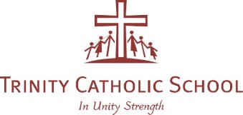

18th November, 2020

Dear Parents,
This semester we will hold Parent Teacher Chats in lieu of our usual Student Led Conference for those parents who would like the opportunity to discuss their child’s report. As social distancing restrictions are still in place this will be done in either 2 ways.
- Zoom call (The teacher will send you a link)
- Phone call (The teacher will ring the number you provide at the designated time)
Teachers will be available on Tuesday 1st December between 8:30-10:30 am and Thursday afternoon between 2:30pm-5pm.
We will again use the online booking system called PTO in order that you can choose your own appointment times. Please logon to the below link to register using the email address you used during last semester. https://sites.google.com/a/tcsrichmondnth.catholic.edu.au/tcsstudentportal/technology-how-to-s/parent-teacher-online-parent-help
If you have any difficulties with this process, please contact Georgie Hession: ghession@tcs.catholic.edu.au
Furthermore, this semesters report will also look different again. Following the advice from Catholic Education Melbourne and Victorian Department of Education this report will provide:
- A report on English, Maths, Religious Education, Physical Education, Science, Mandarin, Music and Art.
- A Progress score for English, Maths and Religious Education
- An overview of the Victorian Curriculum taught in Semester 2
- A comment on your child’s achievement according to the Victorian Curriculum
- A comment on how your child adjusted to the remote and flexible learning environment

Reports will be sent home on Monday 30th November.
Regards

Lindy Smith
Principal (Acting)

