Pinocchio gets surgery
The Muffin man Thursday 31st August 2023
On a sunny Thursday morning Pinocchio was found in the magic forest trying to become a real boy. The reason why is so his nose wouldn’t get larger every time he lied.
Pinocchio caught in the magic forest on a sunny Thursday morning trying to become a real boy yelling at the magic tree trying to get the magic tree to turn him into a real boy the magic tree said no. Then Pinocchio went to Shrek’s Swamp to see if Shrek had an idea. Shrek said go to the hospital to see if you can get surgery. Pinocchio went to the hospital.
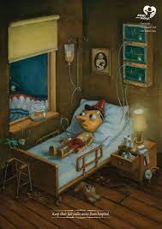
Pinocchio was waiting in the hospital for hours. Donkey said he had saw Pinocchio and he had been waiting in the hospital for 4 hours 21 minutes and 6 seconds until his name was called. Pinocchio was in the hospital for nine days and had lots of needles about 21 needles in his body. Shrek said he visted pinocchio in the hospital and he did not look like a real boy.Pinocchio was in the hostpital for seven more days. He finally came out of the hospital.
Pinocchio in hospital picture take Shrek
The Muffin Man

