Boiled Chocolate Cake

Ingredients
- 125 g unsalted butter
- 2 tbsp cocoa
- 1 1/2 cups caster sugar
- 1 cup water
- 1/2 tsp bicarbonate soda
- 1 1/2 cups self-raising flour, sifted
- 2 eggs
Instructions
- Preheat the oven to 180°C and grease and line an 18 cm round cake tin.
- Melt the butter in a saucepan over a medium heat.
- Add the cocoa, sugar and water. With a hand whisk, gently stir the mixture until ingredients combine and the mixture starts to boil. Reduce the heat and simmer for a couple of minutes before removing from the heat. Allow to cool slightly,
- Then add the remaining ingredients to the saucepan and stir with a whisk until the mixture forms a smooth consistency.
- Pour the cake mixture into the cake tin and bake in the pre-heated oven for 50 minutes. Remove from oven and leave to stand in cake tin for 5 minutes, then turn out onto rack and leave to cool.

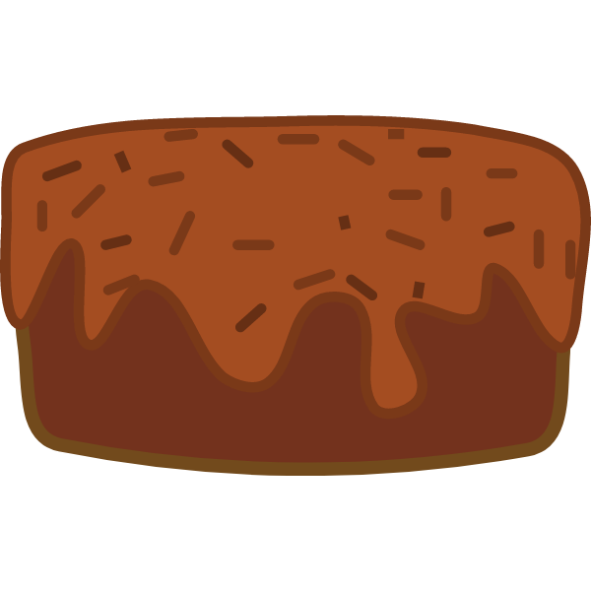
Chocolate Frosting

½ cup butter softened, both salted or unsalted work fine

¼ cup cocoa powder sifted

2.½ cups powdered sugar sifted

1 teaspoon vanilla extract

2-3 tablespoons milk

Instructions
- Whip butter and cocoa together until smooth in a large bowl. Stir in vanilla extract and powdered sugar. Slowly stream in milk until frosting reaches desired consistency. Scrape sides and whip again until light, fluffy and smooth, 1-2 minutes. Frost your Cake.

