Level 5 Homework Matrix
Homework tasks should ideally be completed with adult supervision. The Homework Matrix for each level will be available in the Connect newsletter once a fortnight. Tasks will be completed in student homework books and handed in to the teacher, to be signed, two weeks later on a Friday morning (even weeks). Teachers will sign homework books.
L5/6 – Reading + 8 tasks/fortnight
Reading (compulsory)  Read for: minutes every day.  Record the title of your book and the pages read in your diary. Ask an adult to sign your diary.  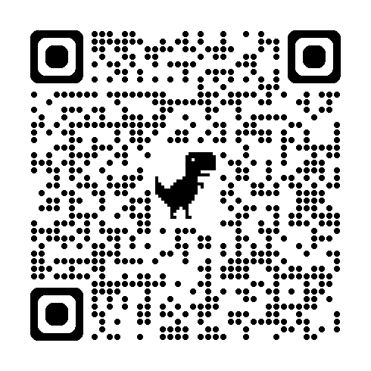 | Writing (grammar)  Write out your words in a list. Ask an adult in your family how they learned spelling at school. Write down what you remembered from your conversation. | Physical Education Challenge  - Net/wall practise - Stand near a wall and hit a soft ball (tennis ball or balloon) against it using your racquet or hand. Try to keep it going for 5-10 hits in a row.  - Cross Country practise - Alternate between jogging for 30 seconds and walking for 30 seconds for 5 minutes. Try to keep a steady rhythm | Gratitude  Pick 3 people you are grateful for  this month. Make sure you explain  why you picked each person.
Spelling:  Responsible  Flexible  Audible  Reversible  visible  Possible | Maths  You have been given $30 to spend  Decide which items from a catalogue you can buy.  Write the name, price and rounded amount of the items.  Calculate the total estimate. | Art Challenge  One-Word Artwork  Task:  Choose one word (e.g. strength, calm, chaos, hope).  Create a small drawing that shows this word without writing it.  Focus: symbolism, visual communication  Materials: pencil or optional colour | Mindfulness  Lay in a quiet room of the house or  somewhere comfortable outside  e.g. on the grass for a few minutes.  Take a moment to just stop and  listen to all the sounds around you.
Handwriting  Choose a passage from your book and re-write it in your best handwriting being mindful of punctuation spelling and spacing. | Maths Skills/Fluency  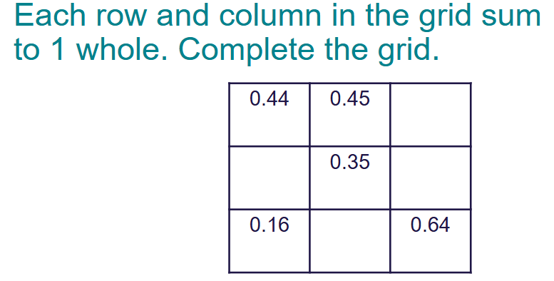 | Science Challenge  The Moon  Read this information and record 5 key facts.  https://science.nasa.gov/moon/facts/ | Emotional Literacy  Create a feelings collage using  magazines, coloured paper or art  supplies. Find pictures  representing different emotions to  create a collage that visually  portrays your feelings
Maths  Complete these multiplication problems using the vertical algorithm. | Online Platforms  - Read a book on Wushka  - Complete tasks on Mathletics  - Play a game on Maths frame  - Listen to a story on Storybox | Mandarin Challenge   | Empathy  Think about 3 ways in which you  can brighten someone’s day this  week with random.

