Melbourne Girls’ College
Athletics Program 2019
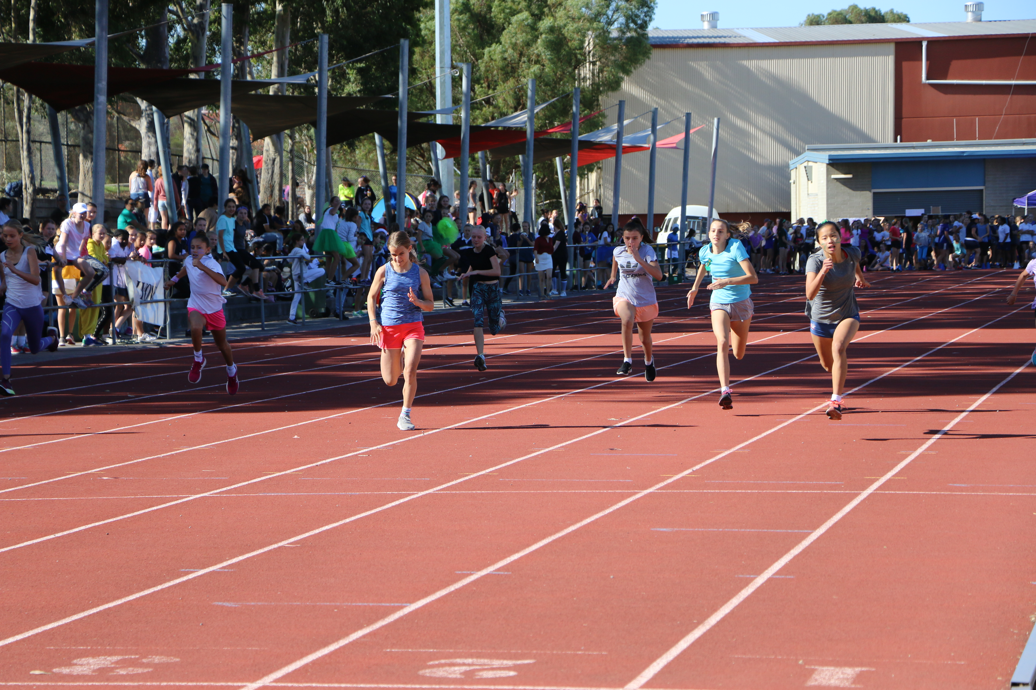

WAYBACK WEDNESDAY
Collingwood Athletics Track, Wednesday, 27th February

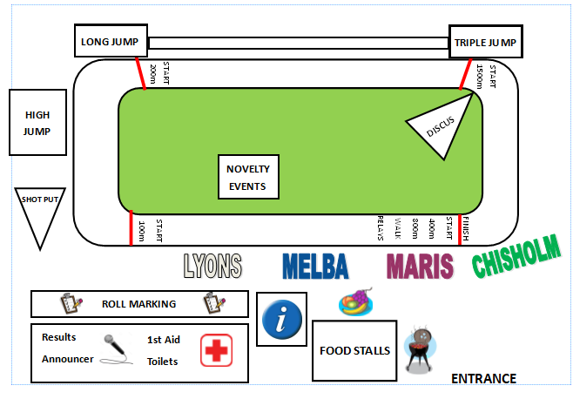
EVENTS
Time | U13 A-K | 13 L-Z | U14 | U15 | U16 | U17 & U21
10am | Shot Put | Discus | High Jump | Long Jump | Triple Jump
10:35am | High Jump | Long Jump | Triple Jump |  | Shot Put | Discus
11:10am | Triple Jump |  | Shot Put | Discus | High Jump | Long Jump
11:45pm | Discus | Shot Put | Long Jump | High Jump | Triple Jump
12:20pm | Long Jump | High Jump | Triple Jump |  | Discus | Shot Put
12:05pm | Triple Jump |  | Discus | Shot Put | Long Jump | High Jump
Time | Event
10:00am | Yr12 100m Opening Ceremony
11:30 – 1:30 | MGC Tough Mudder
11:30 – 1:30 | Longest Footy Kick
Time | Event
9:45am | 1500m
10:15am | 100m
11:00am | 800m
11:45pm | 200m
12:15pm | Walk  Fashion Parade 100m
12:30pm | 400m
1:00pm | 4 x 100m relay
1:40 | Pack up, roll marking
2:00pm | Dismissal

