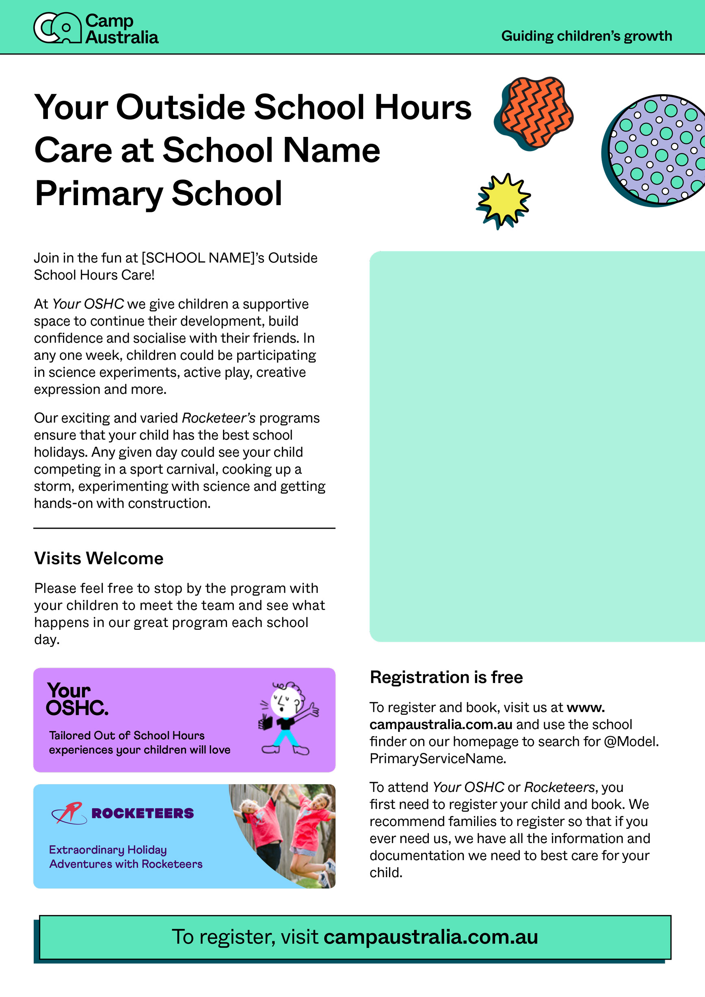

Your Outside School Hours Care at School Name Primary School

Get to know (Coordinator Name) with these fun facts

* Pancake Making
* Roleplay
* Sport/Games
* Craft/Drawing

Join in the fun at Oatlands Primary School Camp Australia Outside School Hours Care!