Mary research task:
Artworks of Mary analysis:
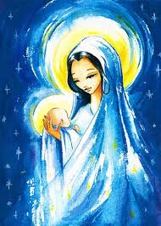
Name of artwork: Mary mother of Jesus
Artist: unknown
Location: DoorFoto Pinterest https://pin.it/RSWNHFw
Time of completion: unknown
Impressions: The style and the choice of colours was very wise and well thought. There are blue, white and gold which are colours that represent good and purity. Shows a depiction of Mary holding infant Jesus.
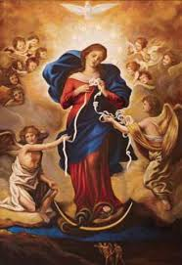
Name of artwork: Mary, Undoer of Knots
Artist: Joahann Georg Melchior Schmidtner
Location: Catholic pilgrimage church of St. Peter am Perlach, Augsburg, Bavaria.
Time of completion: around 1700
Impressions: It’s how’s Mary untying knots as angels surround her, the knotted snake depicts the devil. Surrounding Mary is the white glow of the Holy Spirit. On top of her is a white dove symbolising purity. https://en.m.wikipedia.org/wiki/Mary,_Untier_of_Knots

Interpretation of the artworks:
Mary Mother of Jesus:
Colours: | Lighting: | Figures: | Symbols: | Other:
Light blue, yellow, gold, white, Dark blue, brown,  These colours represent understanding, power, knowledge, purity, faith, calmness, heaven.  The artist has chosen very spiritual and positive colours. | Lighting of gold and yellow behind Mary and Jesus’s head. | The figures of Mary placed in the middle of the artwork, Jesus is placed in Mary’s arms on the left side of the artwork. | White Stars surrounding Mary and Jesus could represent the birth of Jesus or the white could mean purity and peace between mother Mary and son Jesus. | Another thing I noticed was that Jesus is bundled up in Mary’s dress.  This could mean how close Mary and Jesus were.

Mary, Undoer of Knots:
Colours: | Lighting: | Figures: | Symbols: | Other:
Creams, light golds and yellow, blue, red white, brown. | There is a luminous glow of white surrounding Mary. This could mean how heavenly and pure she was. | Angels surrounding Mary observing her, this could also mean how she was protected by angels.  Dove on top of her. Dove represents peace, love and hope. This is because Mary brought these things in life with her. | There is a knotted rope that Mary is holding. Mary is untying it. I think it means how Mary got rid of many problems in the world by giving birth to Jesus. | 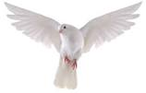  Located at the bottom where Mary’s legs are you can see a snake wrapping around the legs, the snake could be Satan.

Compare and contrast:

Similarities:
- Colours are similar like blues and golds,
- Mary has appeared.
- Lighting is similar, because there is lighting behind both Mary’s in artworks,
- The positions of both Mary is similar because they are both located in the middle of the artwork.
Mary mother of Jesus:
- Different setting, in the sky with starts
- Jesus baby in the mother’s arms.
- White stars and and blue sky could represent the time of birth of Jesus during Christmas.
- The art style is more simple, less realistic and colourful and less detailed.

Mary, Undoer of Knots:
- Different setting, in heaven with lots of clouds.
- Satan appears in the artwork below Mary.
- Dove appears in the artwork, it represents many positive and spiritual aspects in the bible.
- Angels are surrounding Mary, this is showing how protected and honoured she is in heaven.
- The art style is more realistic and has more tiny details hidden. Viewers will see these details the more they look such as the little people down at the bottom that reenact a story.

Reflection:
Why did you pick these artworks?
I picked these artworks because it has a clear and nice art style of Mary and it’s more realistic to what Mary would have looked like. I also like how both of them show Mary very independent and strong. I also liked the colours and how it matched Mary’s personality
Reflect how the artworks relate to modern society.
It relates to modern society because the first picture shows the love between mother and child. Also the second picture related to us now because there are many problems and without Mary most of those problems won’t have solved.

