CAREER NEWS Friday 24 July
 Dates to Diarise in Term 3
- University / TAFE Open Days 2026 – late July and throughout August
- Year 12 VTAC timely applications – early August until end September
- VTAC SEAS and Scholarship applications – throughout August and September

 Webinar Series
VTAC is excited to partner with Alana Kilmartin to present this webinar series to help Year 12 students and their parents navigate tertiary education and career planning beyond Year 12. Please use the links below to register for these free events.
Playbook For Success Beyond Year 12 Series - for students | Tuesday 21 July 2026, 5:00 PM - 6:00 PM | Year 12 students | Register here
Playbook For Success Beyond Year 12 Series - for Parents and Carers | Thursday 23 July 2026, 6:00 PM - 7:00 PM | Year 12 Parents and Carers | Register here

 Upcoming Discover Monash Events
Monash University will be hosting morel Discover Monash events or activities over the coming weeks. Unless specified online**, these will be face-to-face events.
Participating in one or more of these events will assist students in making informed choices about their study options after Year 12.
A number of events will take place from August to November, and students are encouraged to register early.
Registration for the event listed below is open:
Monash Information Evening ** | Tuesday 1 September, 6.30 - 8.00pm

Registrations for the events listed below will open in August:
Parkville Campus Tour | Monday 21 September, 10.00 - 11.00am
Clayton Campus Tour | Tuesday 22 September, 10.00 - 11.30am
Peninsula Campus Tour | Tuesday 22 September, 2.00 - 3.15pm
Caulfield Campus Tour | Tuesday 29 September, 10.00 - 11.15am
Clayton Campus Tour | Tuesday 29 September, 2.00 - 3.30pm
Clayton Campus Tour | Thursday 22 October, 2.00 - 3.30pm
Clayton Campus Tour | Thursday 12 November, 10.00 - 11.30am

For a complete list, and to register, visit Events Calendar - Discover Monash.
 Early Entry & Pathways Webinar
ACU will be hosting its Guarantee Early Offer, Entry Programs and Pathways Webinar (VIC) on Tuesday 11 August, from 6.00pm- 6.45pm.
Learn about ACU’s entry and pathway options, including the ACU Guarantee early offer program, key dates and how to apply. Plus, hear from current students about their journeys. This webinar is for Victorian Year 12 students and their parents.

To register for this, or any other webinars, visit Study at ACU webinar series.

 Internet of Things IoT Bachelor of Computer Science (Honours)
Computer scientists are problem solvers and innovators.
Throughout this specialised four-year Bachelor of Computer Science (Honours) course, students will develop the knowledge and practical skills required to design and develop innovative software solutions to address multifaceted information and technology challenges. They will have access to specialised facilities, including dedicated robotics, cyber security and augmented and virtual reality laboratories, all supported by experienced, industry-connected staff.
Students will have access to the following four majors:

- Computational Mathematics
- Data Science
- Internet of Things
- Robotics

Importantly, students will have the opportunity to undertake a professional placement as part of their studies, or work in teams with an industry partner to tackle authentic business challenges as part of a capstone project.
 Internet of Things IoT Bachelor of Computer Science (Honours)
Similarly to Deakin University, Swinburne University also offers Bachelor of Computer Science (Honours) with a major in the Internet of Things.
With a focus on software development, this course is taught by some of the best computer minds in the business. Students learn in industry standard labs and choose to specialise with a major in Artificial Intelligence, Cyber security, Data Science, Games Development, Software Development or Internet of Things.
The Internet of Things major gives students the core skills needed to program a host of devices and develop software solutions. They learn to problem-solve through analysing data from internet-connected devices.
Worth noting, this course includes a guaranteed Work Integrated Learning opportunity, which could be a placement, internship or industry-linked project.
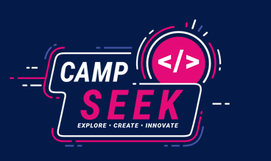 Camp SEEK 2026
Camp SEEK is a four-day immersive daily learning program for Year 9 and 10 girls and non-binary students. Spend four action-packed days at SEEK HQ in Melbourne learning about careers in technology, developing coding, design and product practical skills, exploring real-world problem solving and pitching with your fellow Camp SEEKers.
The technology industry is not as diverse as it could be. There is a shortage of women and non-binary talent in STEM school subjects, at the tertiary level and in the workforce.
As a leading technology company, SEEK champions diversity within its industry and its own talent pipeline, and Camp SEEK is a favourite, and most fun, program. It is designed to increase the number of girls and non-binary students who choose to pursue a career in technology.
Date: 21 – 24 September 2026
Times: Similar to school hours
Venue: SEEK HQ in Cremorne, Melbourne
Applications are open, and students are encouraged to register as soon as possible at Camp SEEK 2026.

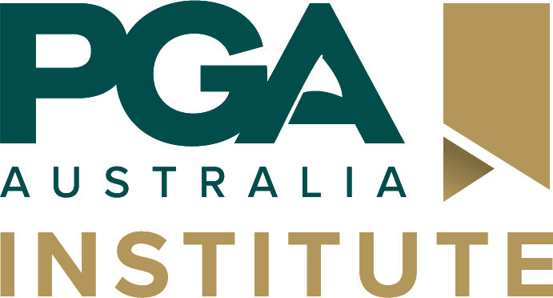 PGA Institute Careers in Golf Scholarship
Recently launched, and supported by Golf Australia, this scholarship is designed to help aspiring students take their first steps towards a career in the golf industry.
The scholarship program offers:
- Up to $7,500 in tuition bursaries for on-campus study in Melbourne.
- Up to $5,000 towards an online diploma.
- Up to $600 towards PGA Institute micro-credentials.
The Melbourne-based scholarship stream is aimed at Year 12 graduates who are passionate about golf and interested in building a rewarding career in the industry.

Applications are now open, with expressions of interest closing on 1 October 2026. Learn more and apply at PGA Institute Careers in Golf Scholarship.
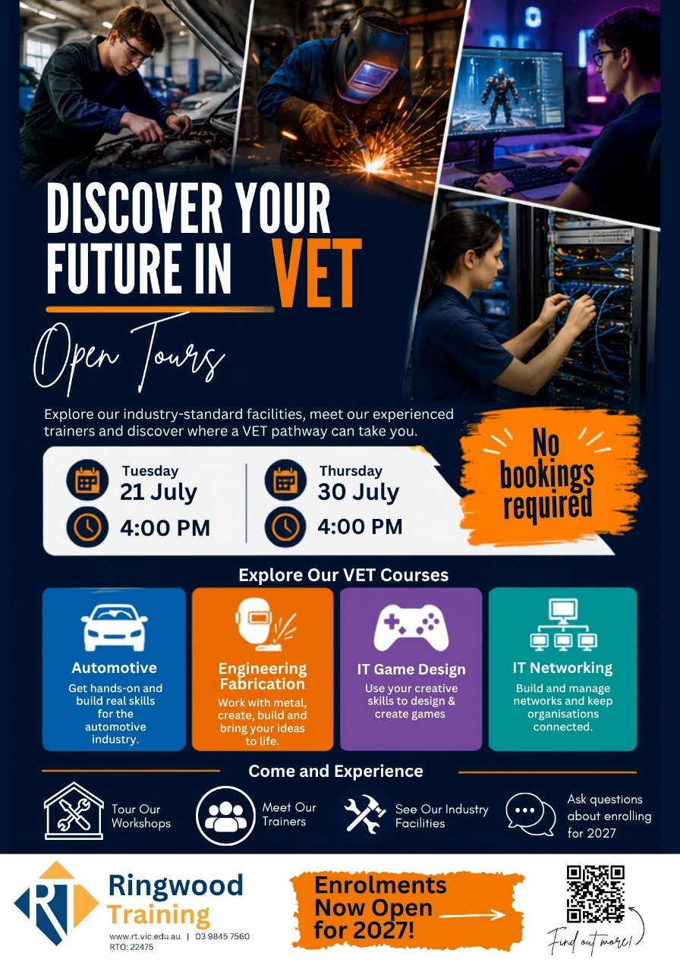
 Agriculture Degrees in Victoria in 2026
Growing enough food to sustain the world is one of the biggest challenges the world is facing in the 21st century. Below are several degrees that prepare students to become experts in the science of agriculture, so they can take on an advisory role in agriculture and farming practices.
For a comprehensive list of courses (including the many double-degree options) on offer at Victorian universities, TAFEs, and Private Providers, visit VTAC.
INSTITUTION | COURSE NAME | VCE PREREQUISITES | MAJOR STUDIES IN 2026
LA TROBE UNIVERSITY | Bachelor of Agriculture | Units 3 and 4: a study score of at least 25 in English (EAL) or at least 20 in English other than EAL; Units 3 and 4: a study score of at least 20 in any Mathematics. | Agribusiness, Animal science, Plant and soil science.
LA TROBE UNIVERSITY | Bachelor of Agriculture  (Agribusiness) |  | Agribusiness.
LA TROBE UNIVERSITY | Bachelor of Agriculture  (Animal Science major) |  | Animal Science.
LA TROBE UNIVERSITY | Bachelor of Agriculture  (Plant and Soil Science) |  | Plant and soil science.
LA TROBE UNIVERSITY | Bachelor of Science  (Crop Science) |  | Crop science.
MARCUS  OLDHAM  Students applying for this course must have completed at least 12 months in an industry placement following the completion of Year 12 or equivalent. | Bachelor of Business (Agriculture) | Successful completion of Year 12. Selection is based on the ATAR and an interview. | Agriculture, Farm Management and Agribusiness.
MELBOURNE POLYTECHNIC | Bachelor of Agriculture and Technology  (Agronomy Major) | Successful completion of Year 12. The ATAR may be used as part of the selection considerations. | Agronomy major.
MELBOURNE POLYTECHNIC | Bachelor of Agriculture and Technology  (Viticulture and Winemaking Major) | Successful completion of Year 12. The ATAR may be used as part of the selection considerations. | Viticulture and Winemaking major.
UNIVERSITY OF MELBOURNE  The Diploma in General Studies provides a pathway to the Bachelor of Agriculture.  Students might also like to study the Agricultural Sciences major in the Bachelor of Science | Bachelor of Agriculture | Units 3 and 4: a study score of at least 30 in English (EAL) or at least 25 in English other than EAL; Units 3 and 4: a study score of at least 30 in Maths: General Mathematics or at least 25 in one of Maths: Mathematical Methods or Maths: Specialist Mathematics. | Agricultural economics, Plant and soil science, Production animal science.

 Snapshot of James Cook University (JCU) in 2026
- JCU is the second-oldest university in Queensland and is dedicated to research in areas such as marine sciences, biodiversity, tropical ecology and environments, global warming, tourism, and tropical medicine.
- JCU is also a leading university in the tropics and ranked in the top 400 universities in the world - Times Higher Education World Rankings. Browse here for other rankings.
- JCU has a number of campuses with the main campuses being in Townsville and Cairns, and there is an international campus in Singapore.
- Some of the most highly sought after courses offered at JCU include:
Bachelor of Medicine Bachelor of Surgery
Bachelor of Dental Surgery
Bachelor of Physiotherapy
Bachelor of Veterinary Science
Bachelor of Marine Science
- JCU has a number of colleges and research facilities
- College of Arts, Society and Education
- College of Business, Law and Governance
- College of Healthcare Sciences
- College of Medicine and Dentistry
- College of Science and Engineering
- Indigenous Education and Research Centre
- JCU offers a broad range of student exchange programs - JCU Global Experience.
- Fast Facts for Health or Veterinary Science Applicants
JCU has a few programs where a combination of a written application and academic results may be required for selection including dental surgery, medicine, and veterinary science. Students applying for one or more of these courses should take note of the recommendations made at Domestic Applications for Medicine, Dentistry and Veterinary Science OR International Applications for Medicine, Dentistry and Veterinary Science.


