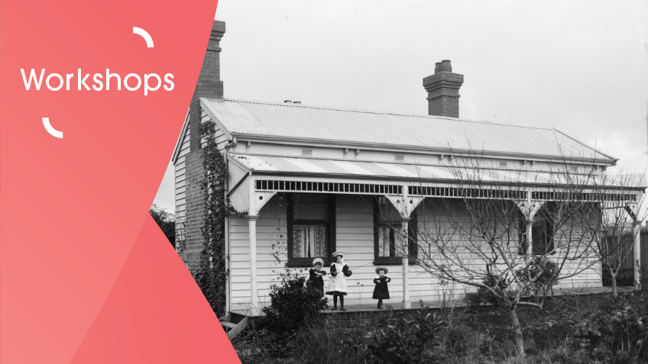

Workshop (Free) – Oh what stories houses would tell, if only they could talk!
When: 8th August 2023
Time: 10 am – 11 am
Location: Via Zoom
Bookings essential – Click the link: https://www.slv.vic.gov.au/whats-on/researching-your-home
This webinar will help to answer questions you may have about your family home, whether it’s the house you are living in or one from your childhood memories.
Librarians will introduce you to a range of resources that can be used to:
- Research your family home
- Find previous people who lived there
- Find the area’s social history

