



When children feel that all-important sense of belonging, they can thrive. Read our full blog on helping to boost your child’s sense of belonging in primary school.

**Boost your child’s sense of belonging**



Visit our blog

Whether it’s your child’s first day of school, they’re joining us at OSHC for the first time or they just need a little encouragement after the summer holidays, our Transitions program will help your child feel safe, valued and included.

**Positive Transitions program**



Did you know you can reduce the cost of care with a Government subsidy? We strongly recommend you apply for the Child Care Subsidy (CCS) to determine what you’re eligible for. For more info, visit Mygov.com.au

**Save on OSHC fees with the CCS**



Join us for a free virtual information session to find out how Outside School Hours Care can help your family, and how our team can guide your child’s growth. These virtual, informative, and interactive sessions will provide insight into how Your OSHC by Camp Australia operates.

**Virtual information sessions**



Book now

All activities are COVID safe, adhere to all health guidelines and follow COVID-19 cleaning practices.

**COVID safe activities**



To attend our program, you must register your child. You can register an account with us at [pp.campaustralia.com.au](https://pp.campaustralia.com.au/) or by downloading our Camp Australia smartphone app from the Apple App Store or on Google Play. Once registered, it’s easy to make bookings and manage your account.

**It’s free to register**

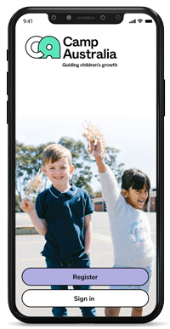

Welcome back to a new school year! Our Outside School Hours Care, Your OSHC provides tailored experiences that aim to inspire your child and help them grow.

We have been busy designing the perfect program and environment to kick off the new year. We can’t wait for your children to experience it.

Our term 1 program will focus on forging new friendships, strengthening existing ones, being secure, and feeling included and confident. We have set up an engaging and inspiring Your OSHC space so every session you child will be able to choose from different experience in our many zones.

We are also excited to introduce Your OSHC coordinator: Chloe Munro

Chloe is excited to get to know all the families and get involved in the fun and exciting activities we have planned. Feel free to come to the OSHC room and say Hi. We would love to meet you. Otherwise you can contact Chloe through email at: rollinsps@oshccampaustralia.com.au.