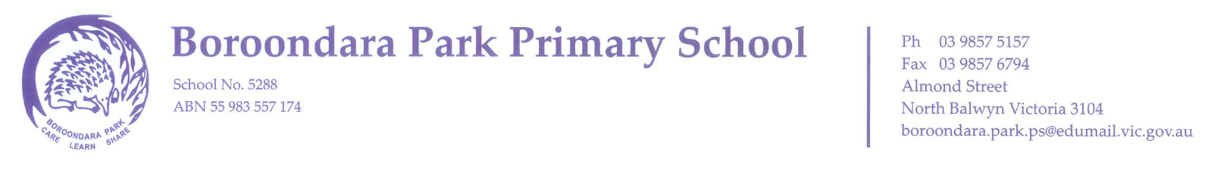

FOUNDATION TRANSITION CALENDAR
FOR STUDENTS BEGINNING SCHOOL IN 2020

Starting school is a major life transition for children and their families. It is time of change that can be both challenging and exciting, during which children and families adjust to new roles, identities, expectations, interactions and relationships. At Boroondara Park Primary School, we provide a range of activities designed to help children and families become familiar with our school environment and build relationships that are crucial to a successful start to school.

School Tours: Wednesdays at 9:30am by appointment
Tuesday May 14th | 2020 Foundation Information Night 7:00pm
Tuesday May 21st  9am - 12 noon  Thursday May 23rd  1:50-3:30pm | Open Days
Friday July 19th | Story Time Session One 2:50 - 3:20pm  (reading activity for Pre-School children)
End of July | Enrolments Due
Friday October 11th | Story Time Session Two 2:50 - 3:20pm  (reading activity for Pre-School children)
Tuesday November 19th | 2020 Foundation Transition Information Night 7:00pm  (for parents of enrolled 2020 Foundation students)
Wednesday November 27th | Foundation Transition Session One 2:15 - 3:15pm  (for enrolled 2020 Foundation students)
Wednesday December 4th | Foundation Transition Session Two 2:15 - 3:15pm  (for enrolled 2020 Foundation students)
Tuesday December 10th | Foundation Transition Session Three 10:00am – 2:00pm  (for enrolled 2020 Foundation students)

