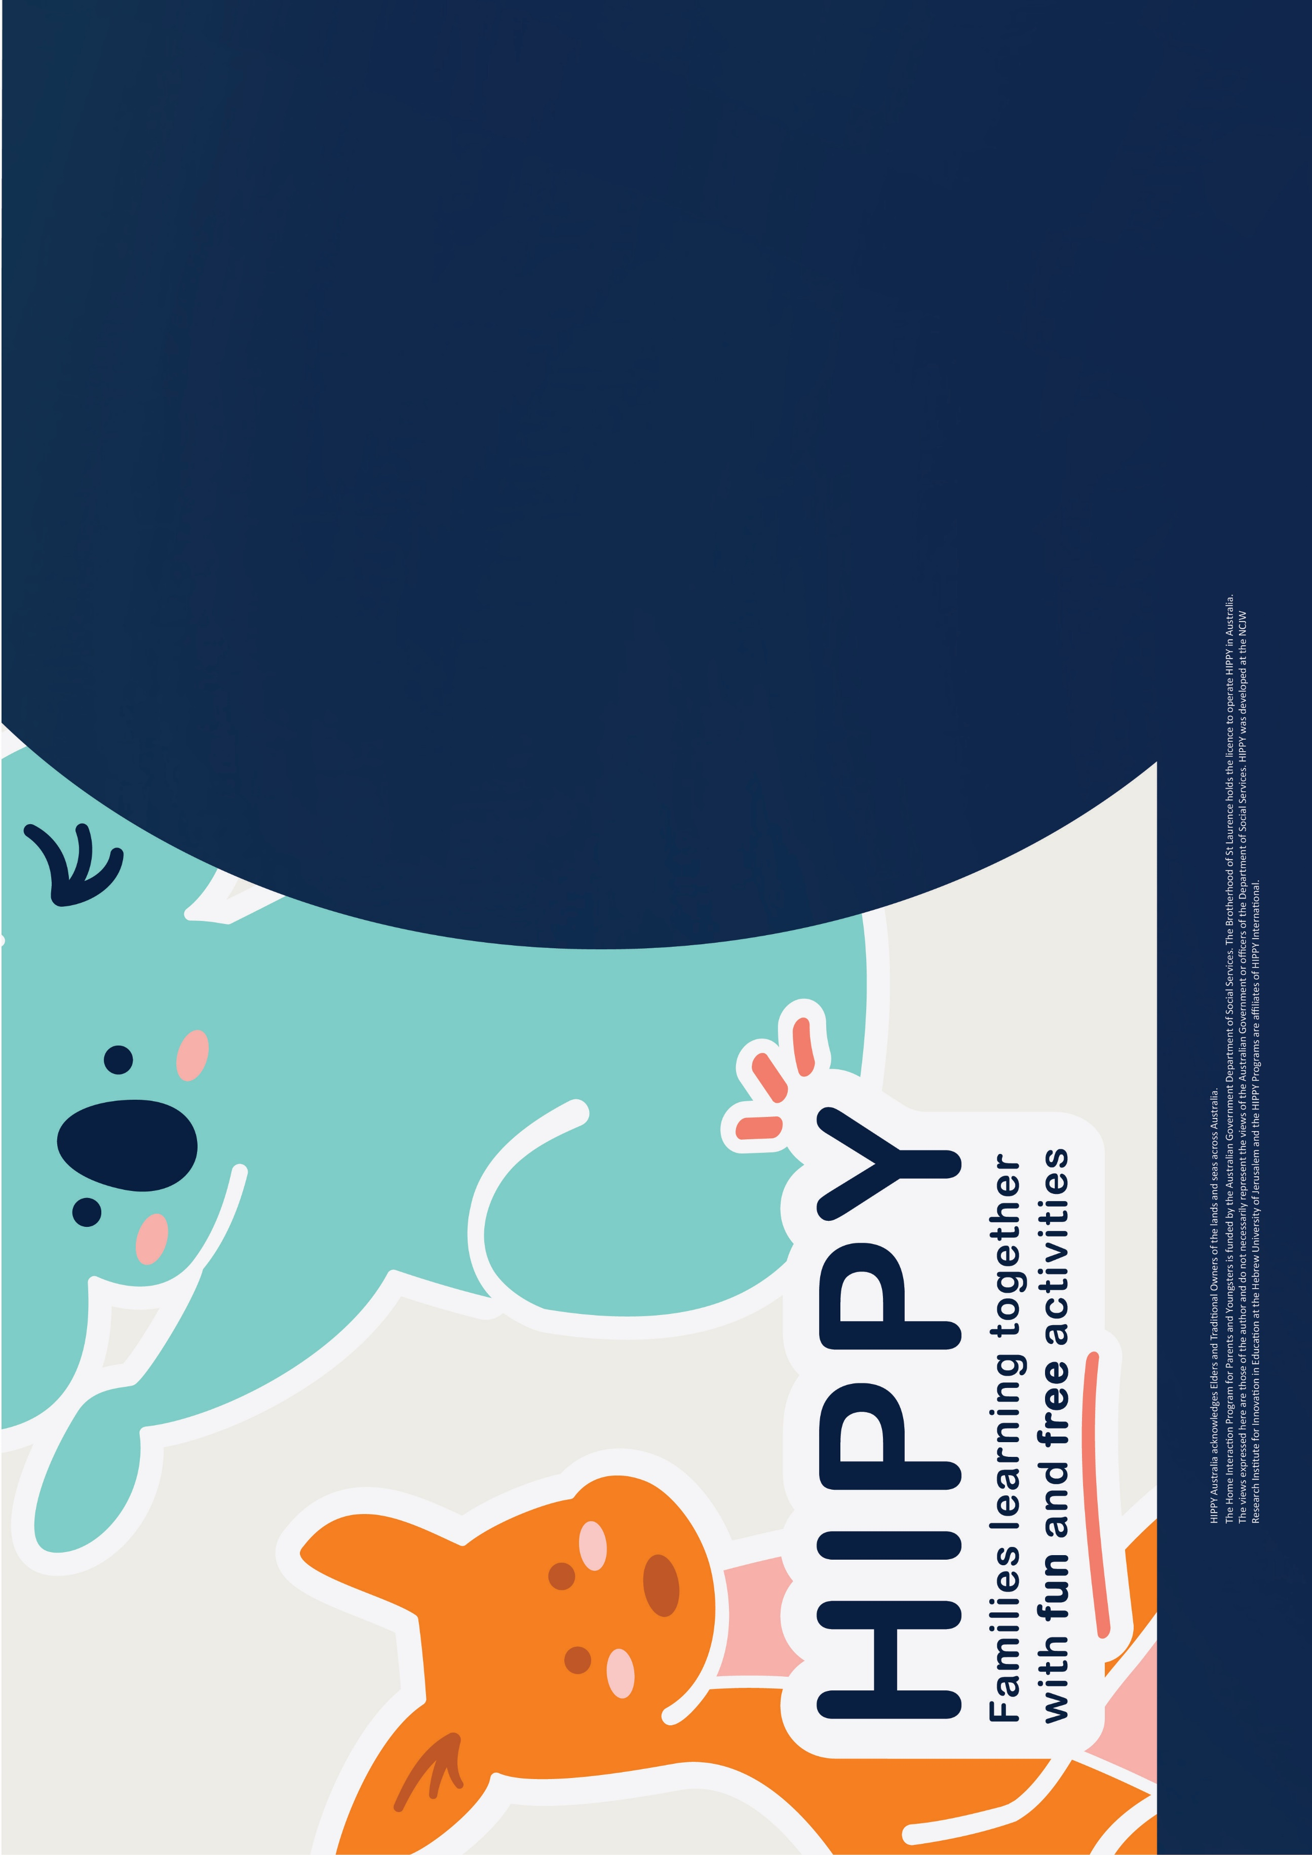
HIPPY GATHERERING
Onkaparinga
Taikurrendi Children’s Centre
8 Price Street Christies Beach
Fortnightly on Tuesday’s
10am-11am

Contact us:
8377 7822
Referral@kwy.org.au
www.kwy.org.au



