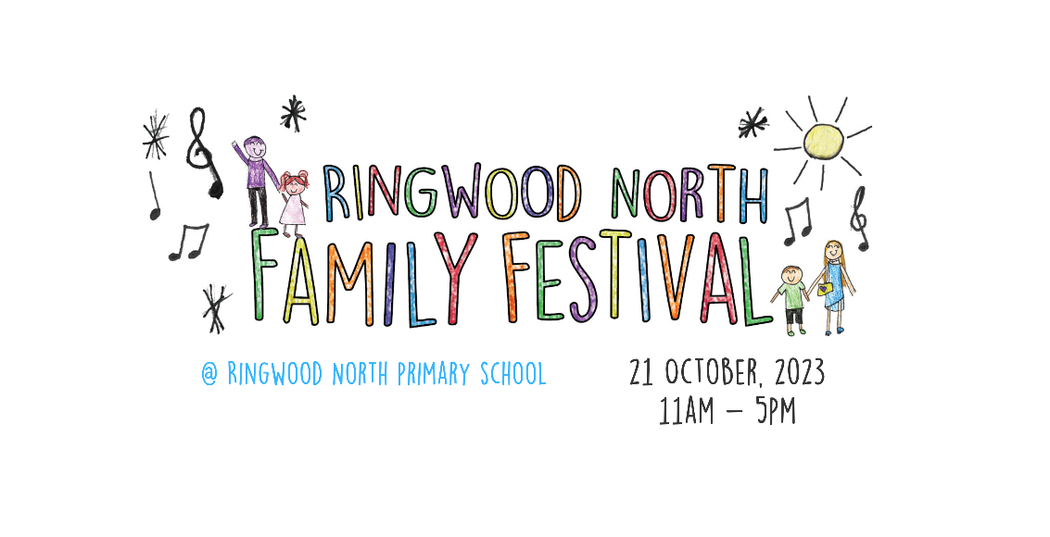28th November 2022

To Whom it May Concern,

We are very excited to announce our Ringwood North Family Festival and Centennial Celebrations to be held on Saturday 21st October 2023. We are promoting a family themed festival for next year with a large focus on not only celebrating 100 years of our school, but also the importance of our supportive local community.
Ringwood North Primary School is a popular and community focussed school which continues to grow every year (440 students). Participation as a sponsor of the 2023 Ringwood North Family Festival allows you to promote your brand/business to the extended community that our school represents. You will have direct access to parents and their families across the community (many of whom are professionals in the wider school community) before, during and after the festival.
Multiple sponsorship packages exist to enable increased participation and promotion, allowing you to choose an option that aligns with your budget and desired marketing outcomes. Our fundraising goal for 2023 and 2024 is to refurbish the Pine Hall. This building was built over 40 years ago by the school community and will be refurbished with a new floor to use in PE lessons, production rehearsals and before and after school care.
To secure a sponsorship package or goods/service donation for your business please complete and email the Sponsorship/Donation Form to Melanie Lawrence (Festival Committee Sponsorship) at Melanie.444@live.com. Should you have any further enquiries, Melanie can also be contacted on 0409 161 124.
We would like to thank you for your consideration for sponsorship. We hope our festival is able to highlight what a unique and wonderful school and community we are.
Warm Regards and thanks
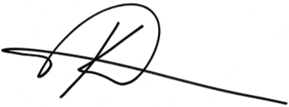
Ken Chatterton
Principal
Ringwood North Primary School

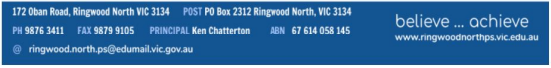

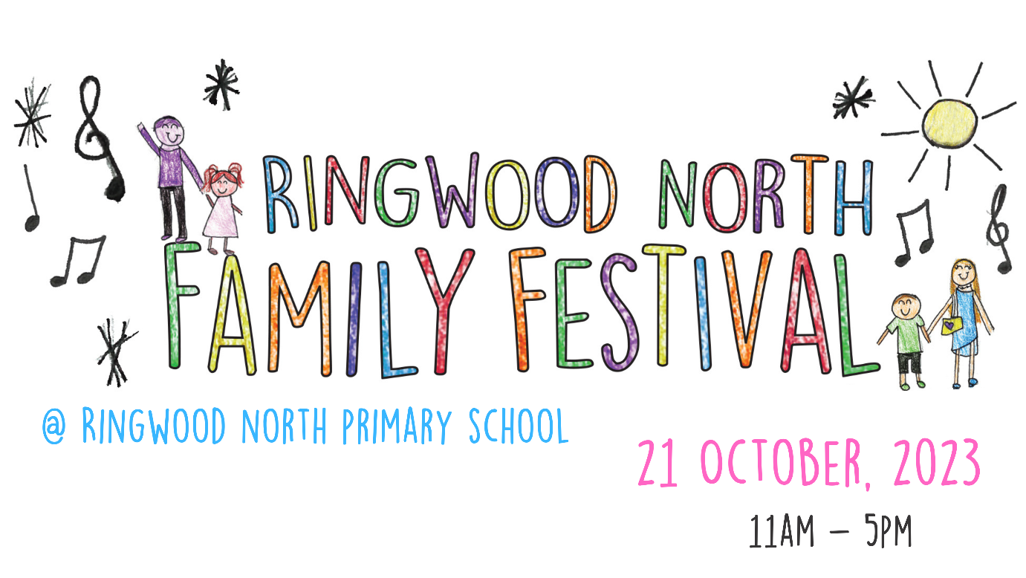
2023 Ringwood North Family Festival Sponsorship Packages

Our school has many wonderful connections with our families and the local community and next year’s festival is aimed at celebrating these. Participation as a sponsor of the 2023 RNPS Family Festival allows you to promote your brand/business to the extended community that our school represents. You will have direct access to parents and their families (many of whom are professionals in the wider school community) before, during and after the festival. We have worked hard to ensure that your sponsorship dollars will be well spent, in terms of delivering tangible benefits for your business. These benefits are outlined in the below sponsorship packages (refer to full table of benefits and inclusions):

1. Platinum Sponsor (1 Sponsorship Package)
Platinum sponsorship provides exclusive promotion of your brand/business with Ringwood North Primary School as a major partner and supporter
2. Gold Sponsor (2-3 Sponsorship Packages)
Gold sponsorship provides you with the opportunity to achieve excellent promotion prior, through and post the festival and ensure you stand out from the crowd
3. Silver Sponsor (3-4 Sponsorship Packages)
Silver sponsorship provides the opportunity to enjoy some limited pre and post event exposure whilst also having some onsite MC recognition on the day
4. Bronze Sponsor (4-6 Sponsorship Packages)
Bronze sponsorship provides an affordable option for business to participate in the pre-event advertising, gaining valuable brand exposure
5. Donations or Goods/Service Donations (Unlimited)
Monetary donations or donated goods/services for the festival or inclusion for our silent auction.

2023 Ringwood North Family Festival | Platinum | Gold | Silver | Bronze | Donation or Donated  Goods/Service
Sponsorship packages (exc. GST) | $2,500 | $1,000 | $500 | $300 | Donation or Goods/Service
No. of Sponsors per package | 1 (Exclusive) | 2-3 | 3-4 | 4-6 | Unlimited
Your Brand Recognition
Your business logo acknowledged on three major real estate boards  advertising the festival, facing main roads in local area | Yes
Your business banner displayed on school fencing facing Oban Rd school pick up zone for 3 weeks before and 1 week after festival | Yes | Yes
Link to your business website from festival page on Ringwood North Primary School website. Active to October 2023 | Yes | Yes
Level of sponsorship advertised (via business logo) on festival flyer to be distributed locally in September 2023 | Yes | Yes | Yes | Yes
Level of sponsorship advertised in fortnightly RNPS newsletter, reaching over 200 plus families. Active to October 2023 | Yes | Yes | Yes | Yes
Level of sponsorship advertised (via business logo) on Ringwood North Family Festival Facebook page | Yes | Yes | Yes | Yes
Certificate of Gratitude and thanks | Yes | Yes | Yes | Yes
Festival Event Recognition
Recognition as our Platinum sponsor by hourly updates over speaker | Yes
Your business banner displayed at the main stage of festival | Yes
A small booth/display/marquee from which to promote your business on festival day | Yes | Yes
Your business promoted on main stage by the MC during the festival | Yes | Yes | Yes |  | Donation wall at festival

2023 Ringwood North Family Festival Sponsorship/Donation Form

Company Name
Type of Business
ABN
Website
Business Address
Contact Name & Position
Contact Phone No.
Contact Email Address
Level of Sponsorship (Platinum, Gold, Silver, Bronze) or donation or Goods/Service donation
If a Goods/Service donation, please provide further details of donation or service and $ value
If a monetary donation, please provide $ value
Financial Risk Assessment:  <Insert Company Name> are able to provide sufficient financial resources to deliver the goods or services described in this sponsorship offer;  <Insert Company Name> is not subject to any current or impending legal action that could impact on their capacity to deliver the agreed sponsorship. | Please provide signature:
Important Note: Sponsorship will only be given to 1 per Industry Category e.g. Real Estate etc. Acceptance of sponsorship will be up to the discretion of the School Principal and Festival Committee. Once this form has been received, we will contact you to confirm your sponsorship/donation interest. You will be sent a letter of sponsorship notification; this will entail further information on payment methods. Please return this completed form to Melanie Lawrence (Festival Committee Sponsorship) via email Melanie.444@live.com. For further information/enquiries please contact Melanie Lawrence at Melanie.444@live.com or 0409 161 124.

