

**23/08/2024**

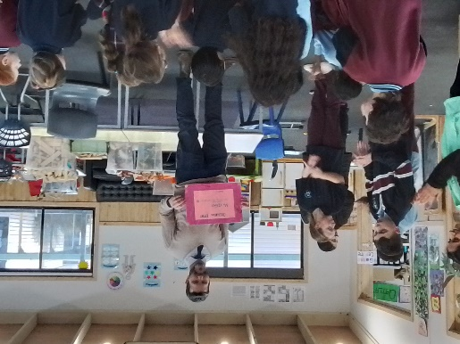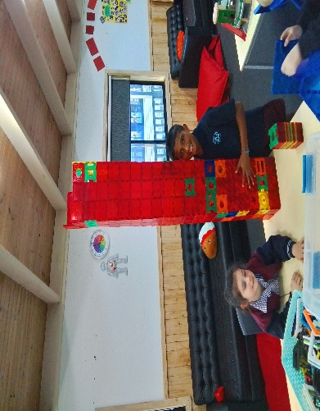[](https://pp.campaustralia.com.au/)

**A message from your Coordinator**

**To Fathers please come and visit on Friday ASC 23rd for a Smoothie and piece of cake, we hope you all have a fabulous weekend with your families.**

**Also our 30th Anniversary Party on the Tuesday 10th September 2024.**

* Fathers Day Craft
* Creating Gift for 30th Party Celebrations
* Cooking Cakes

**Activities coming up**

Join in the fun of Outside School Hours Care activities and experiences with Your OSHC and Rocketeers.

**Make a booking**

Book now

**Oatlands Primary School OSHC**