CAREER NEWS Friday 31 October
 Dates to Diarise in Term 4
- Year 12 VTAC late applications – 30 September – 31 October

 Reminder: VTAC 2026 Upcoming Key Dates
ATARs Released | Thursday 11 December 2025
Change of Preference (CoP) closes | Saturday 13 December 2025
December Round Offers | Tuesday 23 December 2025
January Round One Offers | Tuesday 13 January 2026
January Round Two Offers | Tuesday 27 January 2026
February Offer Rounds | Tuesday 3 February 2026 onwards
For a full list of cancelled, amended, and new courses, visit VTAC Course Updates.

The VTAC website is www.vtac.edu.au

 Summer School with Access Education
Students going into Year 12 in 2026, or who will be completing a 3/4 subject, might like to consider signing up for a Summer School Bundle - Unit 3 Lectures + Notes + Bonus Videos. The team of lecturers delivering these are highly experienced in their fields

- Students will have access to
Extensive online, live, interactive 2 hour VCE preparation lectures
PLUS
- Subject specific study notes prepared by the lecturers
PLUS
- Up to 1 hour of additional video content to view in your own time

Access Education is having a one-day only sale THIS Friday 31 October whereby students can purchase places to take part in the Summer School Program in January 2026 for only $28 per lecture. The price is normally $56 per session, so that is HALF PRICE!
Only available online at Access Education or by calling 1300 338 222 between 8.00am and 6.00pm.

 Foundation Studies at ACU

Foundation Studies offers a pathway for students without a recognised Year 12 qualification.
The program develops subject knowledge across key areas while preparing students for university-level study. Delivered in a supportive environment, students receive all required resources and guidance for a smooth transition to undergraduate study. The program can be completed on campus or online, and ACU covers the full cost.
Students who have a Year 12 qualification have the option to complete the program via accelerated mode (one-semester full-time) or part-time (two-semesters).

Find out more at ACU Foundation Studies.

Changes to courses from 2026
Bachelor of Nursing: ATAR now 60.
Bachelor of Midwifery: launching in Berwick, 3 yrs full-time or 6 yrs part-time.
Bachelor of Social Work: available at Berwick and Mt Helen campuses.
Bachelor of IT: online delivery at Gippsland due to low face-to-face demand. On-campus delivery will remain for Mt Helen and Berwick.

Relaunched specialised Science courses:
Bachelor of Science and Bachelor of Science (Advanced)
Bachelor of Biomedical Science
Bachelor of Biomedical Science (Gippsland Partnership Program)
Bachelor of Food and Nutrition

Changes to Engineering courses:
Bachelor of Engineering (Electrical) (Honours):
Delivered via block-mode (flexible) delivery plus intensive 4-day week of classes per month allowing students to have greater flexibility (remaining a 4 yr course).
Bachelor of Engineering (Civil) (Honours):
Not offered at Gippsland in 2026 due to low student numbers. Future review for possible block-mode (flexible) delivery.

 Psychiatrists and Psychologists: What's the Difference?
According to the Your Health in Mind website, there are three main differences between psychiatrists and psychologists:
- Psychiatrists are medical doctors, psychologists are not.
- Psychiatrists prescribe medication, psychologists can't.
- Psychiatrists diagnose illness, manage treatment and provide a range of therapies for complex and serious mental illness.
- Psychologists focus on providing psychotherapy (talk therapy) to help patients.

It would seem many people get psychiatrists and psychologists confused with each other.
Both psychiatrists and psychologists understand how the brain works, our emotions, feelings and thoughts. Both can treat mental illness with psychological treatments (talking therapies).

However, psychiatrists attend medical school and become medical doctors before doing specialist training in mental health – with up to 11 years of training. As they are doctors, psychiatrists understand the links between mental and physical problems, and they can also prescribe medications.
Further information can be found at Your Health in Mind.

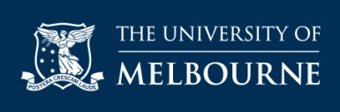 Guaranteed Pathways for Bachelor of Design Students
All University of Melbourne Bachelor of Design graduates who continue into a Melbourne School of Design graduate program will have guaranteed entry—no portfolio or personal statement required.
To qualify, students must:

1. Achieve a minimum 65% WAM in the Bachelor of Design.
2. Complete the corresponding major for their preferred Master’s program.
3. Apply within 2 semesters of completion of the Bachelor of Design.
Examples include:

· Architecture major pathway into the Master of Architecture
· Construction major pathway into the Master of Construction Management
· Landscape Architecture major pathway into the Master of Landscape Architecture
· Property major pathway into the Master of Property
· Urban Planning major pathway into the Master of Urban Planning.
Find out more at Guaranteed and Flexible Undergraduate to Graduate Degree Pathways.
 Employment Projections
Jobs and Skills Australia’s (JSA) employment projections are useful for understanding the impact of the current economic and labour market outlook on Australia’s future workforce needs. The projections give insights into trends and growth areas in the labour market and are used by industry and governments to inform policy decisions and workforce planning activities.
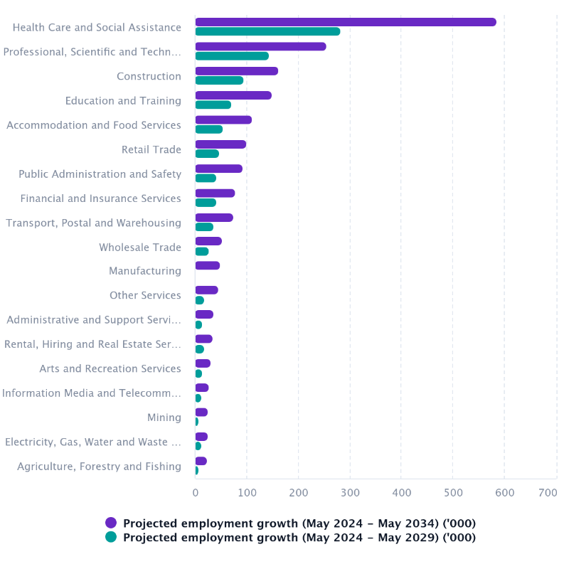
Students are recommended to stay across important information provided by Jobs and Skills Australia’s (JSA), to stay informed. Visit Jobs and Skills Australia’s (JSA) employment projections.

 Games Design Courses in Victoria in 2025
Games Design courses are offered at a number of universities in Victoria. Often, they are specialised courses, other times games design is offered as a major in Computer Science and/or Information Technology degrees (see separate Matrices). Some courses have a specific maths requirement, so students are encouraged to browse the links provided.
INSTITUTION | COURSE | MAJOR STUDIES IN 2025
JMC Academy | Bachelor of Creative Arts (Game Design) | Art History, Art and Animation History, Character Modeling, Character design (2D), Clay sculpture, Colour and Design, Concept Art, Concept Development, Digital Sculpture, Digital concept art, Drawing, Environment Design (2D), Figure modelling, Game Design, Game Studies, Game asset creation (3D) , Game engine scripting [Programming], Game production, Game-play mechanics, Interactive Multimedia, Level design (Games), Motion Capture, Motion Graphics, Pixel art, Production (Games), Prototyping, Rendering, Scriptwriting, Sprite animation (2D), Studio skills, User Interface Design (Games).
RMIT University | Bachelor of Design (Games) | 3D, Animation, Design, Digital art, Game development and programming, Games, Graphic design.
RMIT University | Bachelor of Design (Digital Media) | App design, Augmented reality, Design, Digital audio, Digital media, Digital product design, Digital video, Interactive media, Interface design, Internet and multimedia, Motion graphics, Sound design and effects, Special effects, User experience design, Virtual reality, Visual effects, Web design.
SAE Creative Media Institute | Bachelor of Games Development | Business and Leadership Skills, Employability Skills in Screen Industry Contexts, Game Asset Production and Visual Effects, Game Design Principles, Game Scripting and Game Engine Architecture, Games Industry Best Practices, Project Management, Prototyping, User Experience and User Testing, User Interface Design.
SAE Creative Media Institute | Associate Degree in Games Development | Business and Leadership Skills, Employability Skills in Screen Industry Contexts, Game Asset Production and Visual Effects, Game Design Principles, Game Scripting and Game Engine Architecture, Games Industry Best Practices, Project Management, Prototyping, User Experience and User Testing, User Interface Design.
Swinburne University | Bachelor of Games and Interactivity | 3D modelling for objects and environments, Behaviour and motivation in games, Digital game prototyping lab, Introduction to game studies, Introduction to games production, Pervasive game design lab, Principles of game design, Sound design and acquisition, User-centred design and evaluation, Writing for interactive narratives.
Swinburne University | Bachelor of Games and Interactivity / Bachelor of Animation | 2D and 3D production techniques for animation, 3D modelling for objects and environments, Acting for animation, Action analysis and locomotion, Behaviour and motivation in games, Character and environment design, Character design for animation, Development and pre-production, Digital game prototyping, Genre and the moving image, History of animation, Pervasive game design, Principles of game design, Producing and production management for animation, Production and post-production, Screen writing, Sound design and acquisition, User-centred design and evaluation, Writing for interactive narratives.
Swinburne University | Bachelor of Games and Interactivity/Bachelor of Applied Innovation | 3D modelling for objects and environments, Behaviour and motivation in games, Digital game prototyping lab, Exploring creativity and innovation, Fundamentals of innovation practice, Innovation for challenges of today, Innovation for the future, Innovation sandpit, Introduction to game studies, Introduction to games production, Leadership and facilitation of innovation, Pervasive game design lab, Principles of game design, Responsible innovation futures, Sound design and acquisition, User-centred design and evaluation, Writing for interactive narratives.
Swinburne University | Bachelor of Games and Interactivity / Bachelor of Computer Science | Artificial intelligence, Cyber security, Data science, Games and interactivity, Games development, Internet of Things, Software development.
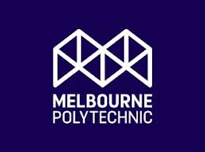 Snapshot of Melbourne Polytechnic in 2025
- Melbourne Polytechnic has been delivering vocational training since 1912 and today offers a diverse range of innovative, hands-on TAFE (VET) and Higher Education (Degree) programs.

- In October 2014, the Northern Melbourne Institute of TAFE (NMIT) changed its name to Melbourne Polytechnic.
- There are over 170 courses to pick and choose from at Melbourne Polytechnic including pre-apprenticeships, apprenticeships and traineeships, and bachelor’s degrees and short courses too.
- Melbourne Polytechnic offers students a range of services and support, facilities and learning resources across its campuses. There are a number of libraries, as well as learning services, conference facilities, restaurants and much more.
- Melbourne Polytechnic has seven campuses, one training centre, and a Skills and Job Centre.

- Melbourne Polytechnic also participates in the Free TAFE course options.
- A number of scholarships are available to a range of students, and they differ from semester to semester and year to year so students are encouraged to keep an eye on what may be available to them.

