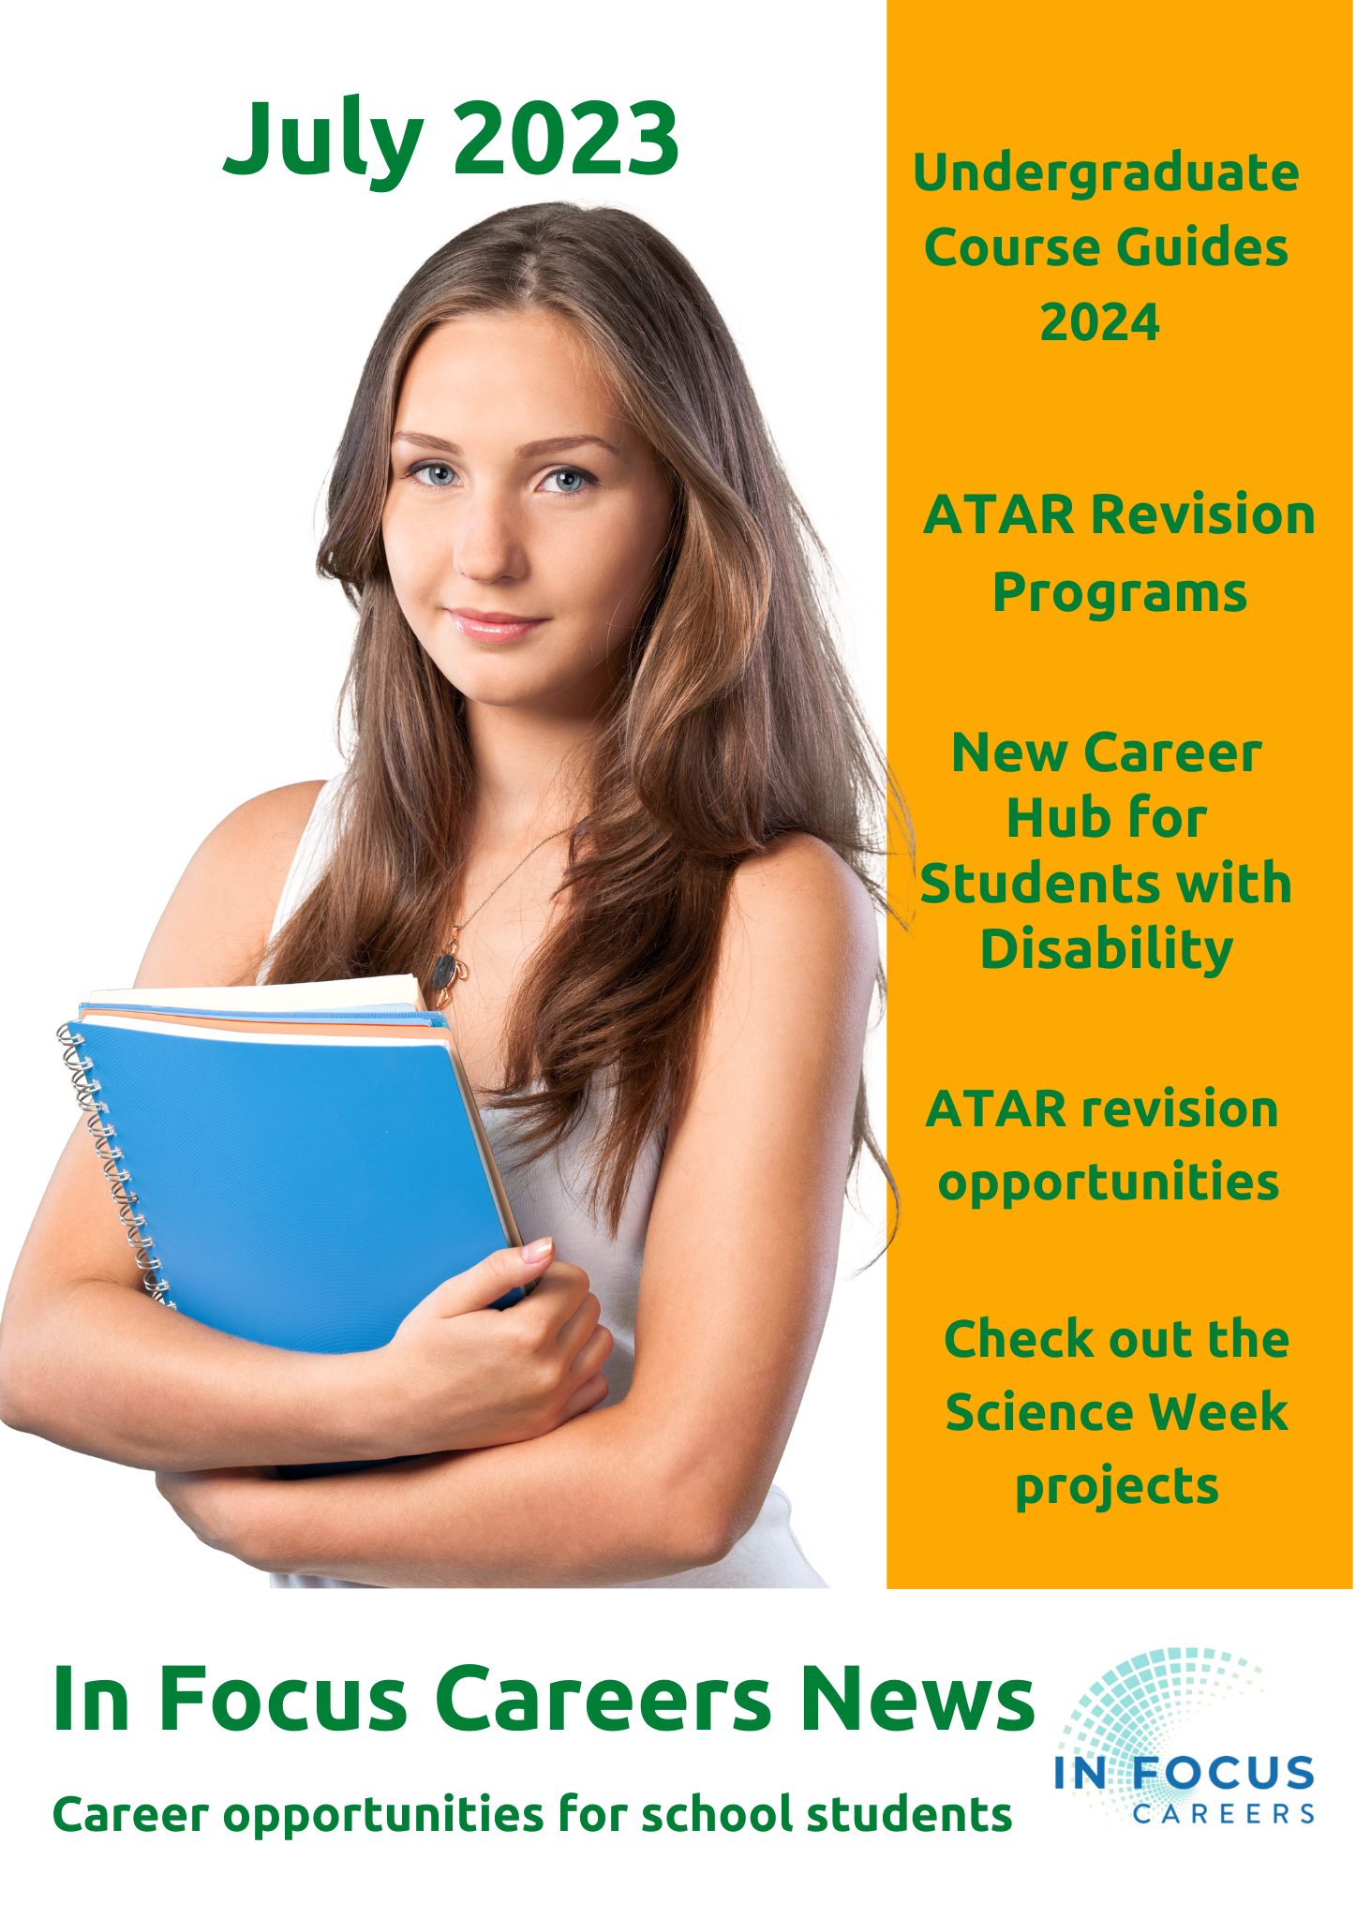

CONTENTS
Section 1: Students and Families
Section 2: Insanely Great Career Advisors
Section 3: Monthly Career Calendar
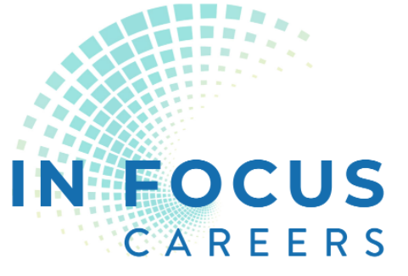
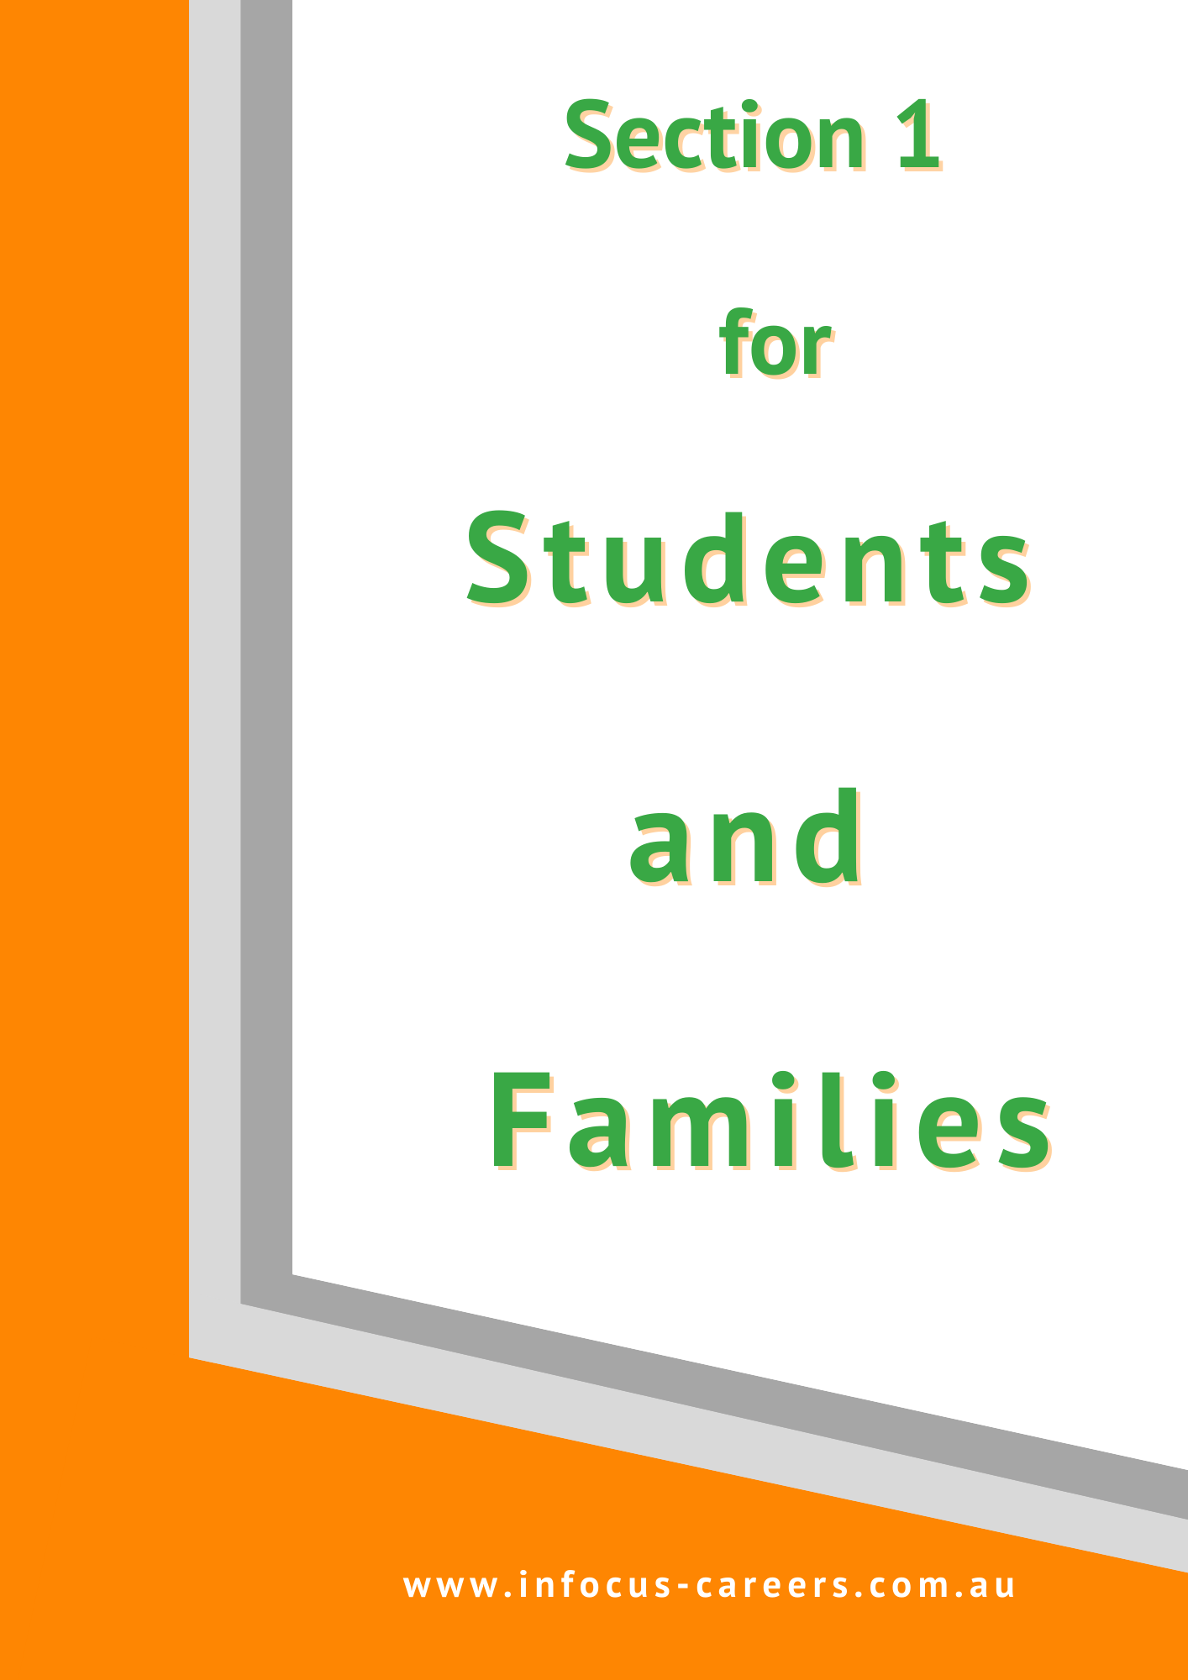

Career Outreach Opportunities for Families
Finding your right career is about your soul. It is about your identity.
It’s about connecting with where you belong.

Your School Needs YOU!
Parents and friends drift away from P&Cs when their kids get to high school. They shouldn’t.
I was talking to Peter Jeffery from Grants Guru this week. He told me of a P&C that has a group of 4 who check out the grants and take turns in writing grant applications.
The school is making a killing.

Lots of Councils subscribe to Grants Guru and provide it for free on their website with localised grant data.
I have been tapping into the Fremantle one. Here are some other examples:
- Bassendean
- Great Southern
- Regional Development – Midwest and Wheatbelt
Check with your local council or check Grants Guru to subscribe for alerts.

Getting grants is probably a whole lot easier than running cake stalls!!

Unemployment figures are static
The latest Australian Bureau of Statistics figures show that the unemployment rate remains static at an extremely low 3.5%.
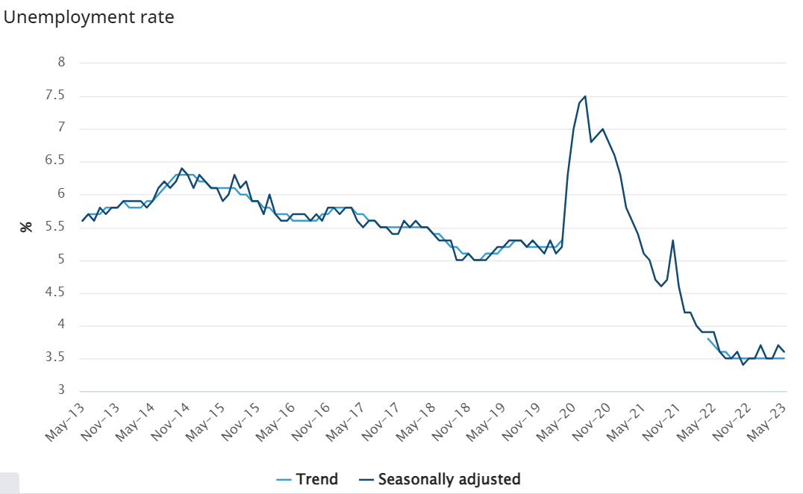
Key statistics for Australia
In trend terms, in May 2023:
- unemployment rate remained at 3.5%.
- participation rate remained at 66.8%.
Check the ABS May 2023 figures HERE.

If you are waiting for the economy to slow in the hope that your interest rates stop rising, the number of jobs advertised decreased by 2.9% in May according to the Internet Vacancy Report.

I hope that means the Reserve Bank holds off on any further interest rate increases!!

World Economic Forum Skills Future of Jobs 2023 – creativity and human skills show a significant rise in demand
We keep being told that jobs are changing or disappearing, and new jobs are being created.
The latest WEF Future of Jobs 2023 idenfities the skills we will need to cope with our changing world of work.
World Economic Forum – Top 10 Skills

 | 2015 | 2020 | 2025 (predicted in 2020) |  | 2027 (predicted in 2023)
 | Complex problem solving | Complex problem solving | Analytical thinking and innovation | Analytical thinking
 | Coordinating with others | Critical thinking | Active learning and learning strategies | Creative thinking
 | People management | Creativity | Complex problem solving | AI and Big data
 | Critical thinking | People management | Critical thinking and analysis | Leadership and social influence
 | Negotiation | Coordinating with others | Creativity, originality and initiative | Resilience, flexibility and agility
 | Quality control | Emotional intelligence | Leadership and social influence | Curiosity and lifelong learning
 | Service orientation | Judgement and decision making | Technology use, monitoring and control | Technology literacy
 | Judgement and decision making | Service orientation | Technology design and programming | Design and user experience
 | Active listening | Negotiation | Resilience, stress tolerance and flexibility | Motivation and self-awareness
 | Creativity | Cognitive flexibility | Reasoning, problem-solving and ideation. | Empathy and active listening

Standing on the Shoulders of Giants – Congratulations Pia Turcinov
Former head of WiTWA, Pia Turcinov is a long term advocate for West Australian girls who are interested in a career in technology.
She has been recognised in the King’s Birthday Honours List as a Member of the Order of Australia:
For significant service to technology and innovation and to women in STEM.
It is wonderful to see this recognition for someone who volunteers her time and attention to support girls into technology in Western Australia.

16 July WAAPA Free Jazz Workshops - for students 12 years old and over
Book Now for 16 July 2.00pm - 3.30pm
The world-class staff from WAAPA's Jazz department will be running free instrumental and vocal workshops for aspiring young musicians. This is a unique opportunity to learn from some of the country's finest jazz performers and educators, whilst getting a glimpse into life at WAAPA.
Instruments
- Piano – Tom O’Halloran | - Saxophone – Jamie Oehlers
- Voice – Victoria Newton | - Guitar – Freddie Grigson
- Bass – Nick Abbey | - Drums – Chris Tarr
- Brass – Jeremy Greig

Please arrive at 1:45pm for registration in building 1 foyer
Workshops 2.00pm – 3.00pm – Multiple rooms
Parents can attend a concert from 3.00pm – 3:30pm in the Geoff Gibbs Theatre
Cost: Free. Bookings are essential.

22 – 23 July WAAPA ACE your WACE 2.0
Dates: Saturday 22 and Sunday 23 July
Boost your confidence and turbocharge your WACE performance exam or audition!
You’ll perform one of your exam/audition pieces in a fun workshop setting - and WAAPA’s classical music lecturers will give you advice and strategies for enhancing your performance.
Cost: Free. Bookings are essential.

11 – 12 August Great Southern Hackathon Mandurah
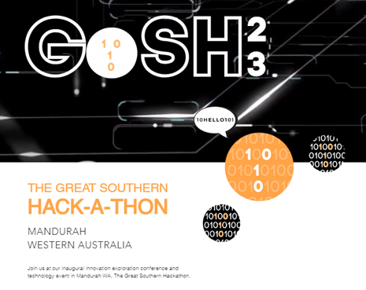
The Great Southern Hackathon is highlighting a multitude of potential future careers in technology through presentations and participation events.

The program looks fantastic. Events will take place across three venues in Mandurah. You can check out the details HERE.

2023 National Science Week Grant Metro Area
Kaarakin Black Cockatoo @Girrawheen  22 August  3.30 – 4.30 | Kaarakin Black Cockatoo will run a hands-on session so participants to meet the Conservation Centre’s resident Dingoes and Black Cockatoos, gain a deeper understanding of their important role in maintaining biodiversity, and build artificial nest boxes.  Find details HERE.
Hologram Printing Competition UWA  19 August | Learn how to manipulate the properties of light while competing in a hologram printing competition.  Find details HERE.
First Scientists  Victoria Park Community Centre | In partnership with local Noongar man Dylan Collard, three experiential workshops will teach participants about our First Scientists. Workshops will be centred around the 6 Noongar seasons, innovations that have, and continue to, contribute to modern practices – such as fire stick farming and utilising the bush for food and medicine, and how our First Scientists designed and secured a balance between human beings and the natural world for the benefit of future generations. Details will go up HERE.
Bird IQ: Getting Curious About Birds Wanneroo Library  5 August Scheduled walk and talk. Walk 9am  and Talk Bird | This series of 12 free community events highlights bird intelligence, behaviour, conservation and ecology. Several scientists and leaders in bird conservation and education in WA will present an inspiring program of interactive events. There will be workshops about the latest research projects from three scientists based at The University of Western Australia, sharing the valuable discoveries they have made about local birds and their latest adaptations to environmental impacts. Get details HERE.

University Opportunities

3 July Curtin ATAR Accounting and Finance
We’re excited to invite all year 12 ATAR Accounting and Finance students to our upcoming revision session. This event is designed to help you prepare for your exams with insider tips and strategies from industry experts.
The session will revise on the below curriculum topics:
- Time value of money
- Cost volume profit for decision making.
- Budgets
- Tips for extended answers
Find more details and register HERE

4 July Curtin Economics Conference
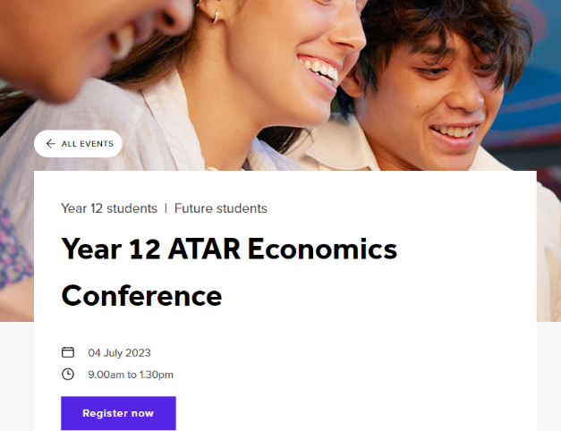
Get ready for the ultimate ATAR economics conference designed to elevate your revision game and prepare you for success! We’re bringing together industry leaders to share their expert insights and knowledge with you.
Find details and get tickets HERE.

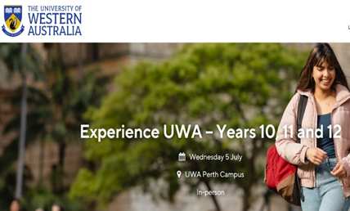
5 July UWA Years 10, 11 and 12 On Campus Experience
Why should you attend this event?
- Take a tour of UWA’s campus including an optional tour of College Row (residential college accommodation).
- Hear about our courses and entry pathways.
- Learn about work integrated learning and how you can get career ready at UWA.
- Meet some of our expert lecturers, current students and staff, including some of our student clubs and societies.

Find details and register HERE.

5 July WAAPA Bachelor of Performing Arts, Performance Making night
WAAPA’s Bachelor of Performing Arts, Performance Making is ideal for those interested in more than one area of performance, from creative development through to performing for an audience, for future writer-performers or director-performers.
To find out more about this exciting course including audition and application information, come along to out Bachelor of Performing Arts, Performance Making Information Evening.
Please note this information evening does not cover our Acting or Musical Theatre programs.
6 – 7.30 PM Mt Lawley Campus
Register HERE.

10 July Notre Dame Architecture Winter School
Get a taste of the Bachelor of Arts (Architecture) and find out what it's like to study, work and create amazing built environments as an architect!

You’ll meet professional architects, create architecture models and drawings, explore the ways people and nature can thrive together, and photograph architecture around the vibrant City of Fremantle. You’ll have the opportunity to learn about what makes architecture such a rewarding career and hear from current students about life here at Notre Dame.
View the complete Winter School schedule, to see the full range of exciting activities planned for the week.
Dates: Monday 10 - Friday 14 July 2023
Cost: $350. For information and to register go HERE.

14 July UWA Future Student Athlete Tour
9am–11.30am
Join the UWA Future Student Athlete Tour and gain a firsthand experience of life as a student-athlete on the UWA Perth campus.
Learn about the various pathways and courses available, explore on-campus accommodation and talk to the UWA Student Athlete Support Team about the opportunities available to help you achieve your dual career aspirations.
Registrations close Tuesday 11 July – register here.

27 July WAAPA Arts and Cultural Management and Production
WAAPA’s Bachelor of Arts (Arts and Cultural Management) prepares students for exciting and challenging careers in the arts and entertainment industries. Whilst our Production and Design programs prepare students for a range of technical live production careers.
To find out more about these exciting courses, come along to our WAAPA Arts & Cultural Management and Live Production Information Evening.
Please note that this information session will not cover performance courses.
Find details and register HERE.

Apply now to live at UWA
Thinking about living on campus in 2024? Apply now as accommodation places are limited.
The recent demand on rental accommodation means a lot more students are choosing to live in a residential college.
If you’re interested in finding out more about living on campus, come take a tour! You can book your tour online at any of our colleges:
- St Catherine’s College
- St George’s College
- St Thomas More College
- Trinity Residential College
- University Hall
If you have any questions, contact residentialcolleges@uwa.edu.au .

UWA Molecular Sciences Laboratory Experiences
Year 11 and 12 students are invited to join UWA’s School of Molecular Sciences for a unique experience completing hands-on laboratory activities with skilled research within UWA’s laboratory classrooms.
For more information and to register, click here.

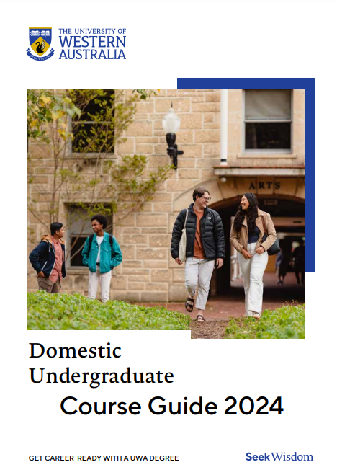
UWA 2024 Undergraduate Course Guide
The UWA Undergraduate Course Guide 2024 helps you to understand how to get the most value from doing their undergraduate degree.
There is so much more available from doing a degree than doing your units online.
Get your copy of the UWA Undergraduate Course Guide HERE.

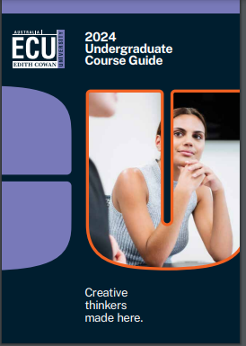
ECU Undergraduate Course Guide 2024
The ECU Undergraduate Course Guide not only provides information about courses. There is information about accommodation, life as a student, support services and international study opportunities.

If you are considering going to ECU check out there course guide HERE.

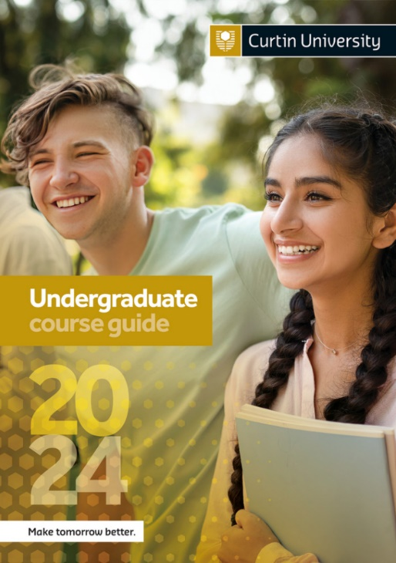
Curtin Undergraduate Course Guide 2024
Curtin’s Undergraduate Course Guide includes a link to an online career quiz. There is information about courses, accommodation, and alternate entry pathways.

You can find the course guide HERE.

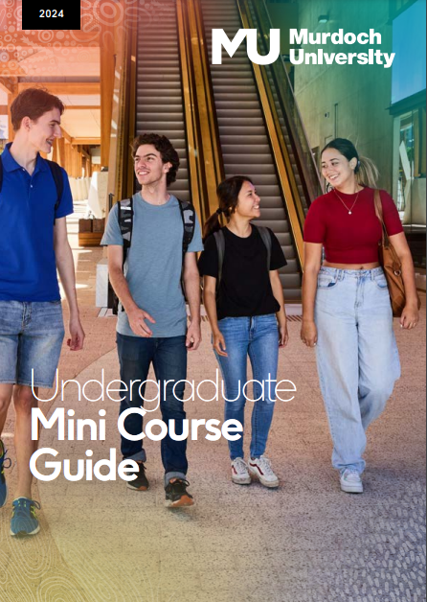
Murdoch Undergraduate Mini Course Guide 2024
Murdoch calls its publication an Undergraduate Mini Course Guide, but it delivers all the essential information that potential students need.

You can find the Murdoch Undergraduate Mini Course Guide HERE.

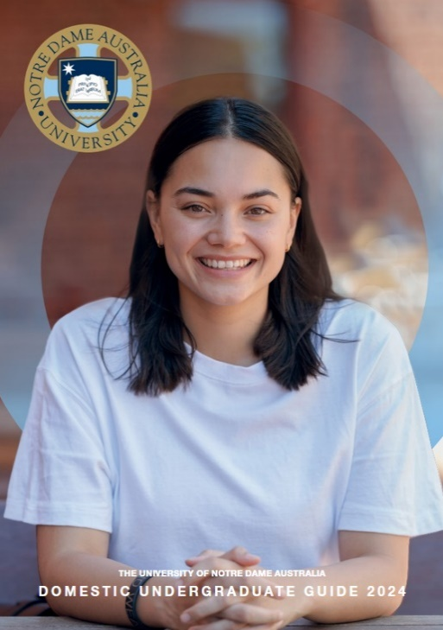
Notre Dame Undergraduate Course Guide 2024
This is a long publication with significant details about Notre Dame’s programs and numerous opportunities for enriched study experiences.
You can find the Notre Dame Undergraduate Course Guide 2024 HERE.

Curtin Focus on Mining 2024
In January and in July Curtin will run 5 day residential camps for Year 11 & 12 STEM students.
Students experience what it is like to study and work in the mining industry in WA.
Check out the details and register your interest HERE.

Curtin Uni Outreach for 13 – 17 year olds First Robotics Competition
FIRST Robotics Competition is a summer robot-building program for students interested in a mechatronics (mechanical + electrical systems) future. Students build a working robot under the supervision of Curtin students and staff.

Students aged from 13 to 17 years of age first register to participate in the Pre-season training at Curtin. Pre-season training runs for 8 days in September/November.
Find out what the Pre Season Training can lead to HERE.

Training Opportunities

27 – 29 July SkillsWest Careers & Employment Expo
This event is one of the biggest held in Perth each year. Universities and training providers, industry representatives and providers of services to job seekers will all be there. Check out the exhibitors HERE.

Schools can register to attend HERE.

2023 WA Apprenticeship and Traineeship Intake Guide
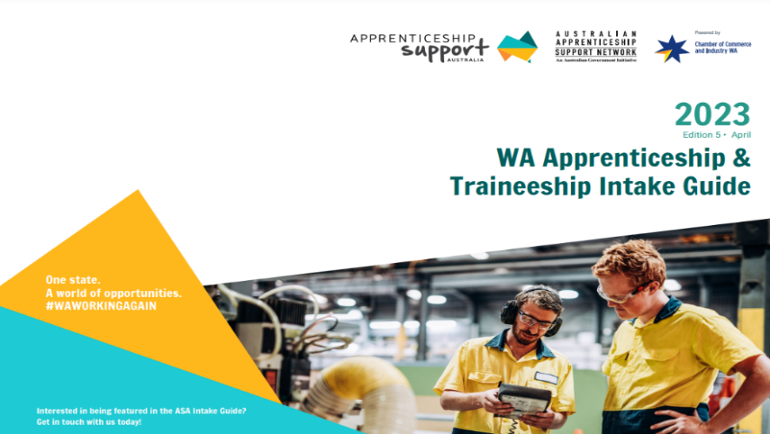
The new Guide is out for 2023.
It is a great resource for students, parents, teachers and career advisors.

You can find it HERE.

Thanks to Georgie Mitchell, CCI Mentor for Women in Trades for sending through the link.

Visit the Construction Futures Centre
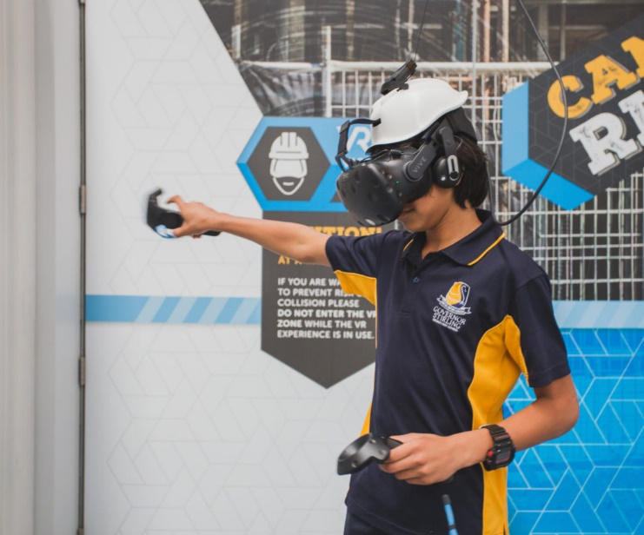
Your school might organise a visit to the Construction Futures Centre, or you could make an enquiry yourself. You can find out about careers in design, construction and different trades.
It is like SciTech for the construction industry. Check it out HERE.

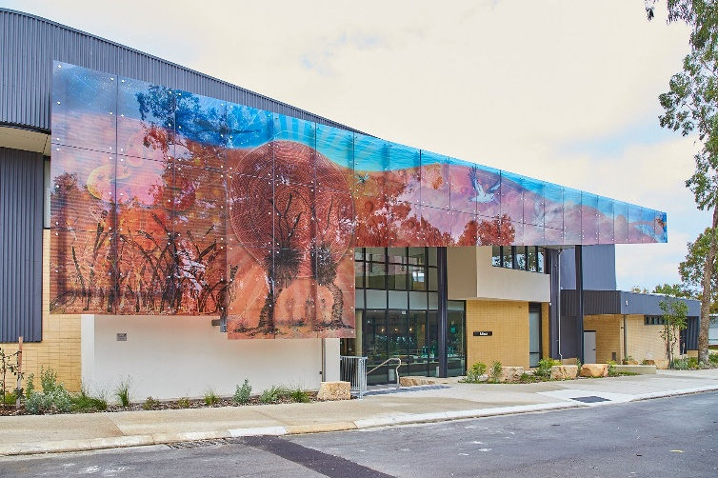
Great look for the new Mandurah TAFE
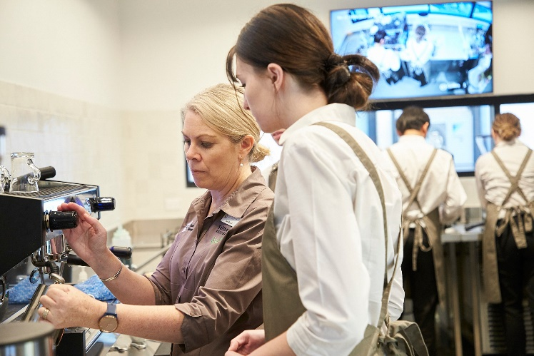
The beautiful new facilities at the Mandurah campus of SM TAFE include a hospitality and tourism training centre.

Read about it HERE

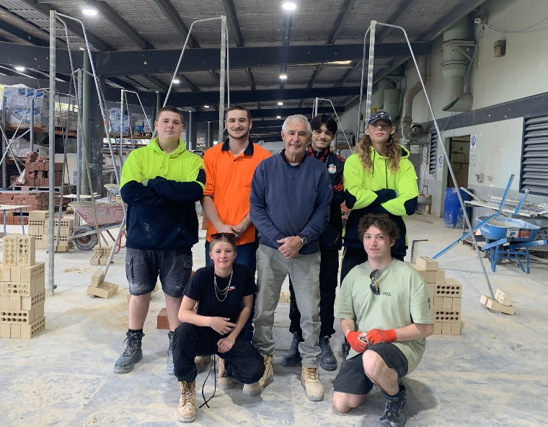
Job Ready Bricklaying
North Metropolitan TAFE’s Job Ready Bricklaying Program at the Balga Campus with seven students successfully secured bricklaying apprenticeships!

- Don't miss this golden opportunity to kickstart your career in bricklaying!
- Here are the dates for our 2023 second semester courses:
7 August: North Metropolitan TAFE Balga or South Regional TAFE Bunbury
28 August: North Metropolitan TAFE Clarkson or South Metropolitan TAFE Thornlie
9 October: South Rio Tinto Metropolitan TAFE Rockingham or South Regional TAFE Bunbury
16 October: North Metropolitan TAFE Balga, and
23 October: Central Regional TAFE Northam.
For more information, visit bit.ly/3J47bn3

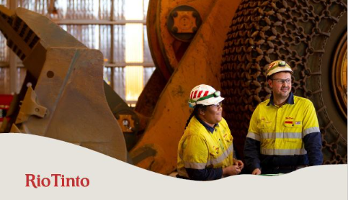
Rio Tinto Apprenticeships and Traineeships launching soon
The 2024 Traineeship and Apprenticeship programs will be opening soon for applications.
Follow the Facebook page HERE.

Indigenous people with any queries or wanting more information, please email Aboriginal.Employment@riotinto.com .

Senior School Opportunities

31 July National Summer School Maths Camp – applications close
National Maths Summer Camp for top maths students
Seven West Australian students will be chosen:
- Two week residential camp.
- 7- 20 January 2024
- Australian National University Canberra
- Cost: $1300 + subsidised flight (Scholarships are available)
Applications Close 31 July. Appy HERE.

West Australian Summer School Maths Camp
WA Maths Summer School for mathematically talented students

- 14 – 20 January
- University of Western Australia.
- Cost $1400
Applications close 31 July. Apply HERE.

25 July Notre Dame Young Achievers Early Offer Information Session
Find out everything you need to know about the program, including selection criteria, the application process, important dates, benefits and more.
You’ll also hear from current students about how receiving an Early Offer helped them finish Year 12 with added confidence and chat with academics about your undergraduate study options for 2023.
6 – 8 pm Register HERE.

29 September – 2 October Register Now: Fogarty Futures Leadership Conference for Years 10 – 11
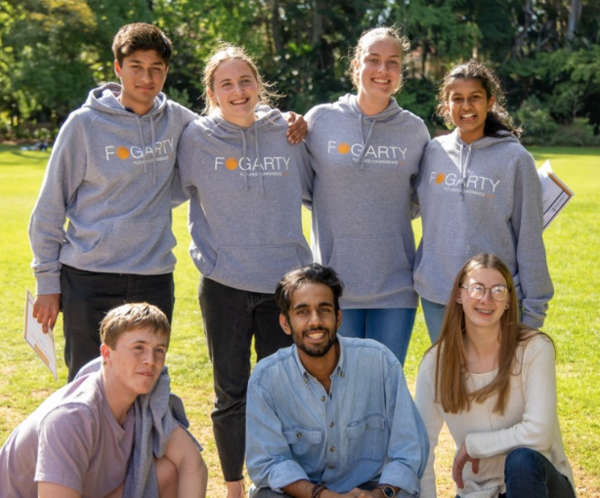
Fogarty Futures Leadership Conference empowers years 10 and 11 students with leadership skills for the future. Based in Western Australia, we seek to encourage students to develop a passion for social justice and benefit their local communities. Soft skills such as leadership, communication and interpersonal skills are not taught in schools, despite being vital to living in a modern globalised world; Futures aims to fix this gap.
Find out more and apply HERE.

Projects Abroad 15 – 18 year olds
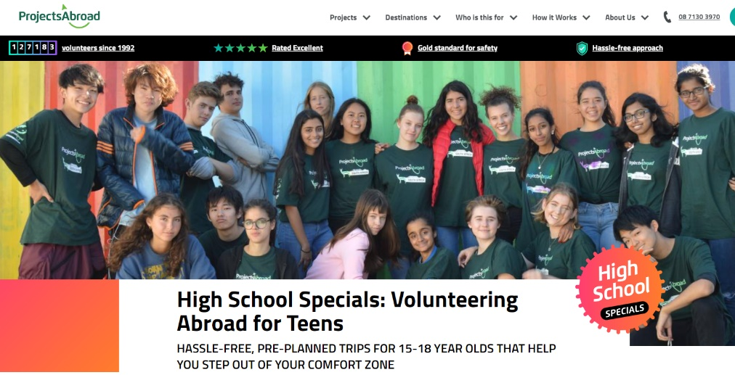
Projects Abroad offers overseas volunteer and service opportunities for high school students. Whether it’s a group mission trip tailored to the school’s requirements or holiday programmes for individuals or small groups of friends, Projects Abroad arranges practical, educational immersion and service projects over 30 developing countries around the world.
For more information go HERE.

Curtin High school student resources
Throughout your time at high school, and as you get closer to graduating, we know you’ll have lots of questions about what to study, the differences between school and uni, and just generally need some advice. Here you’ll find everything you need to know about how to successfully transition from high school to university.
Use these handy links to jump to the section you’re looking for.

Choosing your course

Exam tips and tools

How to apply

Scholarships and finance

Common questions

Before you start uni
Find Curtin resources for high school students HERE.

Year 12 Opportunities

1 July Pinnacle Foundation Scholarships Open
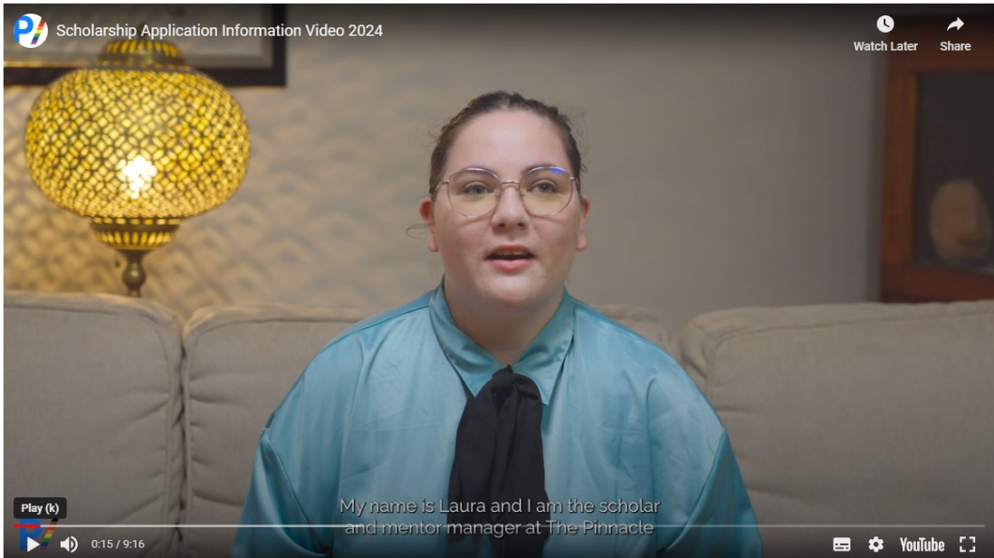
The Pinnacle Foundation provides educational scholarships, mentoring and opportunities for young LGBTIQ+ Australians to realise their full potential and overcome challenges arising from their identity. Scholarships are awarded for fulltime study at public institutions of higher education in Australia, for the purpose of gaining an educational or vocational qualification in any profession, trade or the arts.
Check the information video HERE.
Get more information HERE.

3 July UCAT testing begins
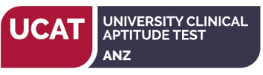
The University Clinical Aptitude Test needs to be undertaken by students wanting to be considered for a place in medicine at Curtin or who want to get into the UWA Medicine and Dental Assured Pathway.
The test can be undertaken from 3 July – 11 August

Good luck to all undertaking the test.

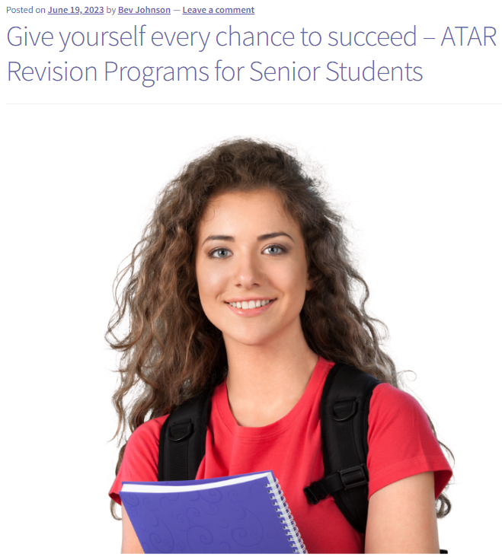
3 July ATAR Revision Programs Start
Year 12 requires significant resolve just to get through. You may tap into some motivation and energy through the ATAR Revisions Programs that are fun through the end of term break.
Find details of some of the programs that are available HERE.

12 July Notre Dame Navigating WACE Exams

Join us for 'Exam Ready: Navigating WACE Exams with Resilience and Confidence', a dynamic and interactive workshop designed to equip you with the tools and mindset needed to excel in your exams.
For details go HERE.

17 July Part II Year 12 Information Handbook
The School Curriculum and Standards Authority puts out two Year 12 Information Handbooks each year. Part I can be downloaded HERE
Part II will be available HERE on 17 July.

2023 ATAR Exam Timetable
2023 ATAR exams start on 11 October with language exams. On 30 October Year 12 written exams start. You can find the ATAR timetable HERE.

ECU has put up its free ATAR Revision Program

Each year ECU conducts ATAR revision programs throughout the end of term 3 holidays. Competition for places is usually strong although it may be more flexible this year as it is all online. The program starts on the week of 25 September.

The revision programs are only in STEM subjects and English. You can register HERE.

Careers in Agriculture
George Monbiot is a revolutionary who says farming is the most destructive human endeavour ever. His ideas on how to feed the world could be a window to the future for agriculture.
Before you become a revolutionary you will need fundamental agriculture skills so that you know what you are talking about.
- The Associate Degree in Agribusiness course is about developing awareness and introduction to commercial farm operations, production systems, cropping science, commerce, Agribusiness Management.
- The Handbook | Curtin University provides pathways into this new world.
- Career Harvest is a hub of information about careers in Agriculture, Forestry and Fisheries.

Part Time Army
If you would like to join the army on a part time basis, consider joining the Army Reserves.
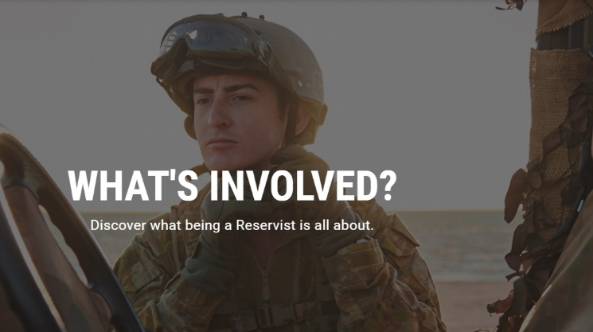
You can choose to work from 20 – 100 days per year, in a block or on weekends.
The hours are flexible, and training is provided.

Check out what being a reservist involves HERE.

Going to Uni in WA 2024
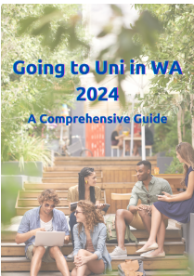
This is a comprehensive guide to navigating getting into uni in 2024.
I have collated information from across the WA education and training network in one place. It is designed for senior students currently at school in Western Australia.

You can get a copy HERE.

Year 11 Opportunities

Curtin Girls + Engineering Tomorrow
Applications are open for Year 11 girls who wish to participate in an intensive out of school course for 10 sessions, run each fortnight over two school terms. Each session includes a maths tutoring component and an engineering exposure component. Contact Aleesha Davis to find out more.

Applications Open for 2024 National Youth Science Forum
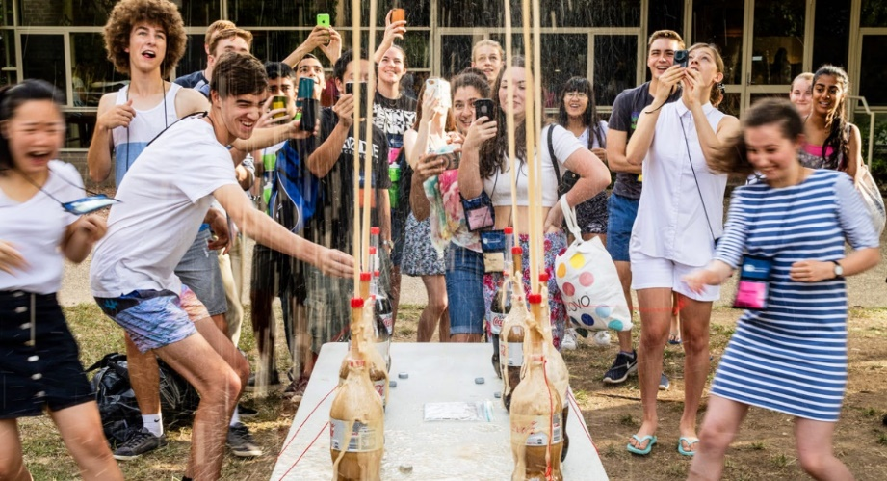
Applications close 31 July
The NYSF program is a 10 day science camp run in Canberra and Brisbane in January for students going into Year 12 who are interested in science, technology, engineering and maths.
The program provides participants with outstanding STEM experiences, opportunities to see a range of careers and you will meet students who could be colleagues throughout your career.

West Australian applicants are encouraged to contact their local Rotary group as Rotary supports this program where possible. You can find out about scholarships HERE.
You can find out about the program HERE.

Year 7 – 10 Opportunities

9 – 10 July & 15 – 16 July Curtin First Robo Academy
Two-day holiday workshops for students interested in coding and robotics. There are beginners, intermediate and advanced sessions as students have fun learning how to program LEGO Mindstorm robots. 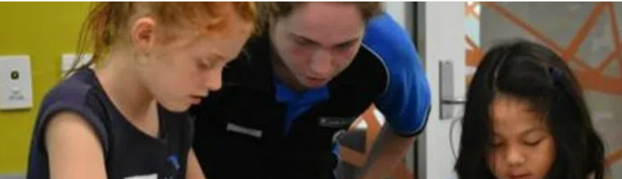
Bookings now open for July school holidays:
- 9 – 10 July | 10am – 3pm | Beginner and Intermediate
- 15 – 16 July | 10am – 3pm | Beginner and Intermediate
Cost: $120 – $150
Find more details and register HERE.

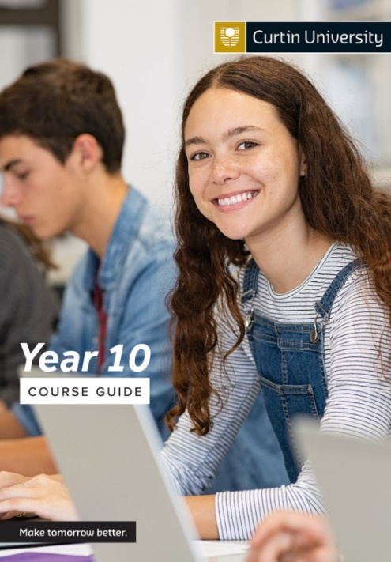
Year 10 Opportunities

Curtin New Year 10 Guide

Curtin has recently updated its Year 10 Guide. This guide includes prerequisite and desirable ATAR subjects for students to complete for university entry in 2026.

View the updated Year 10 Guide today.

Year 9 Opportunities

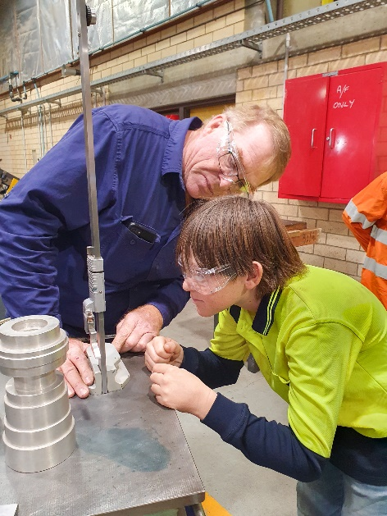
Year 9 Taster Program Nagle Catholic College
Hands-on learning in action! Year Nine students from Nagle Catholic College discovered if Fitting and Machining careers were the 'right fit' during an interactive career taster
To find your school's next experience, visit bit.ly/43OJN58

RRR Opportunities

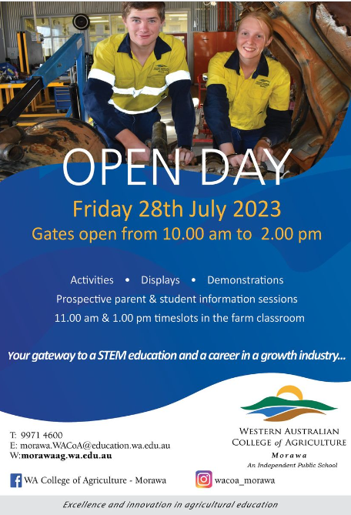
28 July Morawa College of Agriculture Open Day
Staff and students take the opportunity to showcase the college. There will be teachers available to give information about courses and students will be able to tell prospective students what to expect.

Find details HERE.

UWA Regional Students’ Webpage

If you missed the information session for regional students go to the Regional Students’ Webpage for information about
- Courses
- The Broadway Scheme
- Support services
- Accommodation
Find the page HERE.

Book your tour of UWA residential colleges for the school holidays

Thinking about living on campus in 2023? Not sure which residential college to choose?
Our five residential colleges offer tours all-year round, but the July School Holidays
provide an ideal opportunity to tour more than one.
Tours take about 30 minutes per college, and you’ll get to check out the rooms and
facilities, chat to current residents and staff and find out just how close to campus your
new home will be!
Book directly with your preferred college(s):
- Trinity Residential College
- St Catherine’s College
- University Hall
- St Thomas More College
- St George’s College

Want to know more? Visit the website or email residentialcolleges@uwa.edu.au for more details.

New Gateway for North Regional TAFE Broome Campus epitomizes collaboration and teamwork
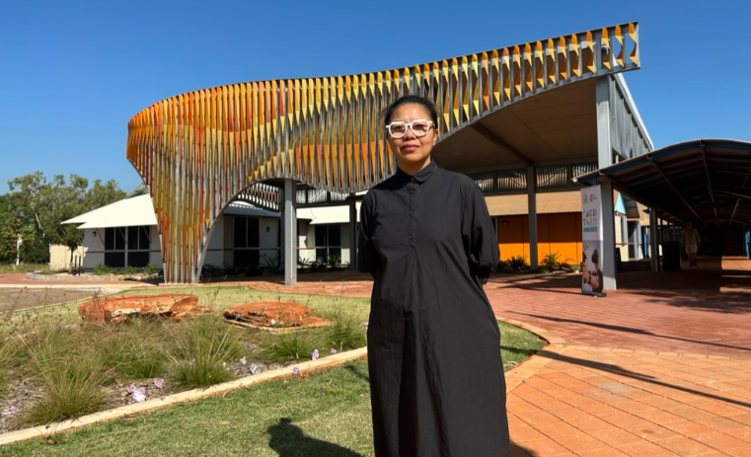
Art and advanced computational fabrication came together to create this beautiful “Pleated Histories”, the entrance to the new hospitality and tourism facility on Broome TAFE Campus.
The work epitomizes the collaboration and teamwork required by 21st Century creative industries.

The entrance was designed by visual artist Jacky Cheng who has lectured at the campus and in communities across the Kimberley along with @if/labdesign along with Vanessa Margetts and the Kilmore Group fabricated and installed this beautiful entrance

The commitment of North Regional TAFE to visual arts and music programs supports the growth of creative industries across the region.

Check out the courses HERE.

Science Week Grants Regional Projects
Jerramungup and Ravensthorpe  Living and Learning the Biosphere | The Fitzgerald Biosphere is internationally and nationally recognised for its high biodiversity richness. The Living and Learning the Biosphere events aims to connect people to foster an understanding and take ownership.
Kondinin  Super Sunday Science Funday  Community Resource Centre | This is a spectacular science stage show and interactive hands-on experiments that participants can rotate through.
Nannup  Birds of a Feather, Flower and Garden Festival  Nannup Garden Village | Experts from the Blackwood Valley Raptor Centre, will be talking about all things birds at this exciting session during the Nannup Flower and Garden Festival
Carnarvon | The Youth Team from the Shire of Carnarvon are delivering three events:  - a Young Rocketeers workshop at the Carnarvon Space Museum,.  - an agriculture workshop, run in partnership with Central Regional TAFE and DPIRD,  - a Young Engineers Challenge
Geraldton  On the Road with STEM Kids  The Community Toy Library | Children aged 3 – 8 and their families will discover how to ask questions, problem solve, experiment, hypothesis and evaluate with 8 curated STEM play environments to investigate.
Harvey  Curious Minds  The Shire of Libraries | For children aged 4 – 14. Activities will include Lego Mindstorm, Turing tables, and challenge activities such as structure and bridge building, algorithm games, and marble runs
Toodyay  Robotics Day  Community Resource Centre | Participants will learn how to interact, service, program and build humanoid robots with advanced digital technology and artificial intelligence.
Broome Festival of STEM  3 – 4 August | There will be two parts to the festival with a school festival during the day and a community festival in the afternoon.  The festival will take place at the Broome Civic Centre. Find details HERE.
Gascoyne Rocks  Mt Augustus rocks, crystals and minerals | Participants will discover what links Mt Augustus rocks, crystals, and minerals to the rocks in space through a night with experts at Gascoyne Junction Town Pavilion.
York  STEM Embrace for All Community Resource Centre | This will include activities like, Lego maze coding, building a hand crank winch, stop motion animation video creations, jellybean building and so much more. The Science Alive team will run two interactive shows for the community.
Hopetoun  Elemental Energies  Community Resource Centre | A series of hands-on workshops for children and adults will teach participants how to create energy from the earth’s elements.
Broome  Red Dirt Robotics | Five 3D design and printing sessions will be delivered at Broome Public Library. The local tech exploration group, Innovation Station, will work with the founder of Red Dirt Robotics to deliver these workshops to their community, inspiring teens to get involved in the local group.  Find details HERE.
Karratha  Makedo Maker Space Library  31 July | Join us at the City of Karratha Libraries for special sessions using the Makedo system in hands-on, large-scale cardboard construction activities.  Aimed at ages 4-12 years old. Find details HERE.

Aboriginal and Torres Strait Islander Opportunities

9 – 15 July Curtin Indigenous Australian Engineering School
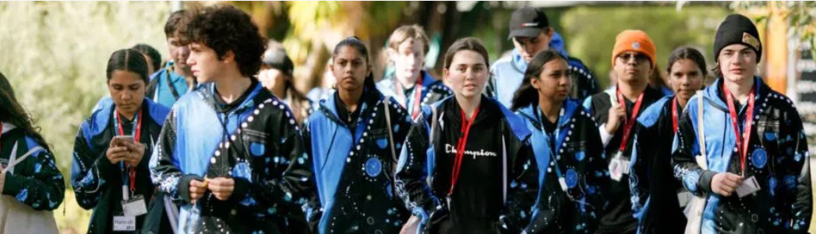The Indigenous Australian Engineering School (IAES) is a week-long residential camp introducing students to engineering studies and careers.
Students do site visits, meet industry representatives and participate in educational activities.
The program targets Indigenous students in Year 9, 10, 11 and 12 with an interest and aptitude towards engineering, science and mathematics.
For more information go HERE. Email Tim Keely to find out more

10 – 14 July (Kalgoorlie) Curtin Indigenous Futures Regional Pathways – Year 7 - 12
Learn about studying at Curtin university as a regional Aboriginal student.

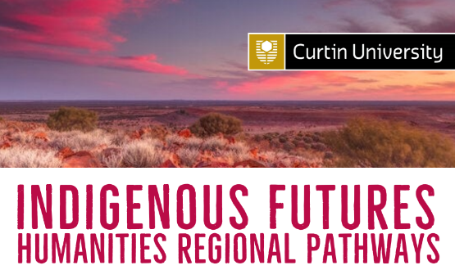
This program introduces Aboriginal people to the Humanities. You will gain insight into what it looks like to be an Indigenous person at university, and ways your career education in Humanities can deliver you to a future in which your community can thrive.
For information contact humanities-engagement@curtin.edu.au

Koomba Birdal program at Midland TAFE
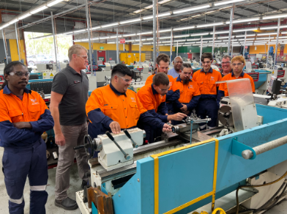
Koomba Birdal is a 20 week program in either Conservation and Eco system Management (Caring for Country) or Mechanical Fitting pre-apprenticeship.
Find out more about the program HERE.

Students with Disability Opportunities

Career Development Learning Hub
The Career Development Learning Hub is the first of its kind in Australia aimed at supporting students with disability. The Hub and provides a range of resources to support university students, educators, parents, career practitioners, and employers. They include:

- advice, tips and guides
- a guide to language about disability
- stories from students with disabilities
- case studies of good practice
- best practice principles
You can find the resources HERE.

Coderdojo@Curtin
Curtin runs a computer programming club for young people. There is a stream for students over 12 years old and a stream for children interested in Curtin’s Autism Academy.
Find details HERE.

Microtoons
Dr Rina Wong
MicroToons-Scab is an animated science story produced with autistic and neurodiverse talents. The project is a partnership between microbiologist, artist and ‘My Mad Scientist Mummy’ children’s book author Dr Rina Fu, animation studio Red Bird Creative, and disability services provider 4lifeskills.
Project/event location: Online Search details HERE.

International Student Opportunities

4 July ECU International Student information session
Join this online information session and ask questions of experts.
6 – 7.30 PM Find more details and register HERE
You can read the report HERE.

Blog Posts

16 Mind Maps for West Australian Career Advisors
This poster is one of the best resources I have created. Behind each of the 16 blocks is a mind map linking you to career information and tools for West Australians.
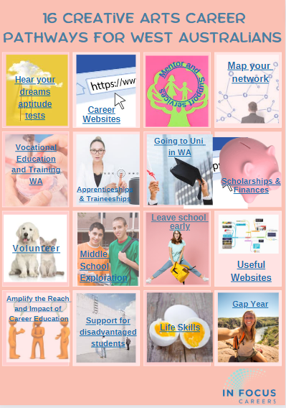
I have been concerned that I overwhelm readers with the amount of information I send out.
I have worked to sorted out and collated resources that I use under 16 headings that readers are most interested in.

Behind each of the 16 headings is a mind map of links and tools for West Australian career advisors.

You can get a copy HERE.

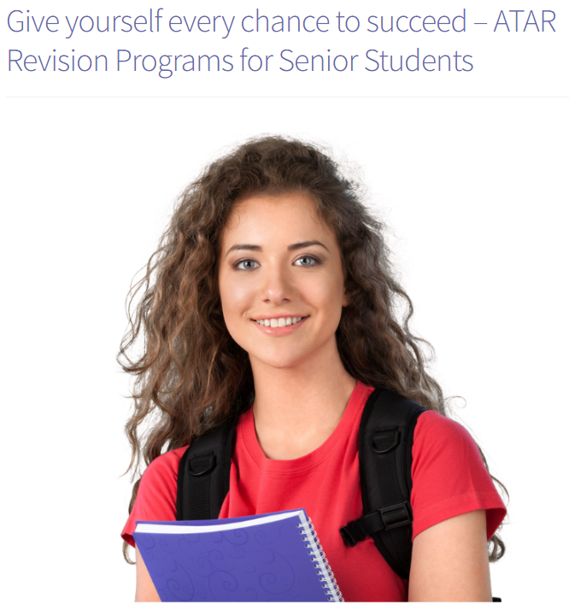
Give yourself every chance to succeed – ATAR Revision Programs for Senior Students
Year 12 can be like a marathon. Students often run out of steam before they get to the finish line.
ATAR revision programs can give students the enthusiasm to push on and finish well.

This Blog Post identifies a range of potential programs that students can enrol in.
You can find it HERE.

Are creative career pathways a passport to poverty? No Way. Check out these Digital Creative Arts VET courses.

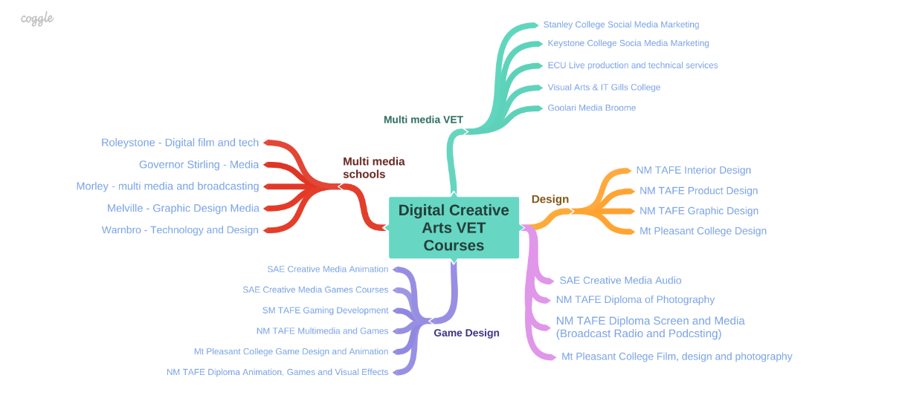
The World Economic Forum Future Jobs Report is anticipating a growing emphasis on creative skills.

If you are interested in a creative career, I have collated a mind map of Digital Creative Arts VET Courses. Check them out HERE.

You can start to prepare your school or organisation to fully engage with Chat GPT

