Meet Buddee.
We’re changing school lunches for good
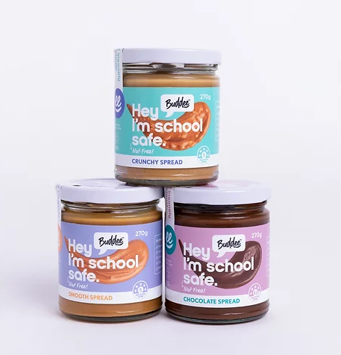

every lunchbox
every child
every home

Buddee is putting spreads back in lunchboxes
Buddee opens the door to over 4 million school lunchboxes across Australia.

Australia is the allergy capital of the world. On average 1-2 children in every school classroom suffer from severe food allergies. This has led to a nut-free policy across Australian schools, which means no peanut butter or choc 'hazelnut' spread.

Buddee exists to fill this gap. We are for every lunchbox, every child, every home.
https://www.heybuddee.com.au/

