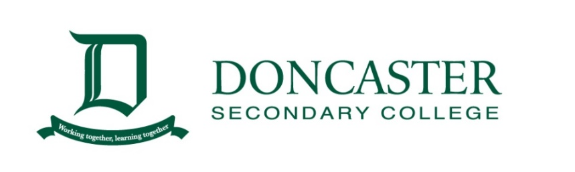

Annual Short Story Competition – 2023

All students across the College can enter the competition. The due date is Friday 28th July. Make sure you send your story to your English teacher on the assigned Learning Task, with the cover letter below attached. For some students, this task will be a CAT, so make sure you confirm this with your teacher.

Short stories should be at least 400 words but there is no maximum.

Look at the different stimuli below and use it to guide your response. You should use one.

If you would like to write a story that does not utilise one of these stimuli that is allowed.

|  |  |
| --- | --- |
| Top Protest Stock Vectors, Illustrations & Clip Art - iStock | Software  demo, Riot, Demonstration  36,962,344 Nature Stock Photos - Free & Royalty-Free Stock Photos from  Dreamstime  3,100+ Sword Fighting Stock Photos, Pictures & Royalty-Free Images - iStock  | Knights sword fighting, Kids sword fighting, Woman sword fighting | 350+ Hearts Pictures | Download Free Images on Unsplash |
|  |  |

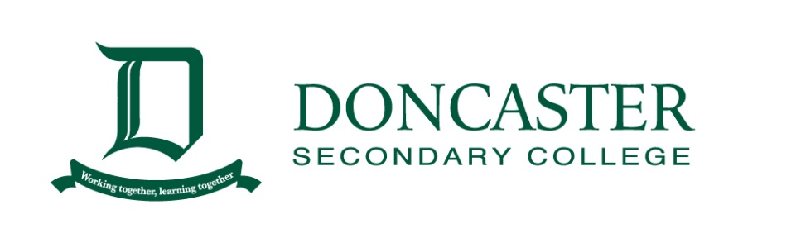

**2023 DSC Short Story Competition**

*COVER PAGE*

NAME:

STUDENT CODE (eg. STA0021):

CLASS:

ENGLISH TEACHER:

WORD COUNT:

TITLE OF THE STORY: ____________________________________________________