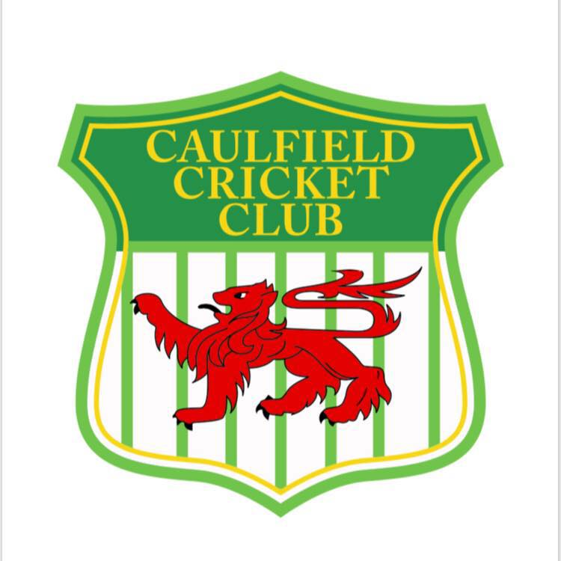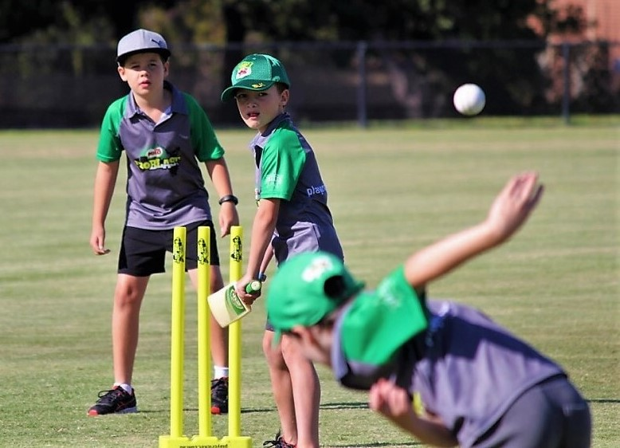
Caulfield Cricket Club invites boys and girls to come and try cricket which operates as the summer sport offered at the Caulfield Park Main Ground Pavilion.
The cricket season runs from October until February/March, depending on the age group.
Junior Master Blasters – beginners, ages 5-7
Master Blasters – T20 style games, ages 7-9
Under 11s – modified rules cricket games, ages 9-10
Under 13s, 15s, 17s – more overs, one and two day games
Pre-season training starts in September for younger juniors and from August for older juniors. During the season, junior training takes place on Wednesdays or Thursdays at the Caulfield Park Main Ground.
REGISTRATION TO PLAY CRICKET AT CAULFIELD PARK IS NOW OPEN.
How to Get Involved
Website: caulfieldcc.vic.cricket.com.au
Facebook: Caulfield Cricket Club Juniors
Registration: playcricket.com.au
Search 3161, Choose Caulfield Cricket Club
Contact: Ty Matthews
Junior President of Caulfield Cricket Club at
magpies_5@hotmail.com or give me a call on 0401997867 to discuss

