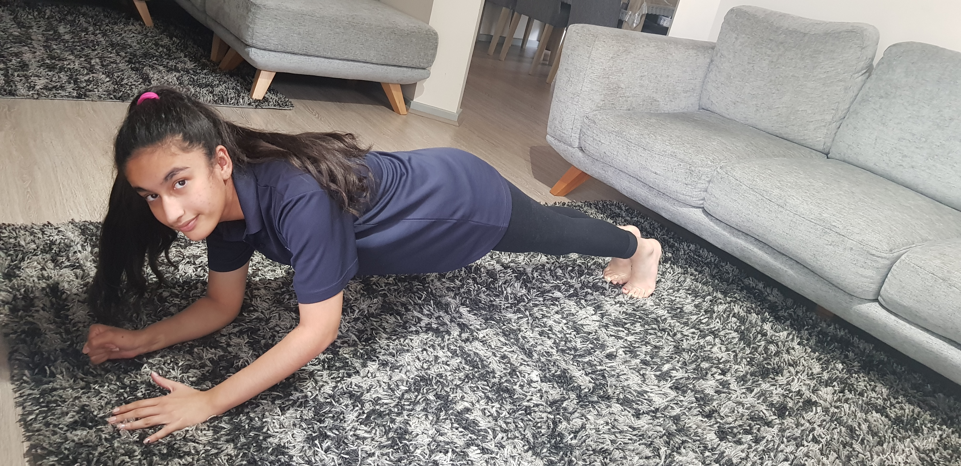  Up, up, down, down plank  Area of fitness: core strength  Body system: muscular  STEPS:  - Start in plank position with your hands under your shoulders and arms straight (no bending elbows).  - Lower your right elbow onto the floor, then the left.  - Now place your right palm on the floor and push yourself up with the left. Now you are in starting position.  - Repeat.  The up and down plank strengthens your core, glutes, arms, wrists, and shoulders. | 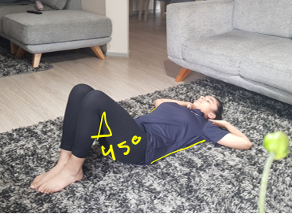  Crunches  Area of fitness: core strength  Body system: muscular  STEPS:  - Starting in the position above: Lie flat on the floor, bend knees at a 45°, keep feet flat. Bend both your arms keeping elbows and chest open, touching the back of your head.  - Bend your hips and waist to raise your body off the floor and stop once you reach your knees.  - Lower your body back to the starting position.  Crunches or sit ups work the rectus abdominis, transverse abdominis, and obliques in addition to your hip flexors, chest, and neck. | 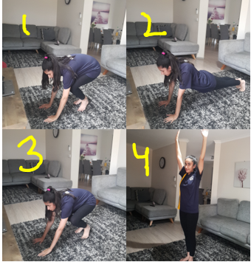  Burpees  Area of fitness: core strength  Body system: muscular  STEPS:  - Start in a low squat position; knees bent, feet shoulder width apart, with your hands touching the floor in front of you.  - Jump with your feet backwards into plank position.  - Jump your feet back into squat position.  - Stand up and reach high with your arms.  Burpees work to strengthen the muscles in your legs, hips, buttocks, abdomen, arms, chest, and shoulders.
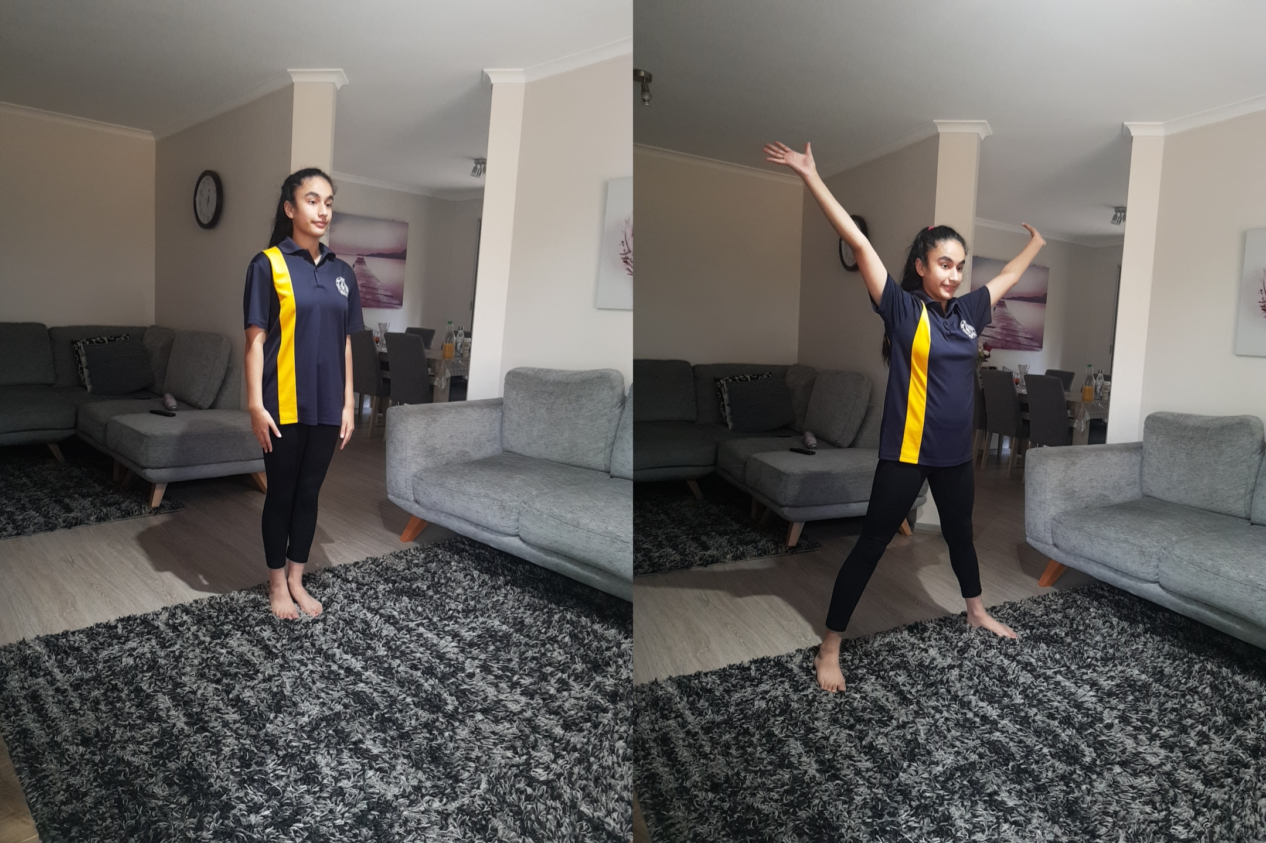  Star jumps  Area of fitness: cardiovascular  Body system: cardiorespiratory  STEPS:  - Stand tall with your arms by your side and legs together.  - As you jump, spread your legs to be shoulder-width apart. Stretch your arms out and over your head (in a ‘V’ shape).  - Go back to starting position.  - Repeat.  Star jumps are a great form of cardiovascular exercise, they get your heart racing and your blood pumping | 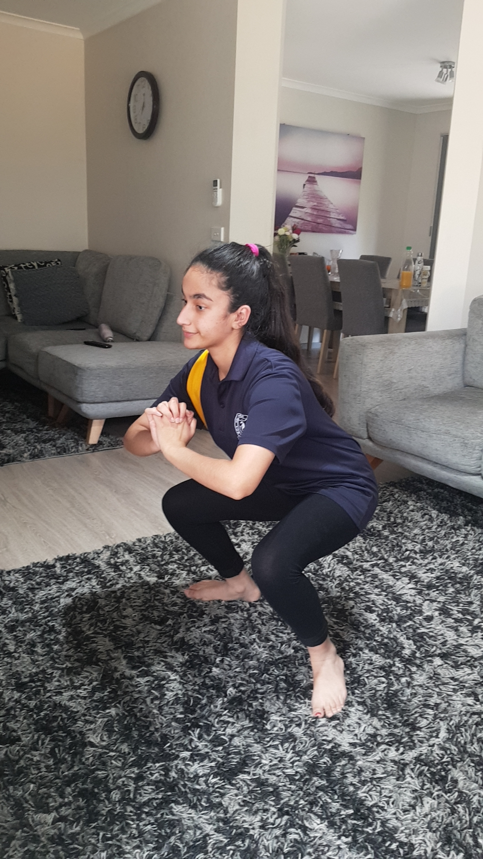  Squat  Area of fitness: strength / resistance  Body system: muscular  STEPS:  - Stand straight with feet about shoulder width apart.  - Keeping your chest high, bend as if you are about to sit down into a chair.  - Get up into starting position and repeat.  Squats strengthen your core, muscles in the lower body and boost your athletic strength and ability. | 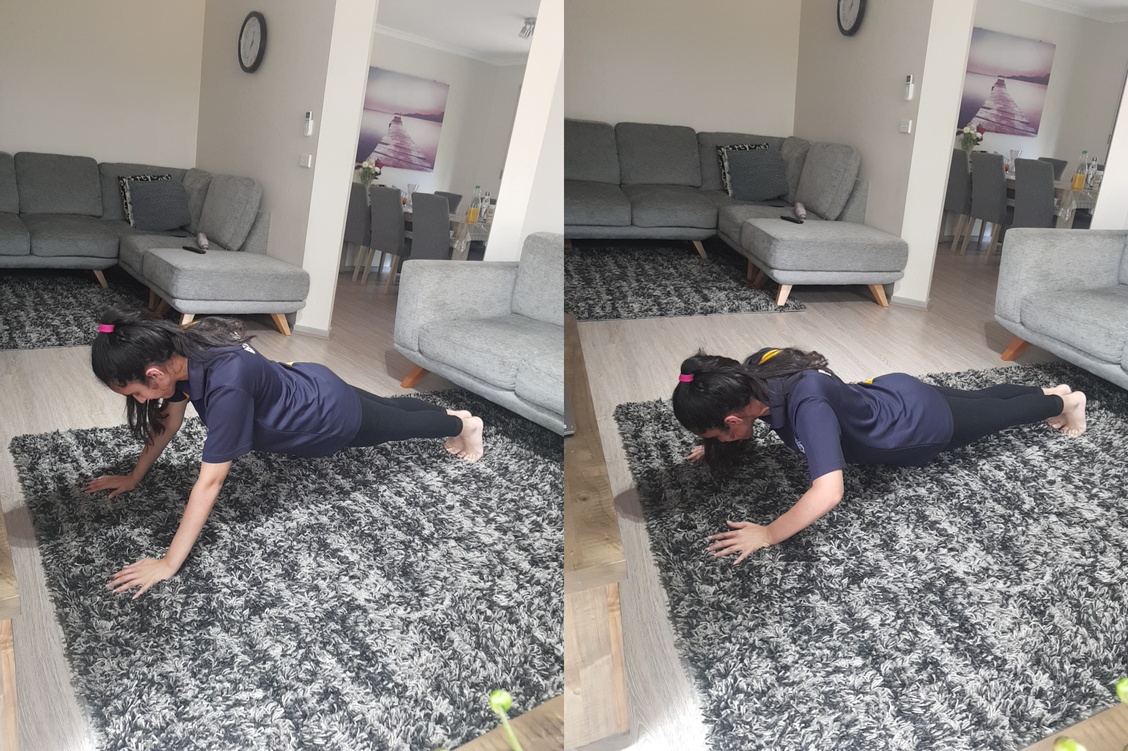  Pushup  Area of fitness: core strength  Body system: muscular  STEPS:  - Start in a high plank position; hands shoulder-width apart, shoulders stacked directly above your wrists, legs extended behind.  - Bending your elbows, lower your chest towards the floor.  - Push through your palms to straighten your arms.  - Repeat.  Pushups work the triceps, pectoral muscles, and shoulders while engaging the core and strengthening the lower back.
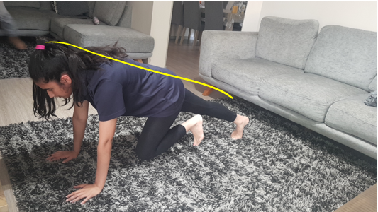  Mountain climbers  Area of fitness: core strength and cardiovascular  Body system: muscular and cardiorespiratory  STEPS:  - Starting in a high plank position, keep your back straight and align with legs.  - Bring you knee towards your chest and touch your toe to the floor.  - Extend your leg back to starting position and repeat with your other leg.  The exercise strengthens your upper body, core and improves flexibility. | 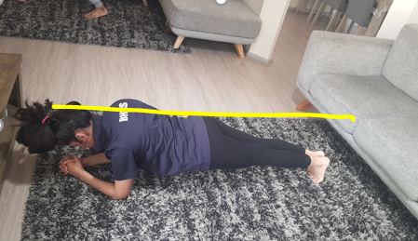  Plank  Area of fitness: core strength  Body system: muscular  STEPS:  - Position your elbows under your shoulders and rest your forearms on the ground.  - Keeping your body in a straight line, pop up onto your toes.  - Keep belly tucked and hold position for required time.  The plank strengthens your spine, your rhomboids and trapezius, and your abdominal muscles. | 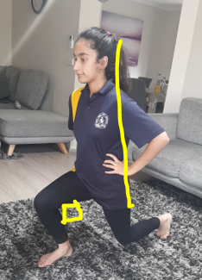  Lunge  Area of fitness: strength / resistance (lower body) and core strength.  Body system: muscular  STEPS:  - Stand tall with feet hip width apart. Tuck belly to engage your core.  - Take a big step forward so that your leg reaches a 90° angle. Start to shift your weight forward so heel hits the floor first.  - Lower your body until thigh is parallel to the floor and shin is vertical. Make sure knee doesn’t go past toe. Lightly tap other knee to the floor while keeping weight in heel.  - Repeat with other side.  This exercise targets your abdominals, glutes, quads, calves, hamstrings and back muscles.

REFLECTION

Throughout my two-week fitness program, I incorporated exercises that assess the four areas of fitness: core strength, cardio, strength/ resistance, and flexibility. The exercises chosen were appropriate to the fitness components as they worked the targeted muscles for each area of fitness, e.g. core strength → Rectus abdominis​, Transverses abdominis , External oblique​, Internal oblique​, Multifidus and the erector spinae​.

In reference to my goal, the training program allowed adaptations to occur for the cardiorespiratory system when performing aerobic exercises. Cardiovascular and strength training increases the cardiac output and ejects more blood per beat. Cardiorespiratory adaptations such as an increase in transfer and use of oxygen, generate energy which prevents muscle fatigue in prolonged aerobic exercising, improving the workout efficiency.

The highlights of my fitness routine were incorporated various exercises without having too many of the same ones, balanced out the four key areas of fitness plus upper and lower body strength, and made me feel much happier in general. And the warmups and cooldowns were also a strength of the program because it is important to warm up your muscles before a workout and complete some stretches to ‘cool down’ after a workout. The ones I included were made for the area of fitness specifically which was very convenient.

Although the program was effective, it could do with some enhancements. In a few exercises, I found it confusing following the sets and reps, so to avoid this confusion, I could either keep them the same for all exercises or change the formatting of how I list them. Another flaw of the program is I didn’t balance out moderate and high intensities. A suggestion for future improvement could be including a combination of more high-level intensity sessions to challenge my endurance helping achieve my fitness goal. These weaknesses indicate that more thorough planning was required, and I should’ve given more thought to how I could prevent them from happening.

The fitness routine was, to be honest, a bit difficult, however, nothing compares to the joy you feel at the end of completing each session of exercise.

